**Start semester  
Orientation phase  
Personal Experience Portfolio**

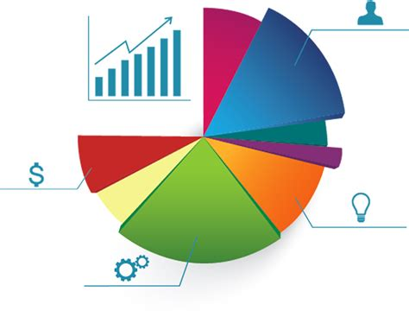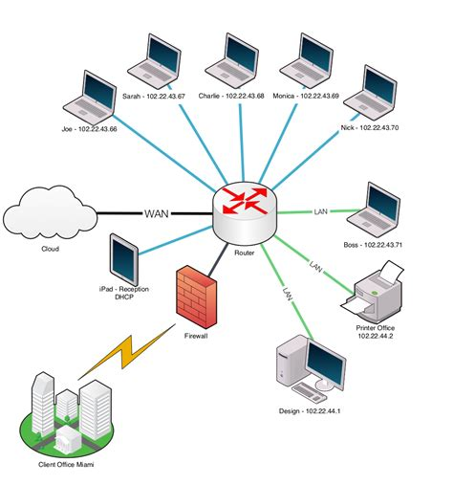





**Student name: Katerina Svetoslavova Slavova  
Student number: 5363233**

**Class: PCB 10  
  
Version: 1.1  
Date: 25-8-2022**

# Purpose of this document

You fill in this document on a regular basis to demonstrate your understanding and growth and performance with respect to all the learning outcomes – both technical and professional.

You record and reflect on your work based on the feedback received from your teachers.

Both professional learning outcomes and technical learning outcomes can be found on the homepage of the Canvas course.

You may provide details under the following headings in this document, as evidence of your work, feedback, reflection, learning, growth, and goals for both professional and technical skills.

* Evidence of your relevant skills and abilities (find examples below this text)
* Which learning outcomes both professionally and technically did you work on
* Feedback that you received
* What was your approach?
* What went well and why, can you improve?
* What research did you do?
* Used Resources

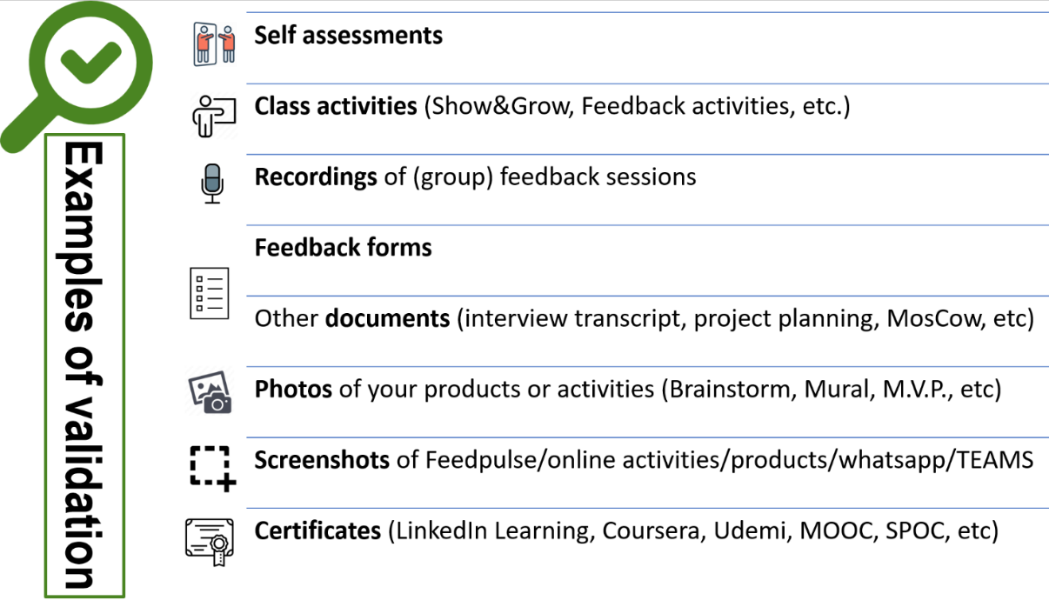

Table of contents

Purpose of this document 2

Table of contents 3

Persona 4

4

Key Take aways in your portfolio 7

Key take aways of the weeks 8

Week 1 8

Week 2 8

Week 3 8

Week 4 8

Week 5 9

Week 6 9

Week 7 9

Week 8 9

Validation of the Learning Outcomes 10

Technical Skills 11

ICT & Business 11

ICT & Infrastructure 13

ICT & Media Design 26

Software Engineering 45

ICT & Technology 73

Professional skills 83

Professional standard 83

Personal leadership 85

Greenhouse project – week 5 and 6 88

# Persona

My name is Katerina Svetoslavova Slavova. I am 19 years old and I am from Nova Zagora, Bulgaria. I studied and graduated in “Hristo Botev” Primary School and “Hristo Botev” Secondary School.

I started studying programing from 8th grade. When I started 10th grade, I enrolled in an extracurricular class called “IT kariera” in order to improve my knowledge in programing and after I graduated, I got a Third level professional qualification as Application Programmer. I can program in C#, Sql, a little bit Html and I have previous experience with Arduino. I love reading, listening to music, going to the gym and hanging out with friends.

My main goal at Fontys is to gain knowledge and work forward to having a successful future in the ICT industry.

# 

|  |  |
| --- | --- |
| **Learning outcomes:**  **Fast Links** | **Projects:** |
| **ICT & Business**  You demonstrate how to convert data into information in order to achieve a recommendation that will make an improvement for a process in an organization. | Greenhouse project(Everlast Agro B.V.)  Data analysis and chart creation |
| **ICT & Infrastructure**  You demonstrate a self-developed, secured network environment with hosts and servers based on a specific application requirement (services). | CLI Basics  CLI Chat App  Wireshark  Visualize your home network  Fast Food Chain  Network Design Visualization  Greenhouse network diagram |
| **ICT & Media Design**  You are able to develop and implement interactive prototypes in an iterative process for the target users based on trends and developments. | Prototype for Guess the Word Game  Appendix Html page  Html page for Guess the Word Game  The balloons game prototype  Time and random light level - html  Updates and Styling - html  Multiple samples - html  My Fontys prototype  Greenhouse Monitoring System - html  Mario and Luigi’s pizza |
| **ICT & Software Engineering**  You develop software applications with attention for algorithmics and hereby demonstrate the basic skills of object-oriented programming. | The High IQ Game  Find The Leap Year  Check the password  Find the classroom  Find The Tallest Player  Guess The Number Game  Inform The Boss  Rainfall Measurments  Extending The Athletics Analyser  GuessTheWordGame  Mastermind  Time and random light level - python  Updates and Styling - python  Multiple Samples – python  Greenhouse Monitoring System - python |
| **ICT & Technology**  You develop and programme interactive embedded systems in which you use sensors and actuators and apply various I/O techniques. | Final LED Blink Challenge  Single Button Challenge  Two Buttons Challenge  Arduino LED Dimmer  Cyclic Display  Greenhouse Monitoring System - arduino |
| **Professional standard**  You apply professional practice, both individually and in teams, in the areas of project organization, communication with stakeholders, exploratory research, and reporting. | Personal plan to increase effort and engagement  Presentation on ICT and Software engineering profile  Presentation about research report  Presenting why I chose software  Marshmallow challenge  Agreements how to work together  My Fontys  Research report  Team charter  Pizza project plan  Trello  MoSCoW |
| **Personal leadership**  You take the initiative in asking for, and reflecting on, feedback. You identify your own core values as the basis for your study career and professional development. | Core Values  Profile choice  Belbin team role test |
| **Key take aways** | Go to key take aways |

# Key Take aways in your portfolio

**Purpose:** The key takeaways section helps you capture the most meaningful insights each week. These takeaways are personal reminders of what truly resonated with you and will guide your future learning.

**Scientific support**

1. **Karpicke & Blunt, (2011).** Summarizing key points improves long-term retention.
2. **Brown et al., (2014).** Reflection and retrieval practice boost understanding and retention.

**How to create your key takeaways:**

1. It should NOT be: about what you DID and learned in class or at home. We also know our program and don’t need to read that here.
2. It should be about: meaningful moments: Choose up to a max of threekey takeaways that were significant to you each week.
3. It should be personal: Use your own words to describe why these moments mattered.
4. It should be concise: Write each takeaway in a few sentences and, not only a few keywords.

**Examples:**

**Week 1:** I found out that I really like Media design. I need to explore and see my potential in this field!

**Week 2:** Turns out professional skill days are very interesting! I'm learning so much about goal setting and approaches.

**Week 3:** Goal: Ask for help. I was too scared to ask for help and did the assignment myself, but it wasn’t easy.

**Week 4:** I really need to spend time on learning more about the Arduino.

**Week 8:** Don’t break the group agreement, I really hindered our group progress and communication."

Start from the next page à

# Key take aways of the weeks

## Week 1

|  |  |
| --- | --- |
|  | Key take aways of this week |
|  | 1. I found that programing in Python is really interesting. I should explore more of this new language.  2. Creating flowcharts could be a little boring at first, but it is very educational. I should exercise more on it.  3. Working in Figma environment is really easy. I should learn more about the tools in order to create a better products.  4.Getting feedback from other students could be very helpful. |

## Week 2

|  |  |
| --- | --- |
|  | Key take aways of this week |
|  | 1. I should exercise more on Python’s syntax, because I get confused with C#.  2. Tip: Ask for help when confused. Don’t wait for the last minute.  3. Professional skills day is very helpful for developing writing skills.  4.Html is really interesting. I should learn more about the different tags. |

## Week 3

|  |  |
| --- | --- |
|  | Key take aways of this week |
|  | 1. I had so much fun while working with arduino. It was really nice to command the leds and see how they lighten up.  2. Take a little break, but never give up. My teacher asked me to rewrite my code and use dictionaries, which at first was a little bit hard, but at the end I managed to do it. The pleasure after a the well-done task was great.  3. I had such a great time presenting my Figma project. I appreciate every feedback that I recieved, beause it helps with the improvement of my game.  4. I really enjoyed Infrastructure lessons. It was very easy for me to do my tasks. |

## Week 4

|  |  |
| --- | --- |
|  | Key take aways of this week |
|  | 1. Business analysis was really interesting. I enjoyed creating solutions for the Everlast Agro B.V.  2. Infrastructure was a bit confusing. I have to do some extra research on it.  3. I like working with Arduino. Right now, I am trying to choose between technologies and software engineering.  4. Tip: Never skip to get a feedback on your work. It helps you with your progress. |

## Week 5

|  |  |
| --- | --- |
|  | Key take aways of this week |
|  | 1. Be more concentrated in class.  2. Try to do tasks on time, otherwise it is hard to meet the deadline.  3. At first I was really scared to present my research, but afterwards I enjoyed it. This showed me that I should not be afraid to try new things.  4. The Profile Market was really helpfull. I believe that I managed to make the right decision for my future. |

## Week 6

|  |  |
| --- | --- |
|  | Key take aways of this week |
|  | 1. I really like the people that I am in a group with.  2. Working with a group is really fun and unique experince, but you have to find the right people.  3. I should manage my time better.  4. Combining python with html was very interesting, but a little hard. |

## Week 7

|  |  |
| --- | --- |
|  | Key take aways of this week |
|  | 1. Creating a trello helped our group a lot.  2. We really enjoy working together. I am really glad that I managed to be in a group, where everyone is communicating and listening to the others.  3. Take a break when you block. Othrewise you won’t be able to think straight.  4. This is the first week that I felt like I made the right choice for my profile. I don’t have any regrets. |

## Week 8

|  |  |
| --- | --- |
|  | Key take aways of this week |
|  | 1.  2.  3. |

# Validation of the Learning Outcomes

**Purpose**

This section is the validation of your development and learning in each of the learning outcomes. You can find the instruction presentation video with some examples in the canvas course called: *“What do we expect?”.*

**Scientific support**

1. **Zimmerman (2002).** Becoming a self-regulated learner: Setting goals, self-monitoring, and self-assessment are crucial for effective learning.
2. **Gibbs (1988).** Learning by Doing: A guide to teaching and learning methods: experiential learning and structured reflection to inform future actions.

TIPS

* Use the learning cycle as your structure (make the parts of the cycle a header of your description)
* DO and include RESEARCH!
* Ask concrete and specific feedback (start your question with: *“can you give me advice on…”*
* Presentations of your work that represent your performance and skills as well as strengths and weaknesses.
* VALIDATIONS: show and not just tell. (Make photos/reflection videos, take screenshots)
* Update it regularly, it should be a documentation of a learning process
* We absolutely love to see proactive learning behaviors! Take initiative and show what you have learned.
* Aim to show multiple learning cycles for each learning outcomes. It should look *somewhat similar* to this, although a lot depends on the quality of the learning cycles and validation. Always make sure you get enough feedback on this of your semester coach.

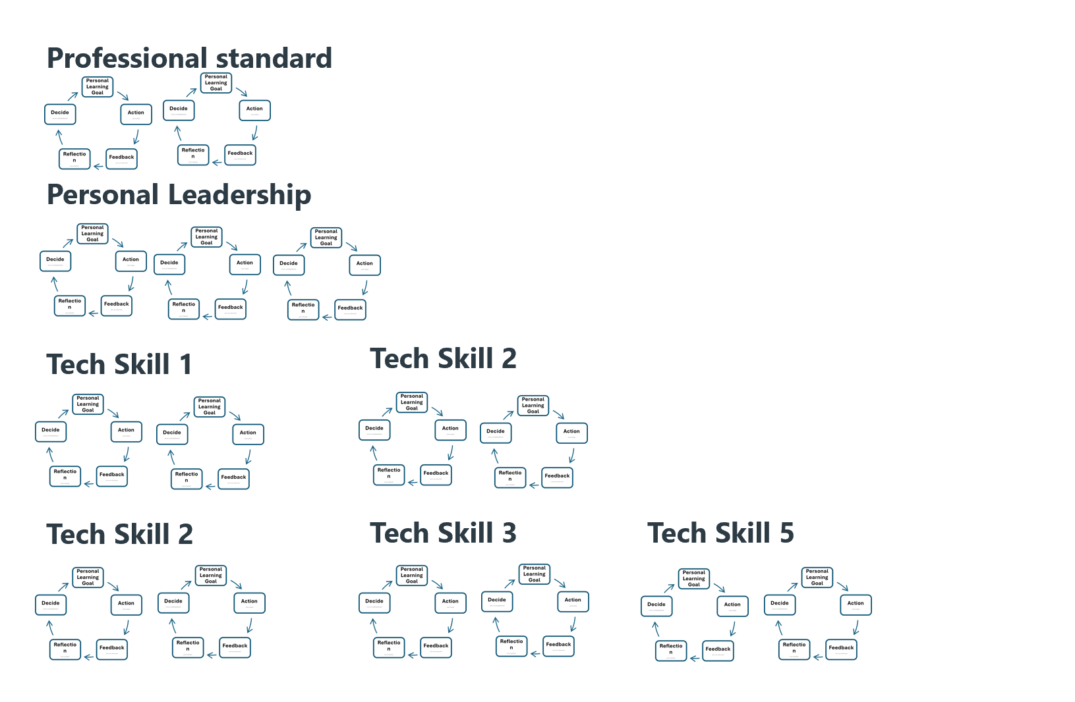 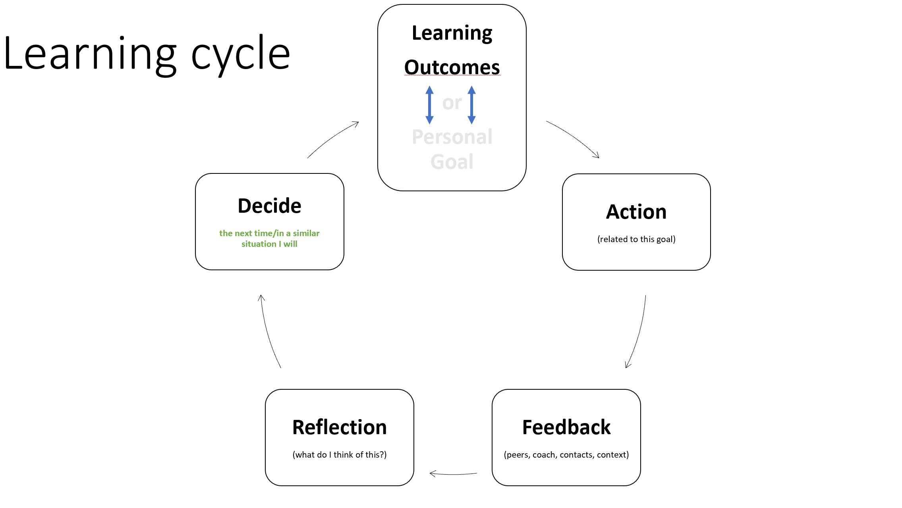

***Check the first page of the CANVAS course to find an in-depth description of each of the learning outcomes of Semester 1***

# Technical Skills

### ICT & Business

You demonstrate how to convert data into information in order to achieve a recommendation that will make an improvement for a process in an organization.

***Greenhouse Project: (Business Analysis)***

* ***Action:***

*I had to read the information about a company and create a document that presents the problems that this company faces. Then I came up with ideas on how to manage these problems.*

*Here you can see my document with problems and solutions:*

[*https://github.com/KSlavova/Fontys-University/blob/ced4c66e34d0c581fdc76c3a49ae98bea5bc3b45/ICT%20and%20Business/The%20Greenhouse%20Project.docx*](https://github.com/KSlavova/Fontys-University/blob/ced4c66e34d0c581fdc76c3a49ae98bea5bc3b45/ICT%20and%20Business/The%20Greenhouse%20Project.docx)

* ***Feedback:***

*I sent my document to my teacher and he told me that in some of the problems that I outlined, I included solutions, which should not be there. So, I rewrote the document with the needed changes.*

* ***Reflection:***

*It was easy for me to come up with solutions about the problems in the document. I learned how to distinguish problems and solutions.*

* ***Future actions:***

*I will be more careful while writing about some problem and will practice finding problems and outlining solutions. I will stop combining solutions and problems.*

***Data analysis and chart creation:***

* ***Action:***

*Practicing data analysis and chart creation.*

*Here you can see the charts and the solutions for Welcome.xlsx:*

[*https://github.com/KSlavova/Fontys-University/blob/f43292f156eeaf5ee62ee80b933547d7d75bd057/ICT%20and%20Business/Welcome.xlsx*](https://github.com/KSlavova/Fontys-University/blob/f43292f156eeaf5ee62ee80b933547d7d75bd057/ICT%20and%20Business/Welcome.xlsx)

*Answers to the questions about the Super Market Data:*

1. Which are the top 3 of best selling products?



1. What was total sales in 2013?



1. What was the turnover for every region in 2012?

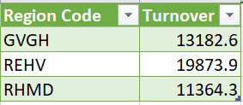

1. Who is the best selling salesperson?

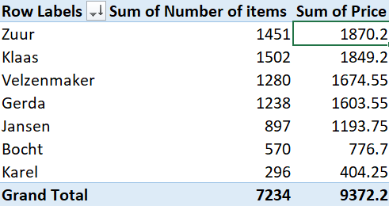

1. How many articles have been sold per product category?

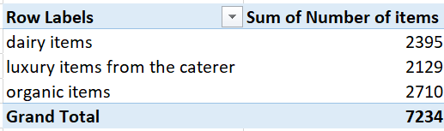

1. What is the average turnover per order?

<https://github.com/KSlavova/Fontys-University/blob/2f2d2469df86896e3bc0dccb81a5db7c93b233b3/ICT%20and%20Business/Average%20turnover%20per%20order.docx>

1. How many orders are there in January 2013 for **region code “**GVGH”?

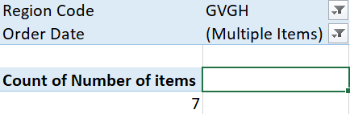

* ***Reflection:***

*It was easy for me to do these tasks, as I followed the steps in the excel document. I learned new fast and easy ways to create charts and tables in excel.*

***Business process diagram:***

[*https://www.canva.com/design/DAGTiXkmKkM/9LK9OWfgbXpIMHQdnAjb8g/edit?utm_content=DAGTiXkmKkM&utm_campaign=designshare&utm_medium=link2&utm_source=sharebutton*](https://www.canva.com/design/DAGTiXkmKkM/9LK9OWfgbXpIMHQdnAjb8g/edit?utm_content=DAGTiXkmKkM&utm_campaign=designshare&utm_medium=link2&utm_source=sharebutton)

* ***Action:***

*Creating a business process diagram that represents the current state of the Pizza project. Me and my team had to present the steps of how Mario and Luigi work in their Pizza restaurant.*

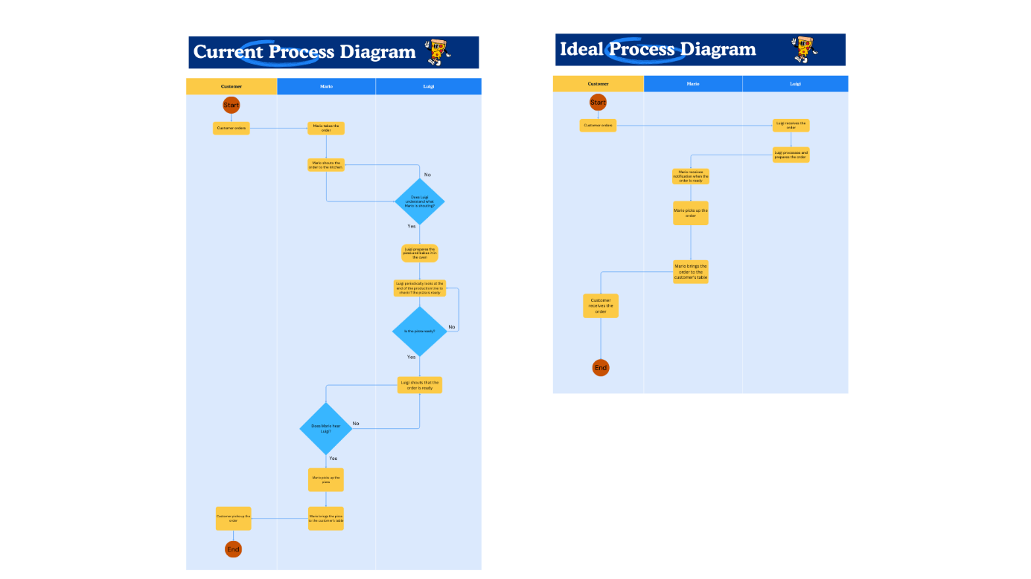

* ***Feedback:***

*We showed our work to our teacher and he advised us to add how our version of the ideal diagram should look like.*

* ***Reflection:***

*We used a shared environment to make the diagrams, everybody worked and exchanged ideas. We finished this in no time.*

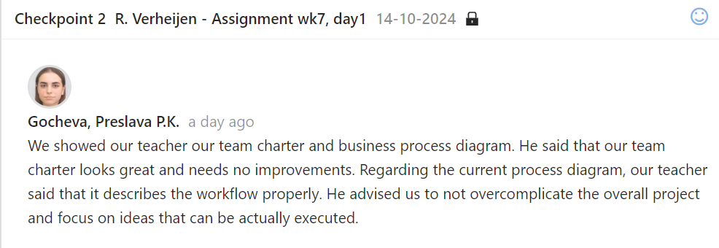

* ***Future actions:***

*We will add the ideal program diagram.*

### ICT & Infrastructure

You demonstrate a self-developed, secured network environment with hosts and servers based on a specific application requirement (services).

***1.CLI Basics:***

***Task1: Getting Familiar with CLI***

* ***Action:***

*I had to use the CLI commands in order to create a folder in my laptop and then visualize all folders and files that are in the same directory as the folder.*

* ***Reflection:***

*It was really easy for me to the this exercise. I learned how to use basic commands work in Windows PowerShell.*

*Here you can see the commands and the results of them:*

[***https://docs.google.com/document/d/1w7CDC31zW3DI67ydkLixfTVF5RUcjWeB/edit?usp=sharing&ouid=104159152318285223125&rtpof=true&sd=true***](https://docs.google.com/document/d/1w7CDC31zW3DI67ydkLixfTVF5RUcjWeB/edit?usp=sharing&ouid=104159152318285223125&rtpof=true&sd=true)

***Task2: File Modifications***

* ***Action:***

*For this task, I had to create a folder(folder1), that has two folders in it – folder11 and folder12. In folder11, I created a text document with information about the date and time. In forlder12, I created a file that shows information about the running processes. While I was in folder12, I managed to see the contents of the file in folder11. Then I moved the file from folder12 to folder 11 and appended the data from the first file to the data of the second file.*

* ***Reflection:***

*I tried to use the commands that were shown in the document, but they were not working for me, so I did some etra research to find some simillar commands. The tasks were not hard once I found the commands that worked for me.*

*Here you can see the commands and the results of them:*

[***https://docs.google.com/document/d/1yXSdtiG_CStLWfQrIlchmC1WfA6Sd4jm/edit?usp=sharing&ouid=104159152318285223125&rtpof=true&sd=true***](https://docs.google.com/document/d/1yXSdtiG_CStLWfQrIlchmC1WfA6Sd4jm/edit?usp=sharing&ouid=104159152318285223125&rtpof=true&sd=true)

***Task3: Networking tools***

* ***Action:***

*I had to use the CLI commands to find my ip, trace the route from my laptop to my friend’s laptop and trace the route to google.*

* ***Reflection:***

*This task was very easy for me. I learned two new commands that are very useful.*

1. ***Find your IP address:***

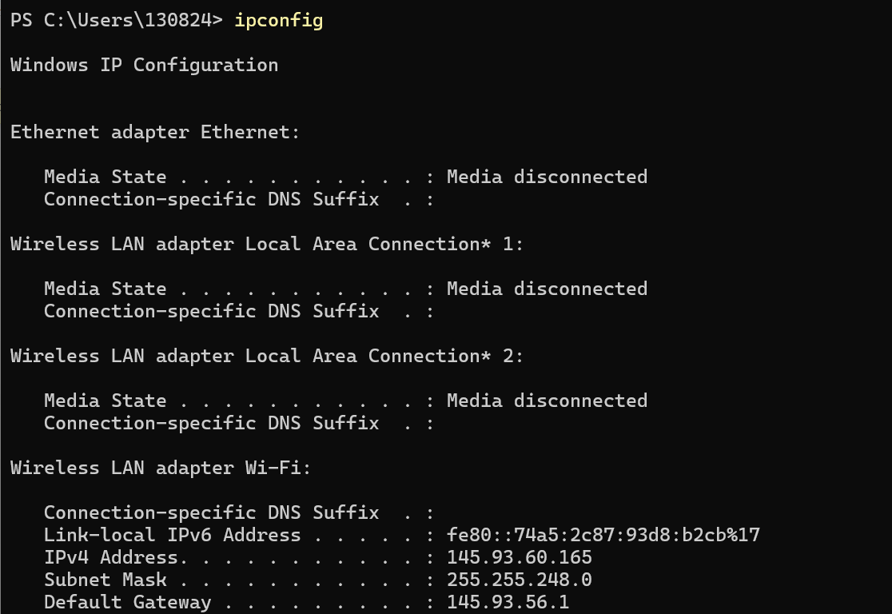

1. ***Show the route from your laptop to another students laptop:***

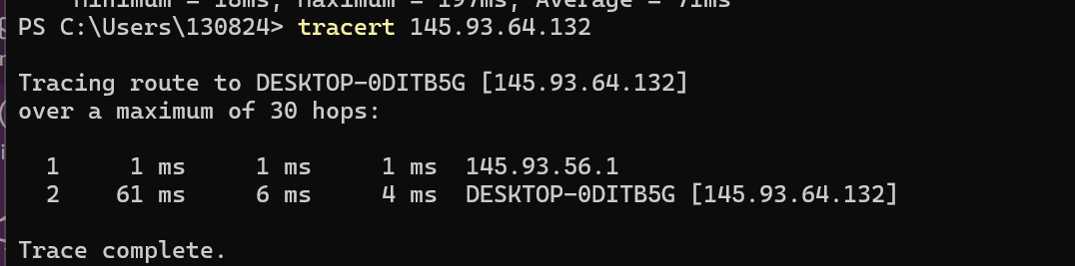

1. ***Show the route to google.com:***

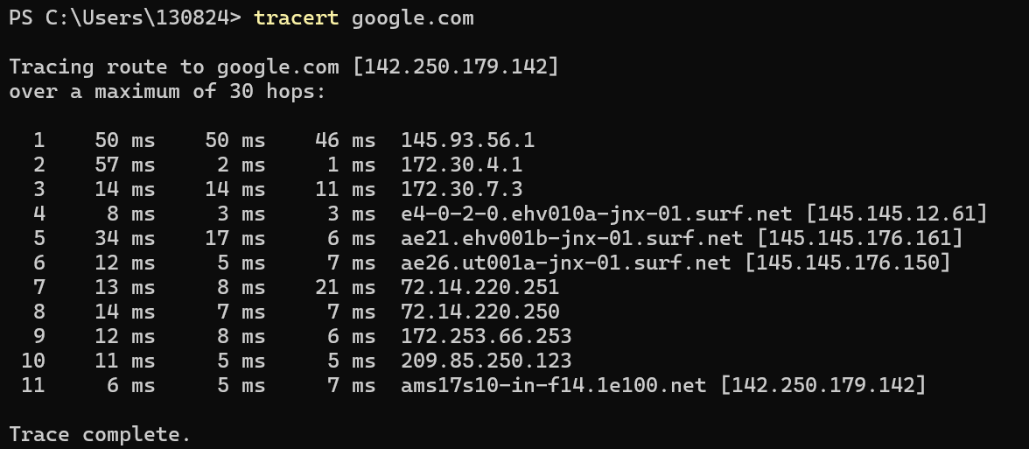

***2.CLI Chat App:***

* ***Action:***

*I installed the Nmap for windows in order to connect with my friend on the Windows PowerShell and create some way of chatting.*

* ***Reflection:***

*It was very easy and interesting assignement. The only problem we had, was that we had to stop our public firewalls, because we could connect to each other, but our teacher helped us. Now we know that this is an important step if we want to trace our laptops.*

***Task1: Installing the Nmap for windows***

***Task2: Chatting***

*Me and my friend had to show that we know how to chat using the CLI and Nmap. 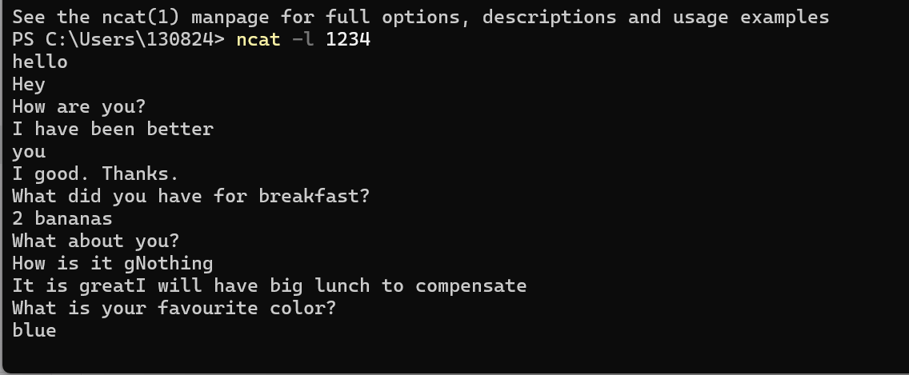*

*With this command Ncat starts a server and listens for on port 1234. My friend entered*

*ncat <my ip address> 1234, to connect and we started chatting.*

***3.Wireshark:***

* ***Action:***

*I had to use Wireshark in order to show the sent data from the CLI and then show both the data from the CLI and Wireshark. Also, I had to use the commands release and renew in order to start the Dora process.*

* ***Reflection:***

*I had some difficulties with this task and tried to search in the internet how to use wireshark. I tried to add a filter, but it was not working so I went to ask my teacher for help. The thing that was the problem was the filter. There was no need of it.*

* ***Future actions:***

*I should read more about how to use wireshark in order to improve my abilities.*

***Task1: Finding the CLI chat***

***1.Show the sent data captured by wireshark and the CLI interface that shows the data send from the CLI:***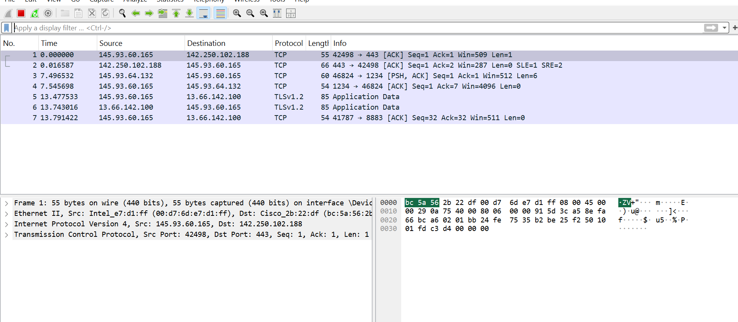

***2. Show the data from wireshark and the CLI:***

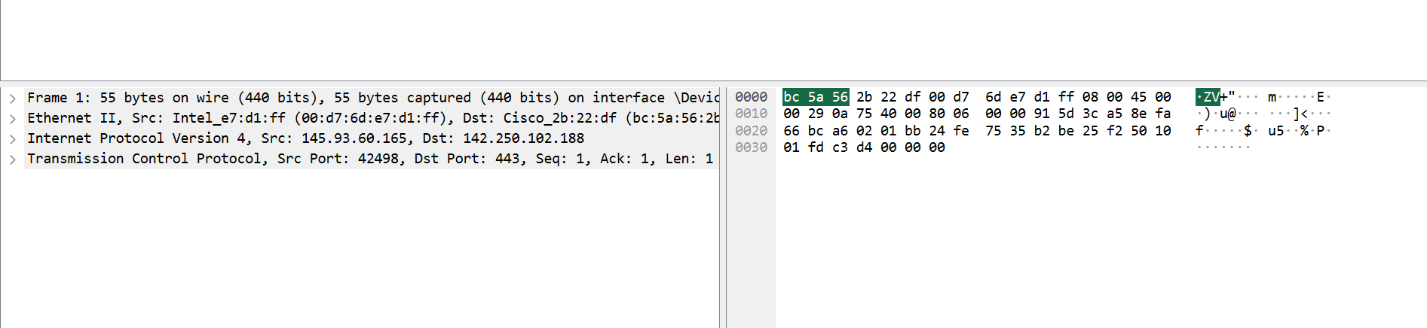

***3.Is there a difference in the received packets compared to those sent?***

***Answer:*** *The sent data is small and contains the request information and consist of bytes. The received one is bigger, because it carries the content.*

***Task2: Dora process***

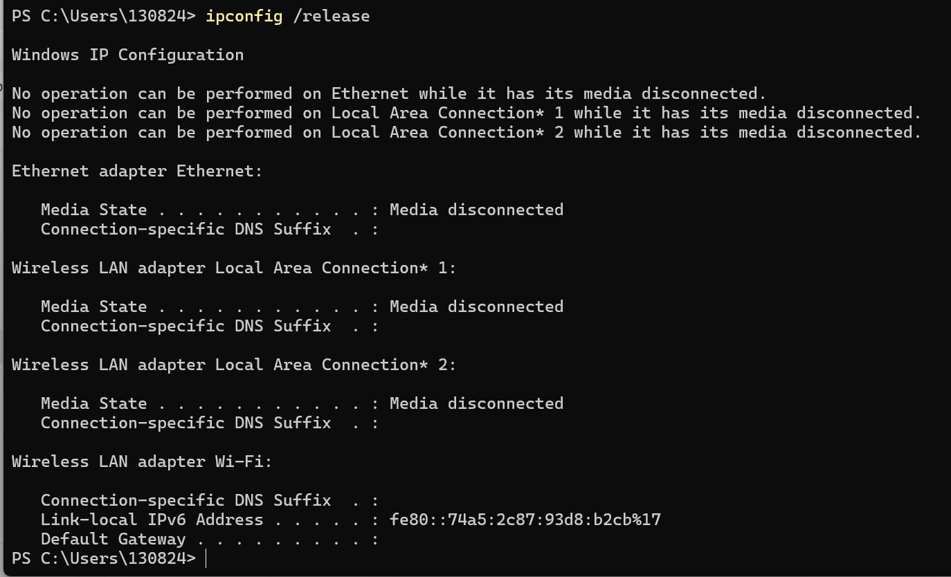

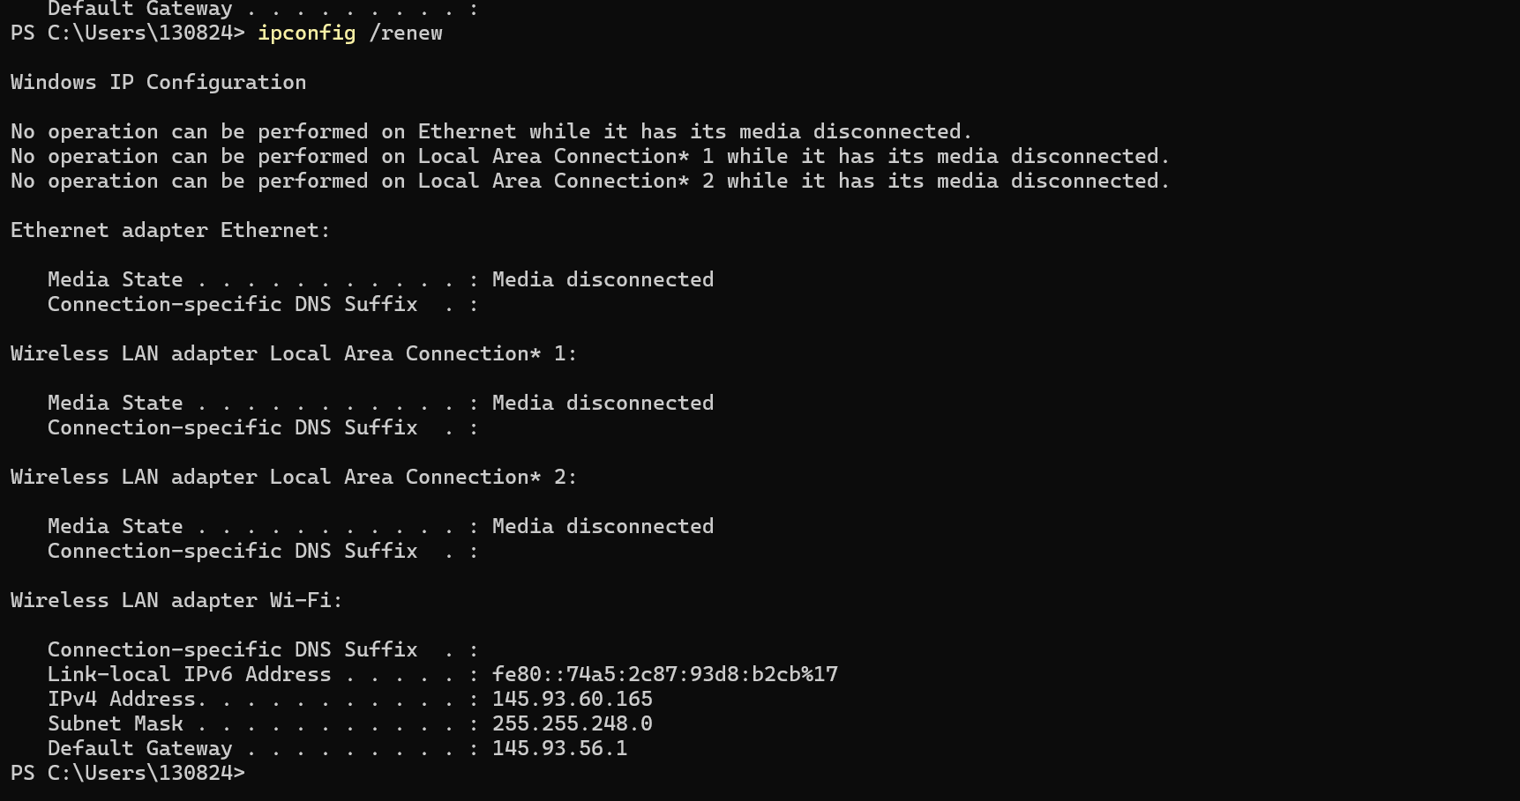

***Visualize your home network:***

* ***Action:***

*I had to gather information about my home network and create a diagram that presents it.*

*My home network diagram:*

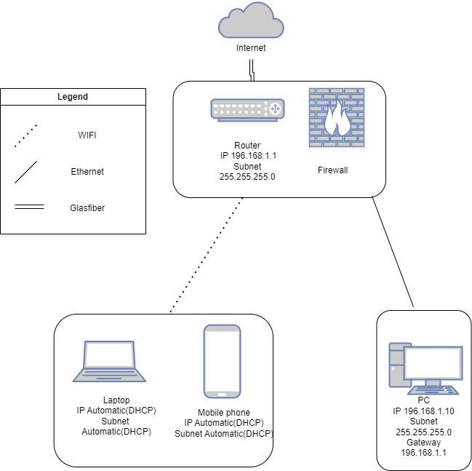

* ***Feedback:***

*I accidentally, added an arrow between the phone and the laptop, so my teacher corrected me about it. I wrote the IP of the firewall, but my teacher advised me to remove it as it is the same as the IP of the router.*

* ***Reflection:***

*I learned what IP is and what is the network diagram used for.*

* ***Future actions:***

*I will be more careful while adding the arrows for the network. I will stop adding the IP of the firewall and will practice more on creating network diagrams.*

***Fast Food Chain:***

* ***Action:***

*I had to create a network diagram about fast food chain with diagrams about customer service, internal employees’ network, internal system and cash registers. Then, I had to combine all diagrams in one.*

*Customer service network: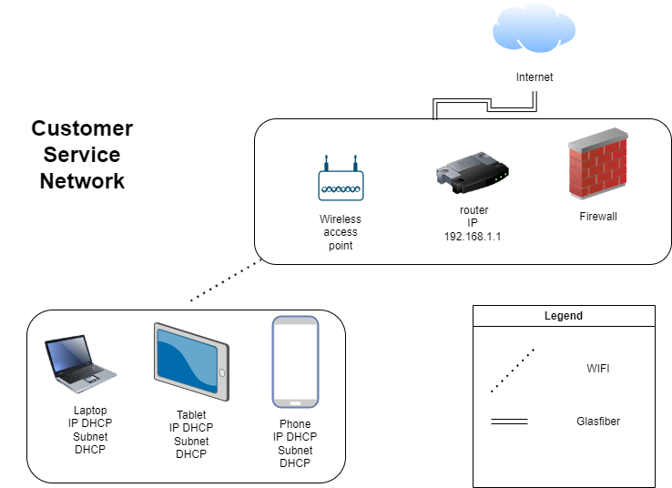*

*Internal employee network:*

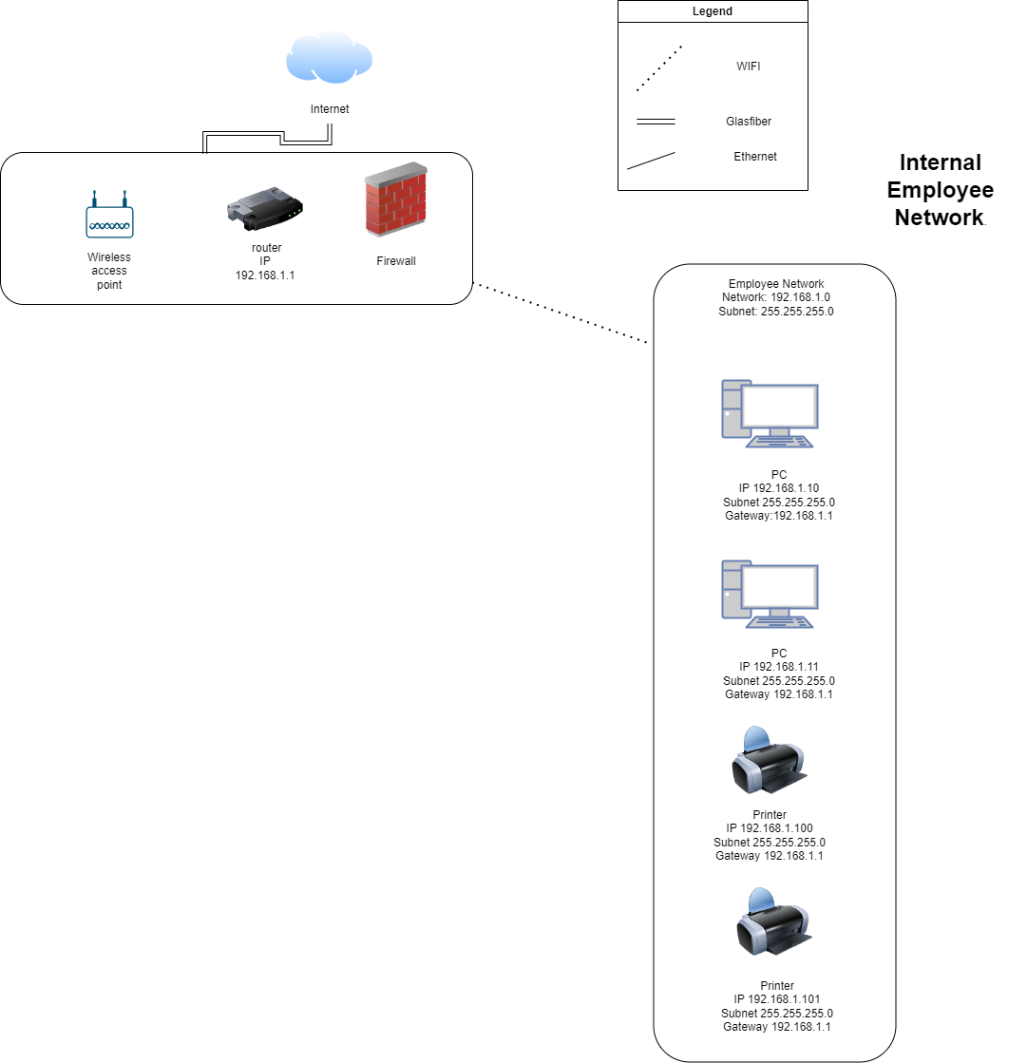

*Internal system and cash register network:*

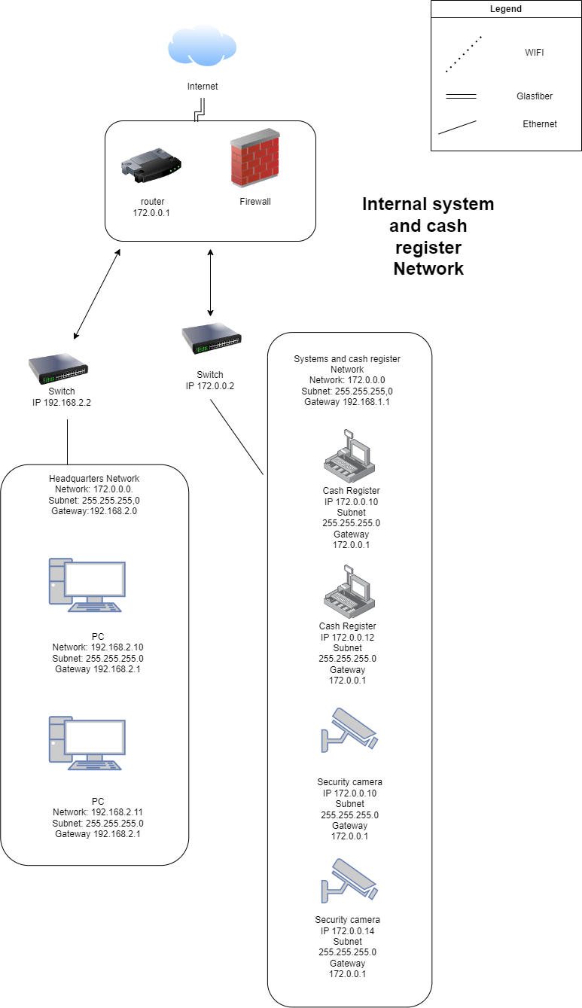

*Tasty-Bites Network: 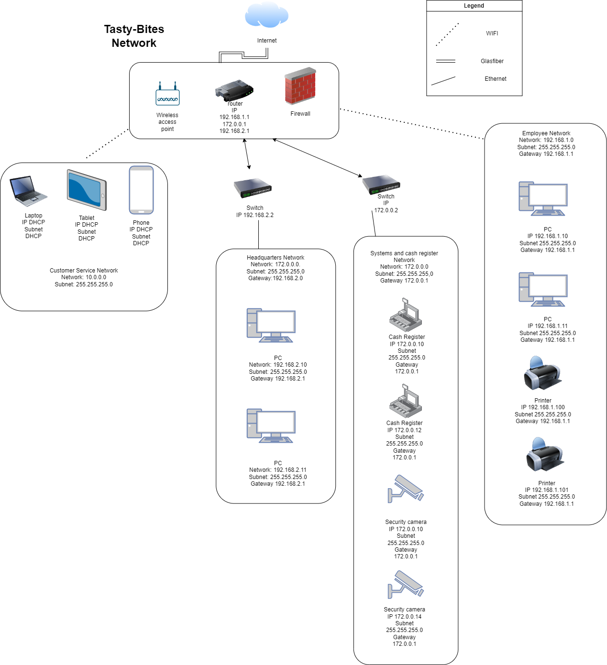*

* ***Feedback:***

*After I talked with my teacher about the diagrams, he told me that I needed to add gateways, because I missed them. Also, I visualized the wireless access point as a different component and not as a part of the router so I corrected this. I needed to manage my IP addresses, because the switch cannot create networks.*

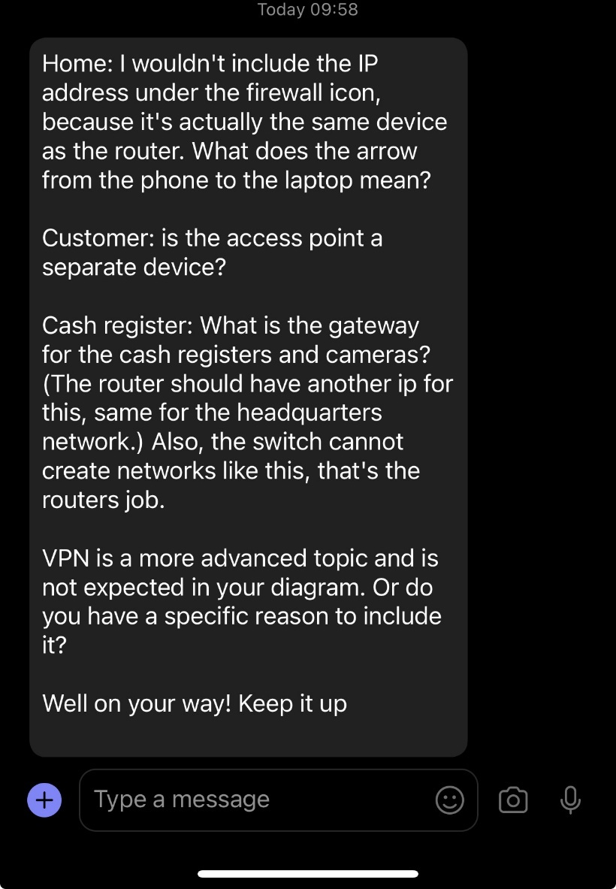

* ***Reflection:***

*I learned that switches cannot create IP addresses. I understand the routers and wireless access points should be one component.*

* ***Future actions:***

*I will never forget to add my gateways. I will carefully manage my IP addresses and will never forget that switches do not create new addresses.*

***Network Design Visualization:***

* ***Action:***

*I had to create the network diagram for the current network of a company and then update it to make it better.*

*Current network:*

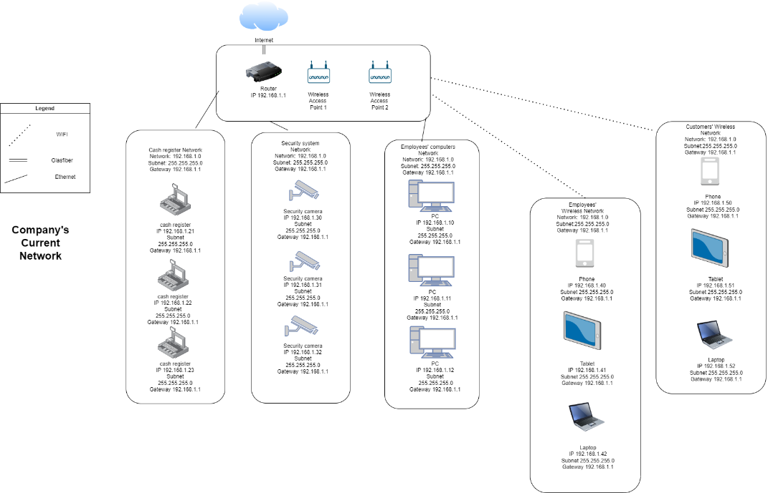

*Updated Network:*

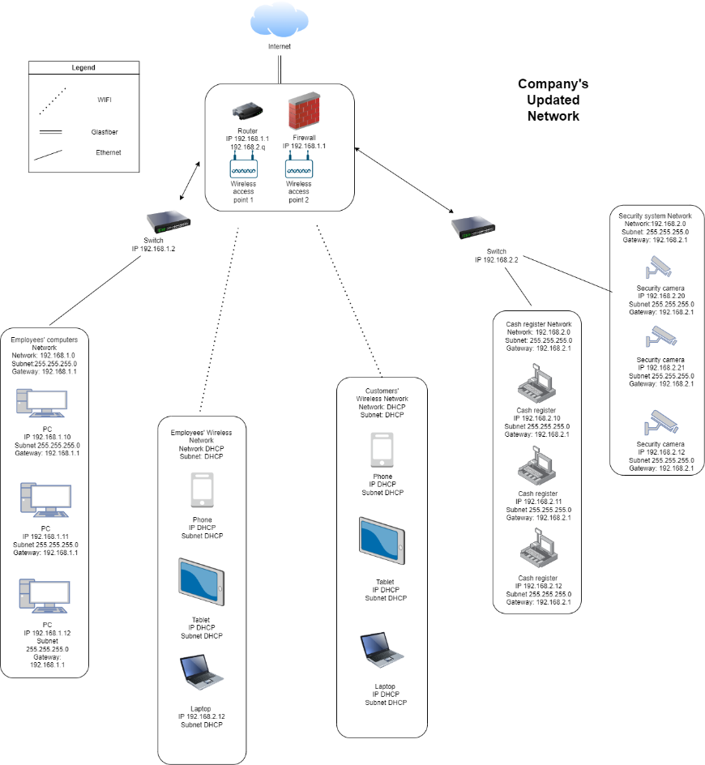

* ***Feedback:***

*As in the previous, task I had to add the gateway to my diagrams.*

* ***Reflection:***

*I practiced creating diagrams. I first created a list with all items that I need to implement and then connected everything.*

* ***Future actions:***

*Next time, I won’t forget to put the gateway.*

***Greenhouse network diagram:***

[*https://github.com/KSlavova/Fontys-University/blob/f6c72124244888960554a726c3be3d0d8287eabd/ICT%20and%20Software%20Engineering/Week6/GMS.drawio.png*](https://github.com/KSlavova/Fontys-University/blob/f6c72124244888960554a726c3be3d0d8287eabd/ICT%20and%20Software%20Engineering/Week6/GMS.drawio.png)

* ***Action:***

*Creating a network diagram for the greenhouse project.*

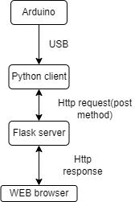

* ***Reflection:***

*I visualized how I imagine the connection between the components should work.*

* ***Future actions:***

*I will try to follow it in order to execute my flask program.*

### ICT & Media Design

You are able to develop and implement interactive prototypes in an iterative process for the target users based on trends and developments.

***Prototype for Guess the word game( new version of the Hangman game):***

<https://www.figma.com/proto/yk8CNYp92PnsDknfPnu8BQ/Guess-the-word-game?node-id=0-1&t=teNwkUHXT519puQT-1>

* ***Action:***

*The goal of this assignement is to use creativity and come up with ideas about how to create prototype that targets young children. This includes creating paper prototype and Figma prototype. Another goal is to gain knowledge on how to work in Figma.*

*First, I had to come up with idea about a new version of the Hangman game.I called this game The Balloons game. Then, I created a paper prototype about each page and some basic rules of the game. My original idea was to create a game where the kid reads the hint and tries to guess the hidden word. At the start, the player is holding two balloons. For each correct letter, the player earns a balloon. For each wrong letter, he loses a balloon. The main goal was not to let your player fall on the ground.*

*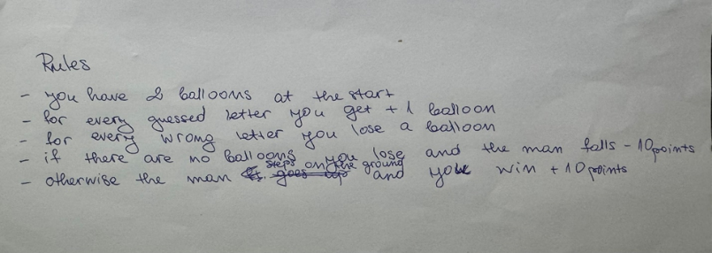***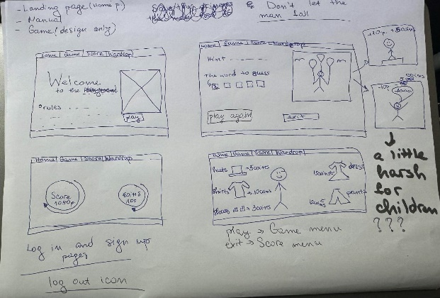**

* ***Feedback:***

*After I presented my paper prototype to some of my classmates and explained the idea, one of them advised me to change the end of the game as it might be harsh for children to see the player falling.*

* ***Reflection:***

*After taking that into consideration, I changed the main goal to not letting the player land on the ground. So if he loses all balloons he will simply land and be sad.*

* ***Future actions:***

*From now on, my main goal will be to carefully adjust my ideas for the interests and needs of the targeting groups, as it is really important for the products future.*

* ***Action 2:***

*Then I created my protype in figma with the added changes.*

*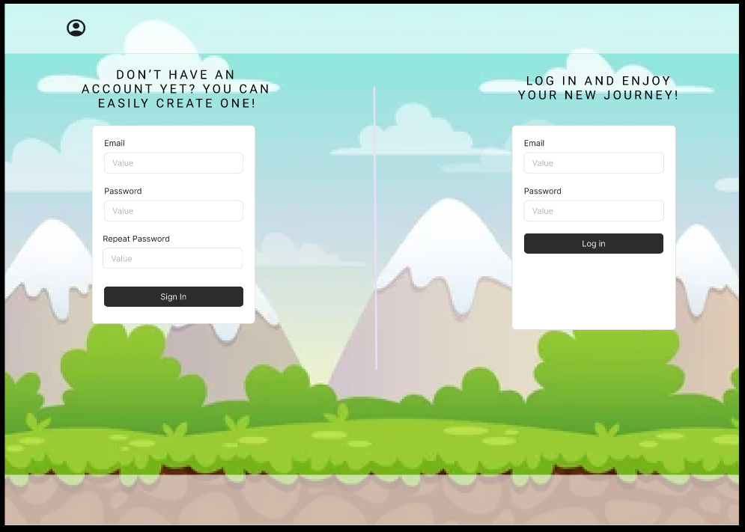Sign in and Log in – users can easily create or log in their account:*

*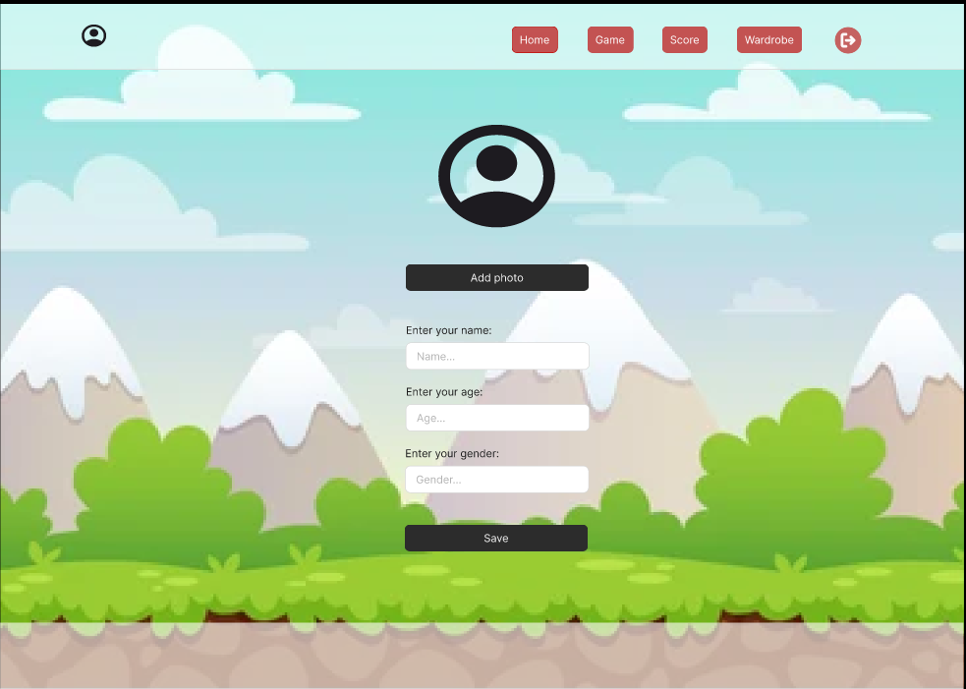Settings – users can add their information:*

*Home menu – users can read the rules and hit “Let’s play” button to start the game:*

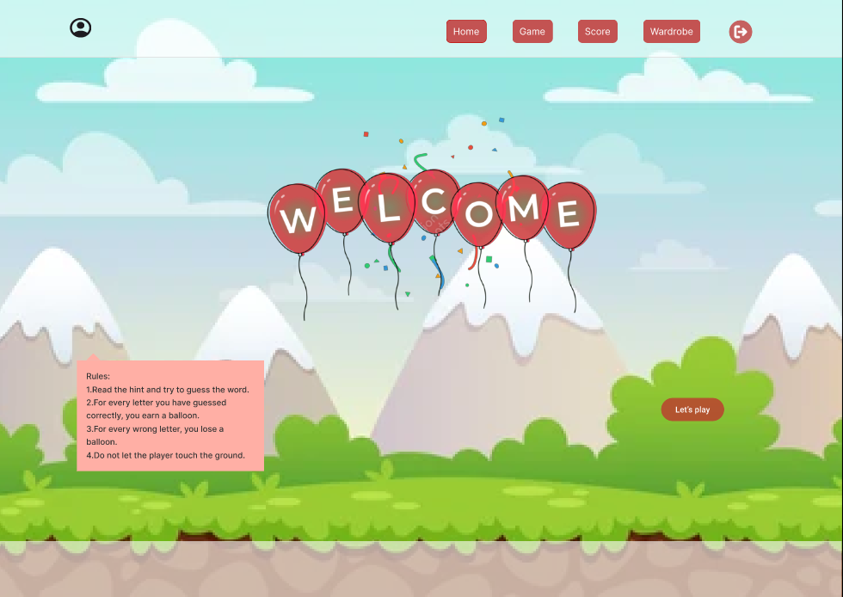

*Game menu – you get a hint and have to guess the word:*

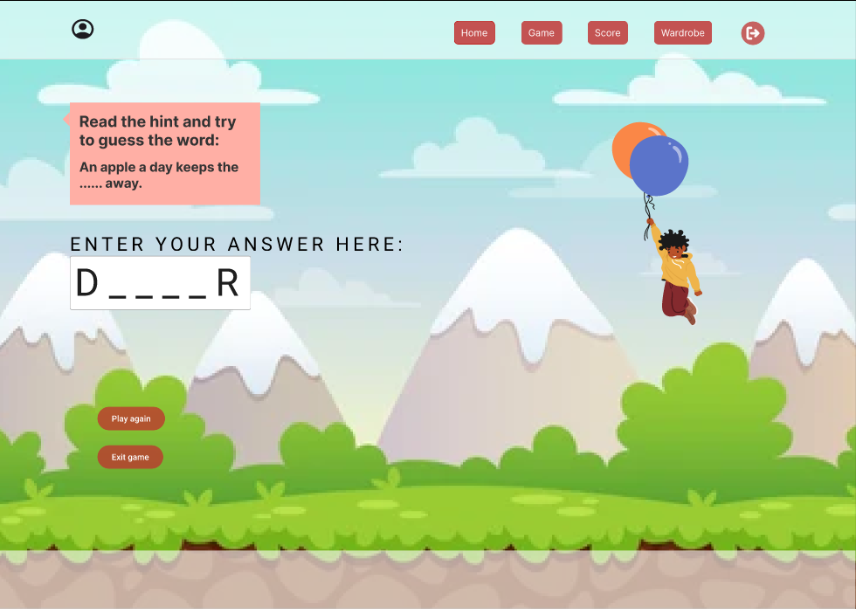

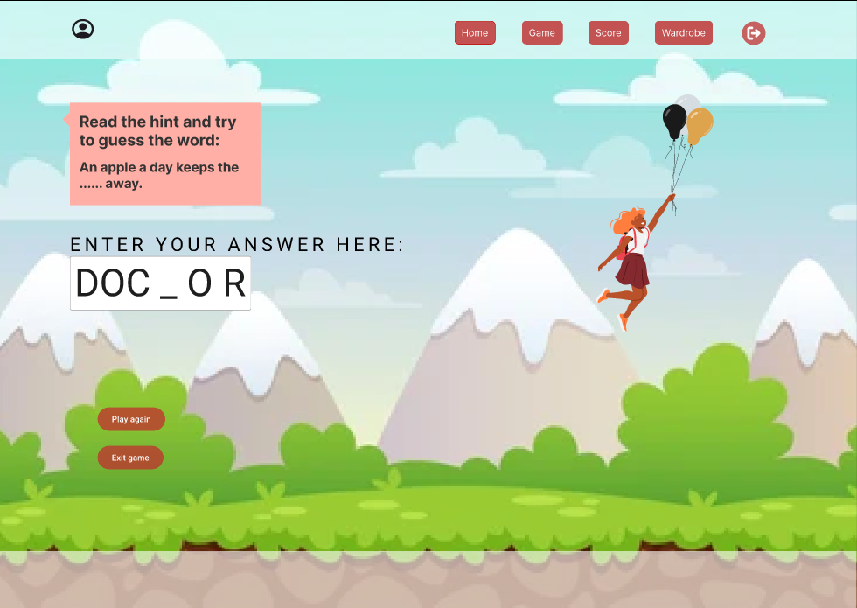*For every guessed letter you earn a balloon:*

*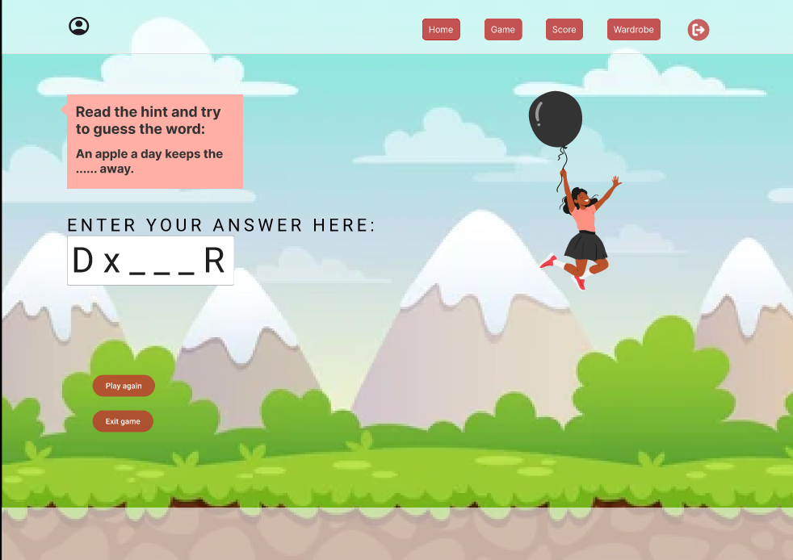For every wrong you lose a balloon:*

*If you win, you earn points and coins:*

*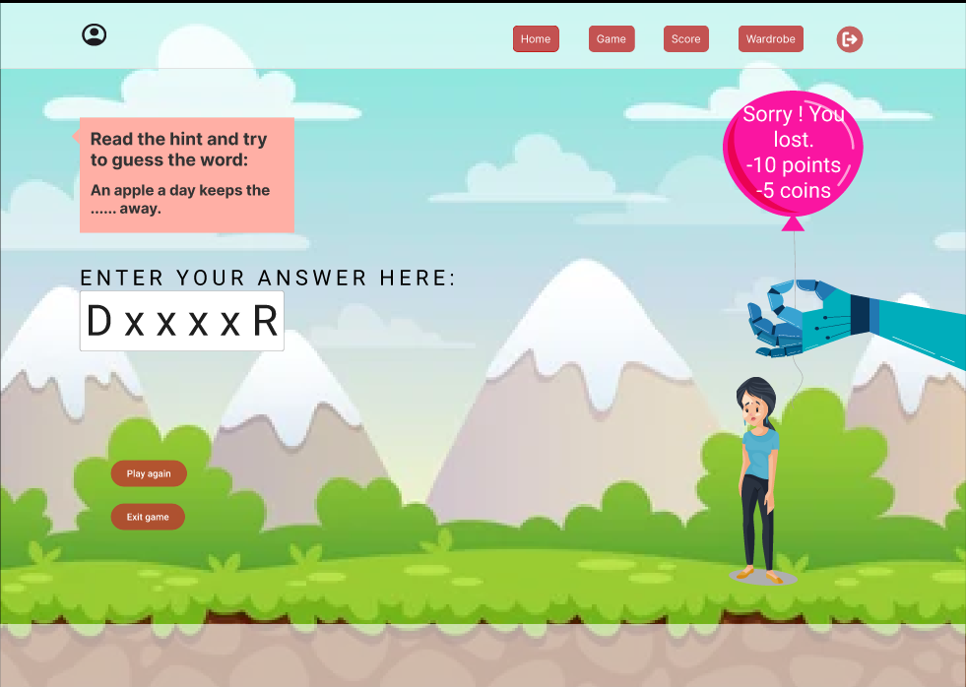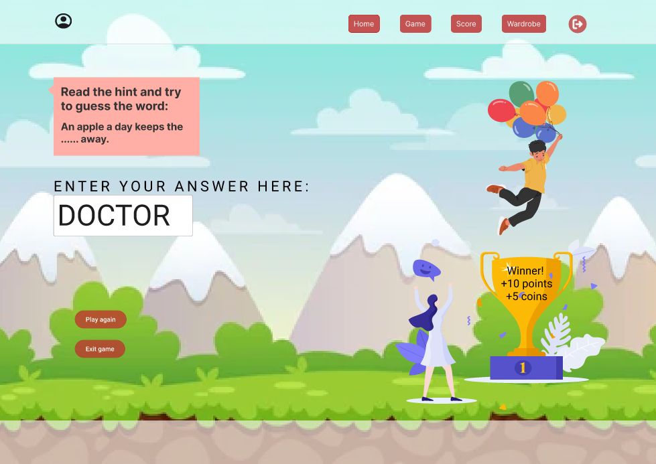If you lose, you lose some of your points and coins:*

*After that you can start a new game or exit the game and visit the score menu where you see all points and coins you have:*

*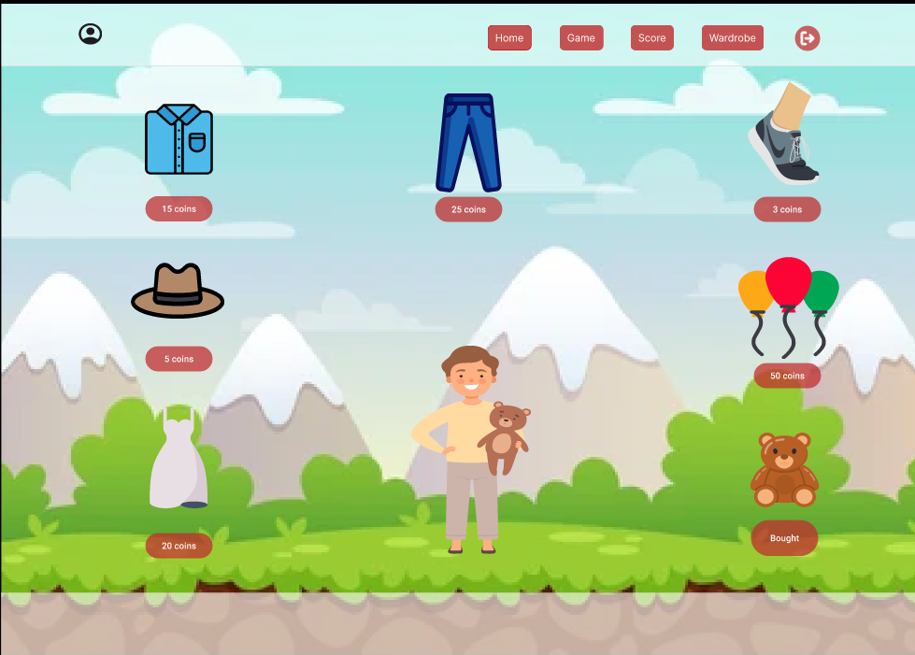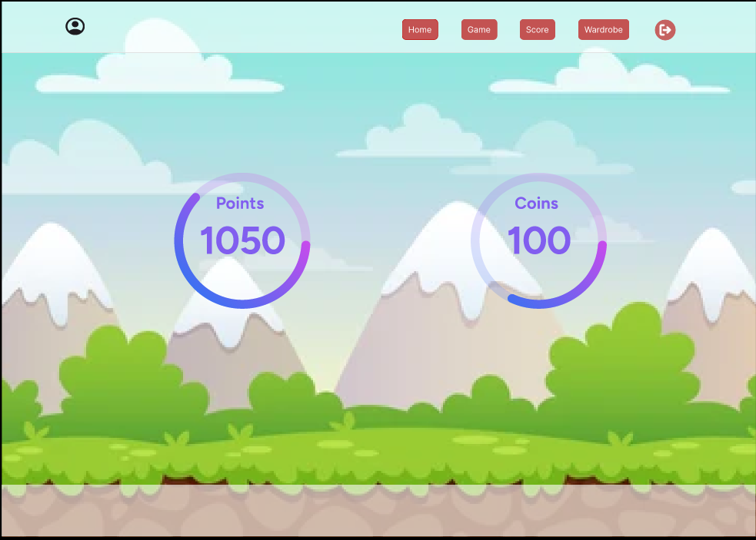With your coins you can buy clothes or toys for your player from the wardrobe menu:*

*I presented my project in front of the class. Presentation link: <https://docs.google.com/presentation/d/1rjdb6QPMVsffuQL_HTCjeTvJlbYntUqa/edit?usp=sharing&ouid=104159152318285223125&rtpof=true&sd=true>*

*In my presentation i added a slide with the question “What I want to imporve?”. My plan for the future is to create a bigger and better version of the Wardrobe menu, so there are more options for clothes and toys.*

* ***Feedback:***

*I presented the prototype to my classmates and they liked the new concept. They said that the design was creative and supported my idea about the wardobe. Some of them even gave me the idea to add food for the player so the kids could feed their avatar and take care of him.*

* ***Reflection:***

*Creating projects like this take a lot of time, but the most important part are the feedback that you receive, because this way you can improve your product and make it look and work better.*

* ***Future actions:***

*I will always ask for feedback as much as possible. I will, also, gain knowledge in order to make all my plans about this project come true.*

***Appendix HTML page: <ftp://i547761@hera.fontysict.net/domains/i547761.hera.fontysict.net/public_html/AppendixHtmlPage.html>***

* ***Action:***

*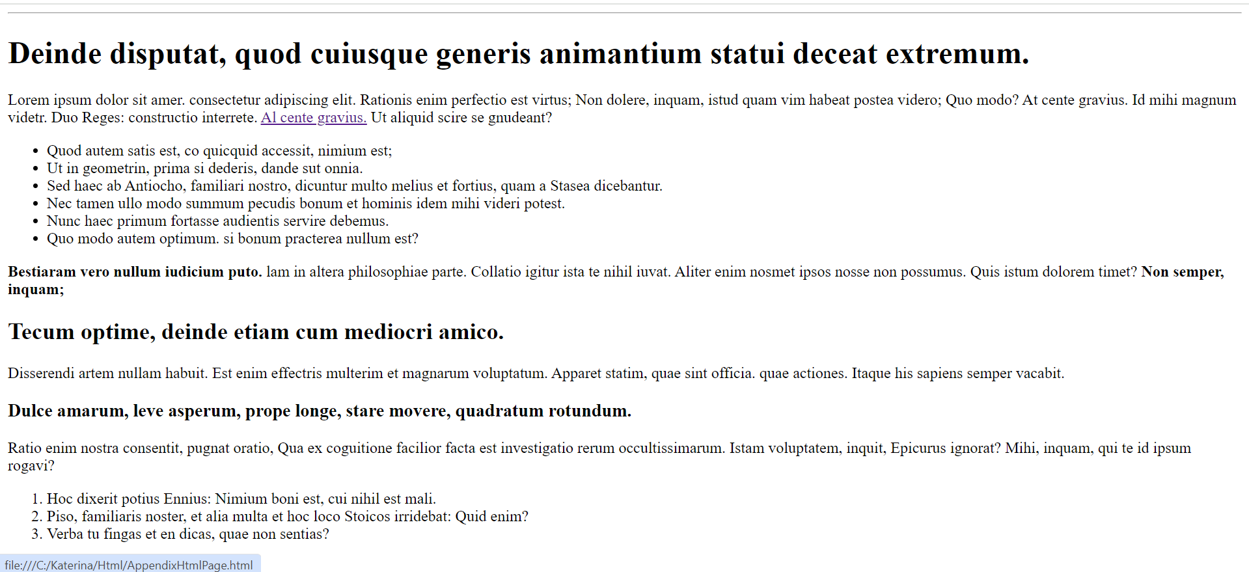Recreating the appendix html page. I copied the text from the picture in the task and used html tags that I’ve learned in class. This is the result of my code:*

*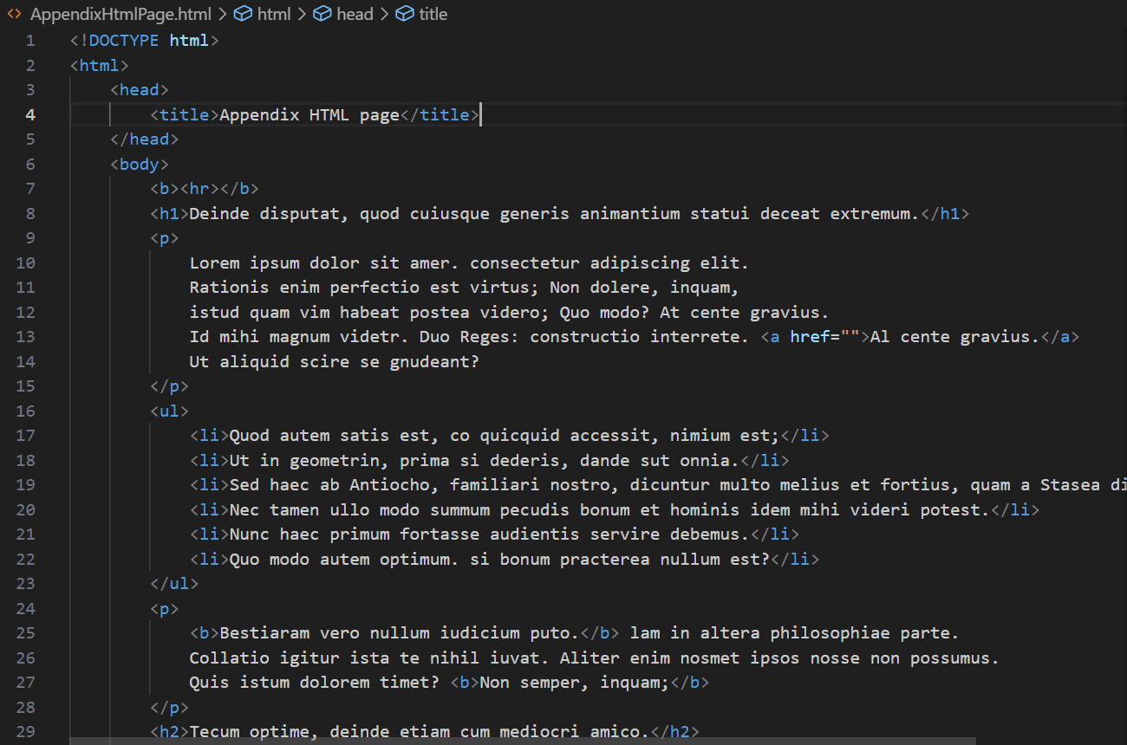Code:*

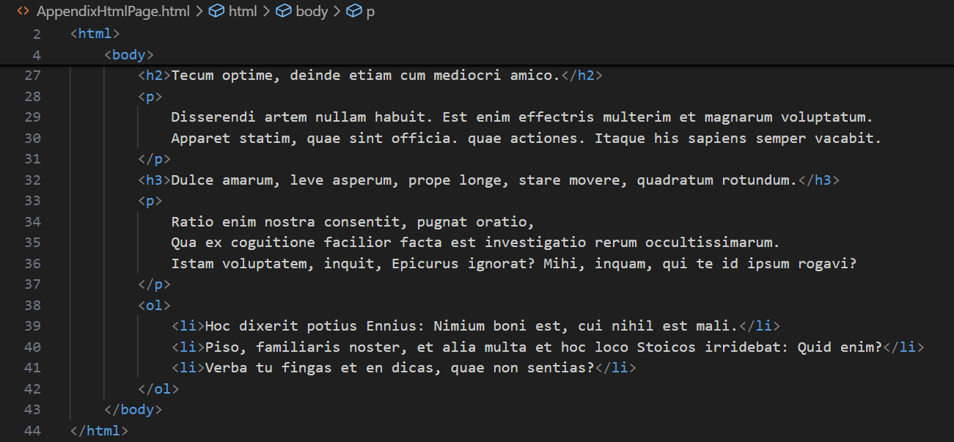

* ***Feedback:***

*My teacher had no remarks.*

* ***Reflection:***

*It was really easy for me to recreate this page. I learned the differences between body and head, and how to defined the title of a webpage.*

* ***Future actions:***

*Now that i know the basics of html, I will continue learning about other tags and structures in order to improve my abilities.*

***HTML page for Guess The Word Game:***

***<ftp://i547761@hera.fontysict.net/domains/i547761.hera.fontysict.net/public_html/ManualPageGuessTheWordGame.html>***

* ***Action:***

*I made a little research about what a manual page contains. Then, I created a manual page for my prototype of Guess the word game that describes how to play, the rules of the game and some useful tips and tricks. I tried to use all tags that I’ve learned from the previous task to test myself. This is how it looks:*

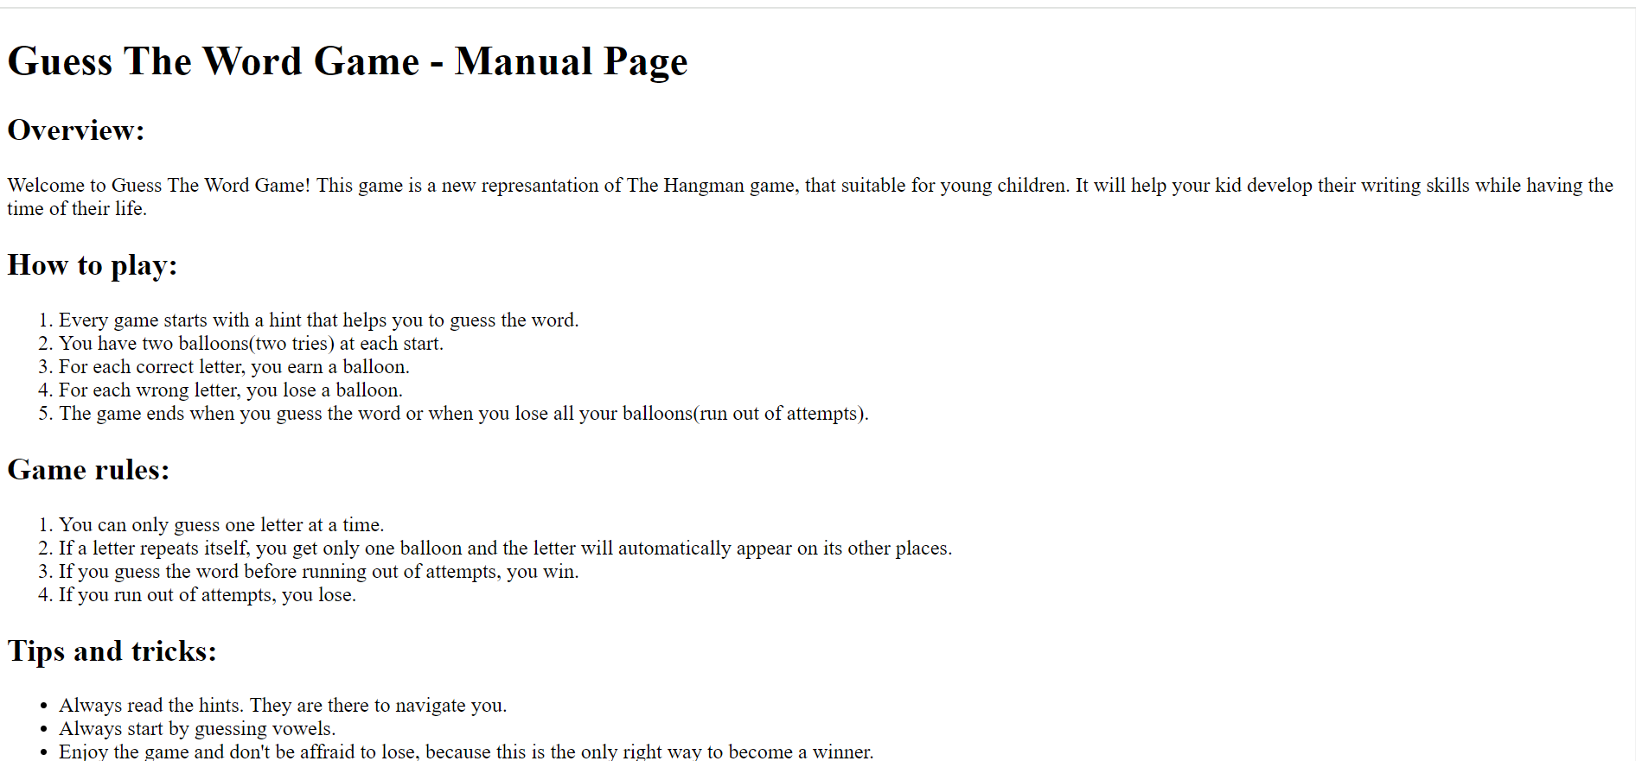

*The code is written in html language: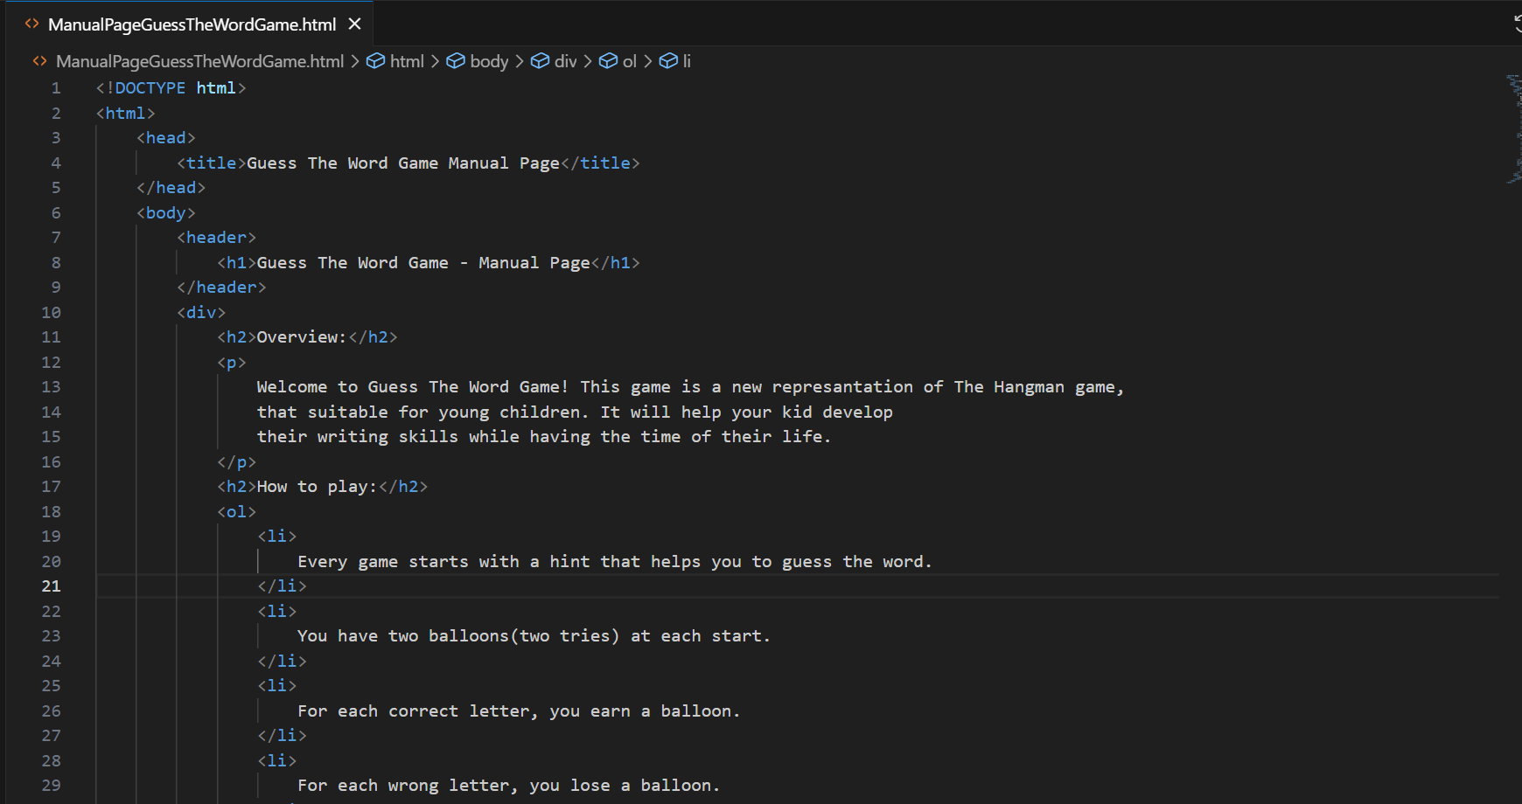 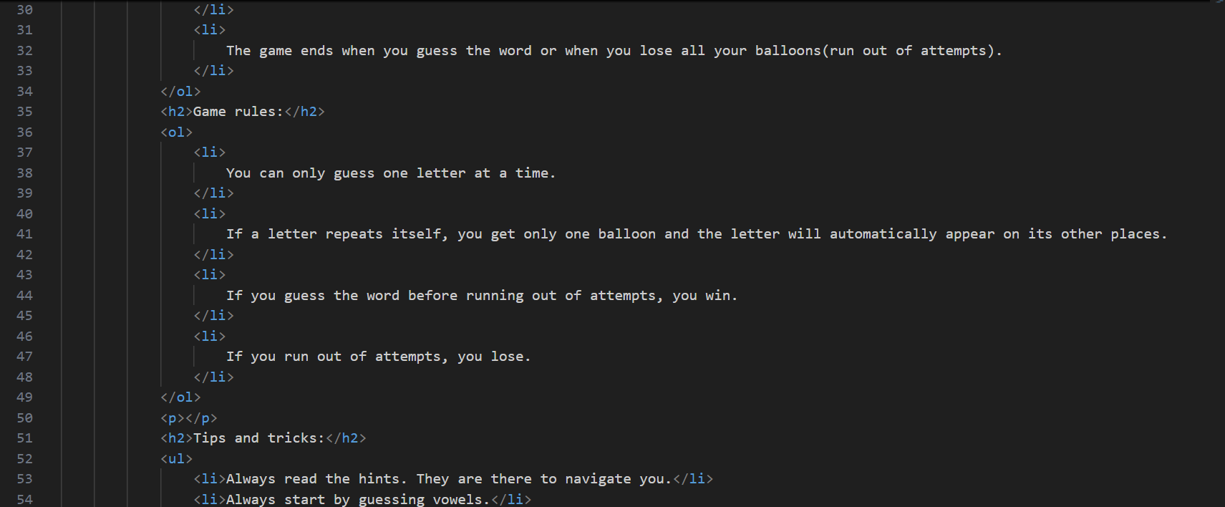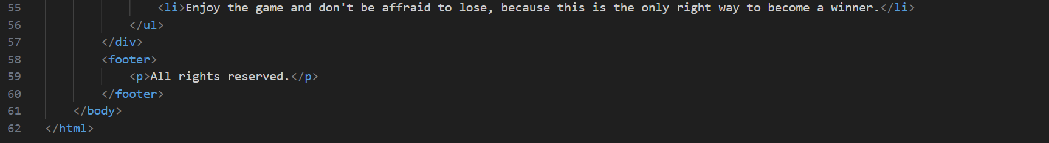*

* ***Feedback:***

*My teacher showed me how to Implement the symbol for All rights reserved, which is:* &copy;

* ***Reflection:***

*Creating the manual page was really easy for me. I learned that there is a code for the special symbols , because if you try to implement them they might break the code.*

* ***Future actions:***

*I will learn more on how to use special characters in my html code so that I imporve my skills.*

***HTML prototype of The Balloons Game:***

*To find the code click here:*

[***ftp://i547761@hera.fontysict.net/domains/i547761.hera.fontysict.net/public_html/Chapter3IntroCSS***](ftp://i547761@hera.fontysict.net/domains/i547761.hera.fontysict.net/public_html/Chapter3IntroCSS)

* ***Action:***

*Recreating the firgma prototype for The balloons game, using html and css code.*

*Here you can see the results:*

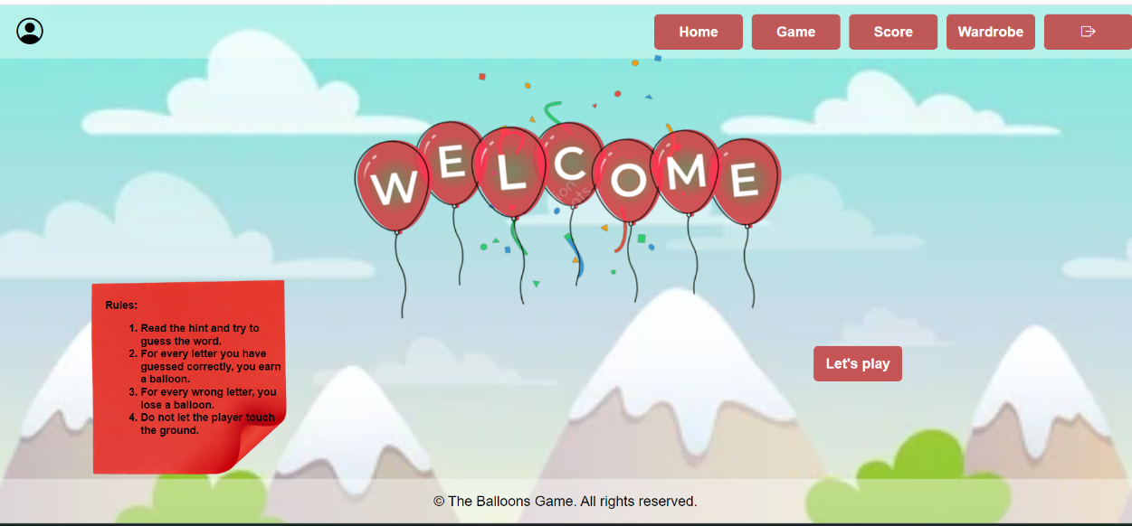

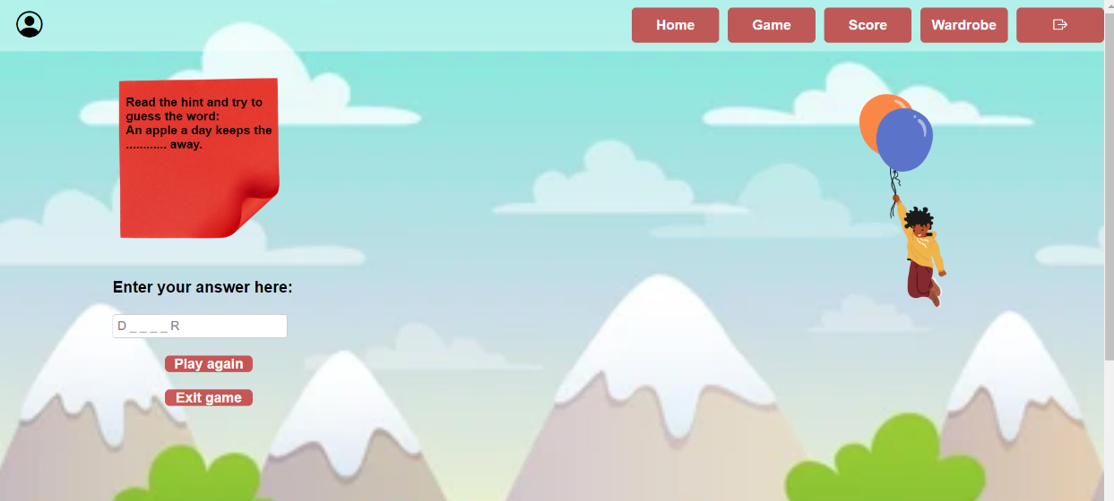

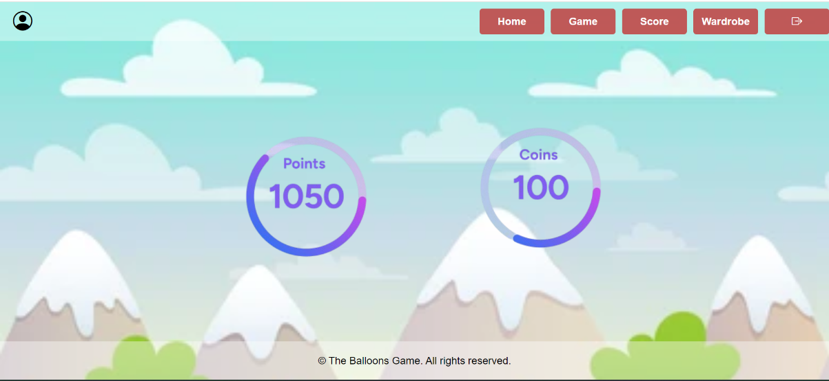

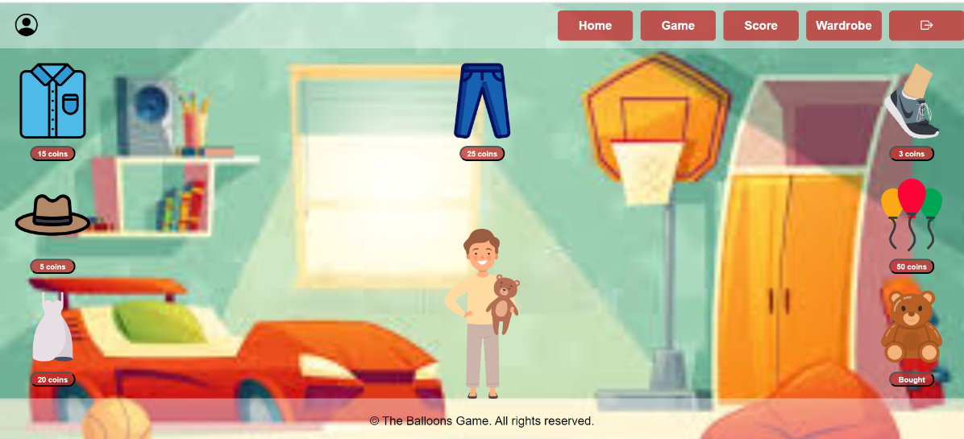

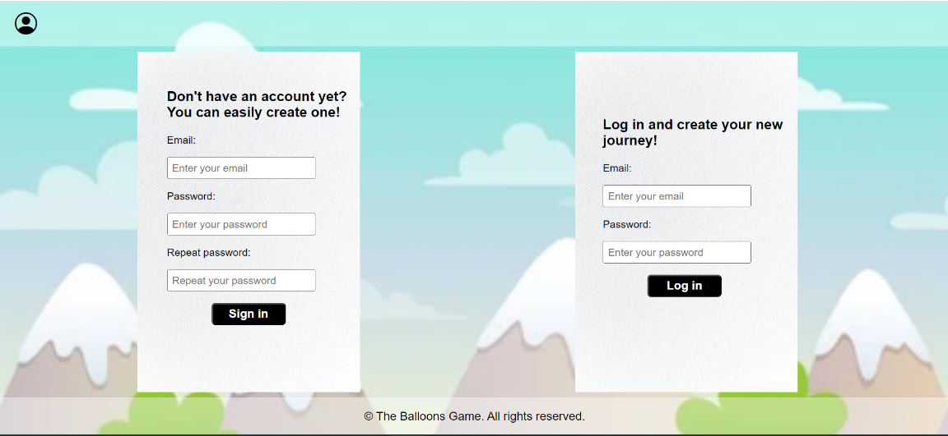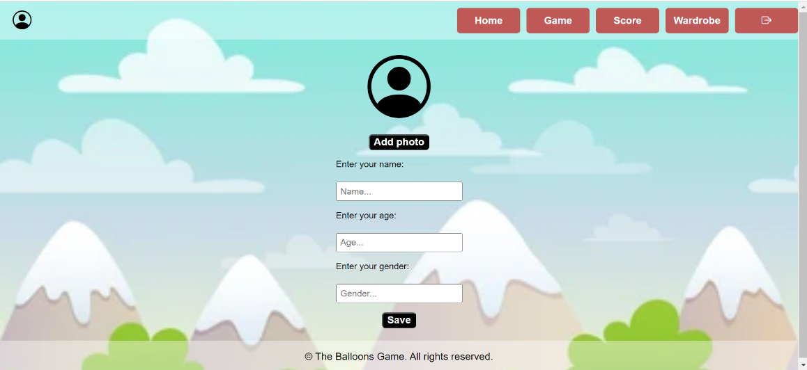

* ***Feedback:***

*After I showed my classmates, how my prototype looks like, they liked that I implemented a better version of the note. They advised me to remove the empty space in the wardrobe page.*

* ***Reflection:***

*The html code was easy for me, but the css code took a lot of time because I had to learn a lot new things and impement them in my code.*

* ***Future actions:***

*In my next projects, I will try to order my items in a way that has a minimal empty space left.*

***Time and random light level – html:***

[***https://github.com/KSlavova/Fontys-University/tree/5a2a1ecf7254b32d22bc4424e3c018a563692450/ICT%20and%20Software%20Engineering/Week5/TimeAndRandomLightLevel***](https://github.com/KSlavova/Fontys-University/tree/5a2a1ecf7254b32d22bc4424e3c018a563692450/ICT%20and%20Software%20Engineering/Week5/TimeAndRandomLightLevel)

* ***Action:***

*Creating an HTML template to display the current time and a light level measurement. This template is supposed to work with a Flask server, which code you can see here:* *Time and random light level – python*

*Here is the code for the template:*

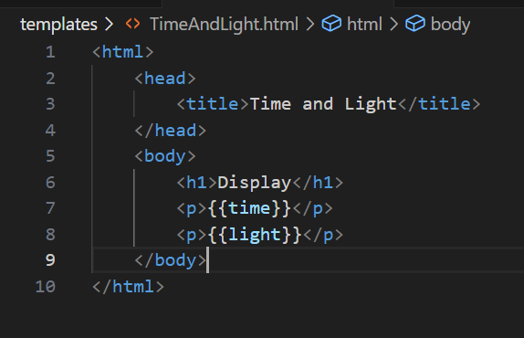

*Here you can see the visualization:*

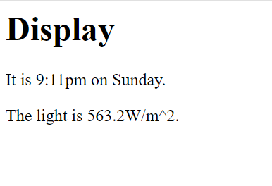

* ***Reflection:***

*I followed the examples in canvas and learned how to use placeholders in html.*

***Updates and Styling:***

[***https://github.com/KSlavova/Fontys-University/tree/8f0fcc3694242718f04000a8ae0e6af00c2cd523/ICT%20and%20Software%20Engineering/Week5/Updates%20and%20styling***](https://github.com/KSlavova/Fontys-University/tree/8f0fcc3694242718f04000a8ae0e6af00c2cd523/ICT%20and%20Software%20Engineering/Week5/Updates%20and%20styling)

* ***Action:***

*Improving the visual design of the webpage of the Time and random light level application by implementing a CSS code (look at the previous exercise). If you want to see the python code, visit:* *Updates and Styling - python*

*Here you can see the updated html:*

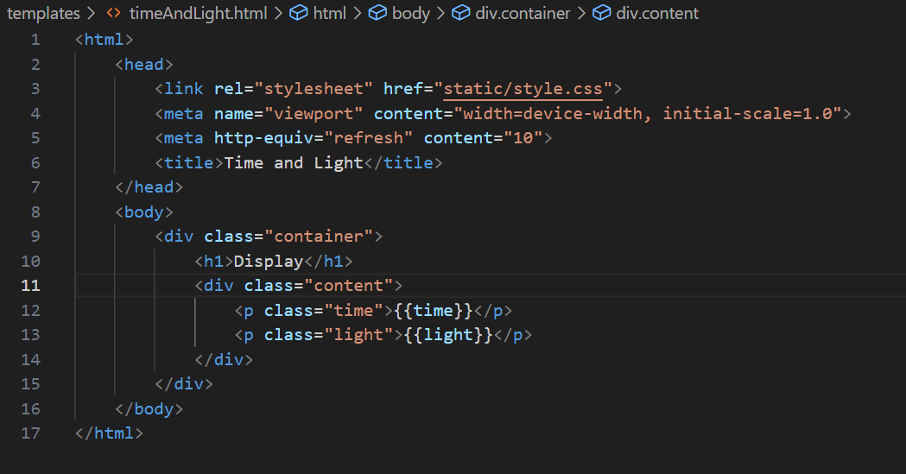

*Here you can see the CSS code:*

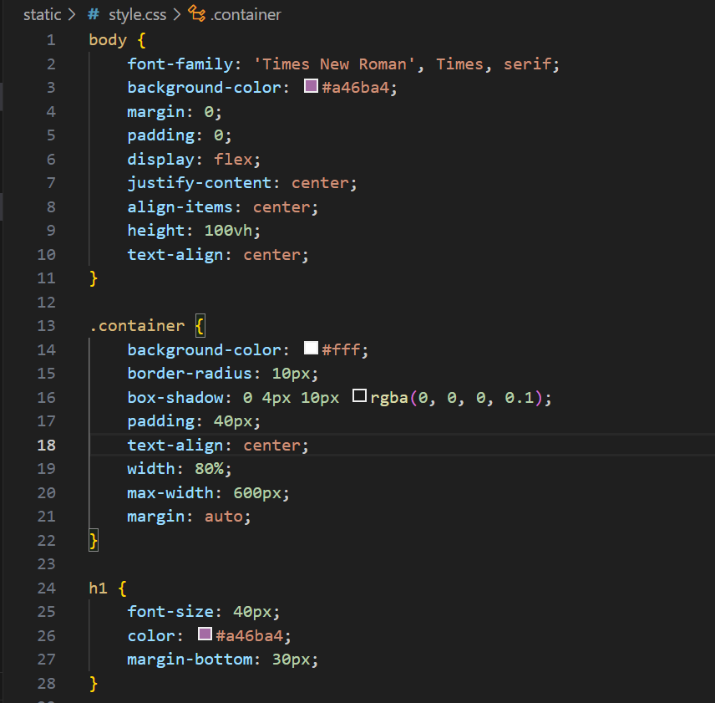

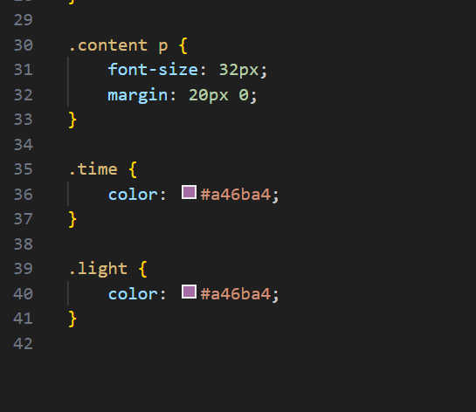

Visualization: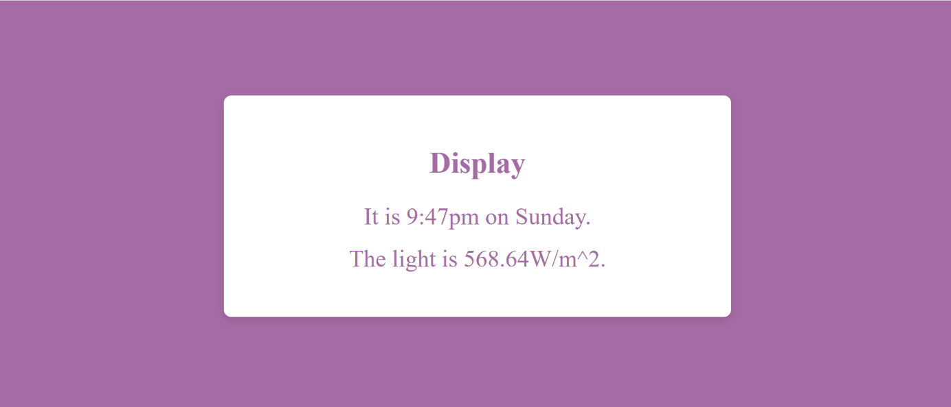

* ***Reflection:***

*I used my knowledge in css and html to add containers and classes and make the visualization more presentable.*

***Multiple samples - html:***

[***https://github.com/KSlavova/Fontys-University/tree/c5bc44161706b2baec337ff5a4f570733f8659db/ICT%20and%20Software%20Engineering/Week5/Multiple%20Samples***](https://github.com/KSlavova/Fontys-University/tree/c5bc44161706b2baec337ff5a4f570733f8659db/ICT%20and%20Software%20Engineering/Week5/Multiple%20Samples)

* ***Action:***

*Adopting previous html template to visualize a list time and light level pairs. To see the python code click here:* *Multiple samples – python*

*Here you can see the code: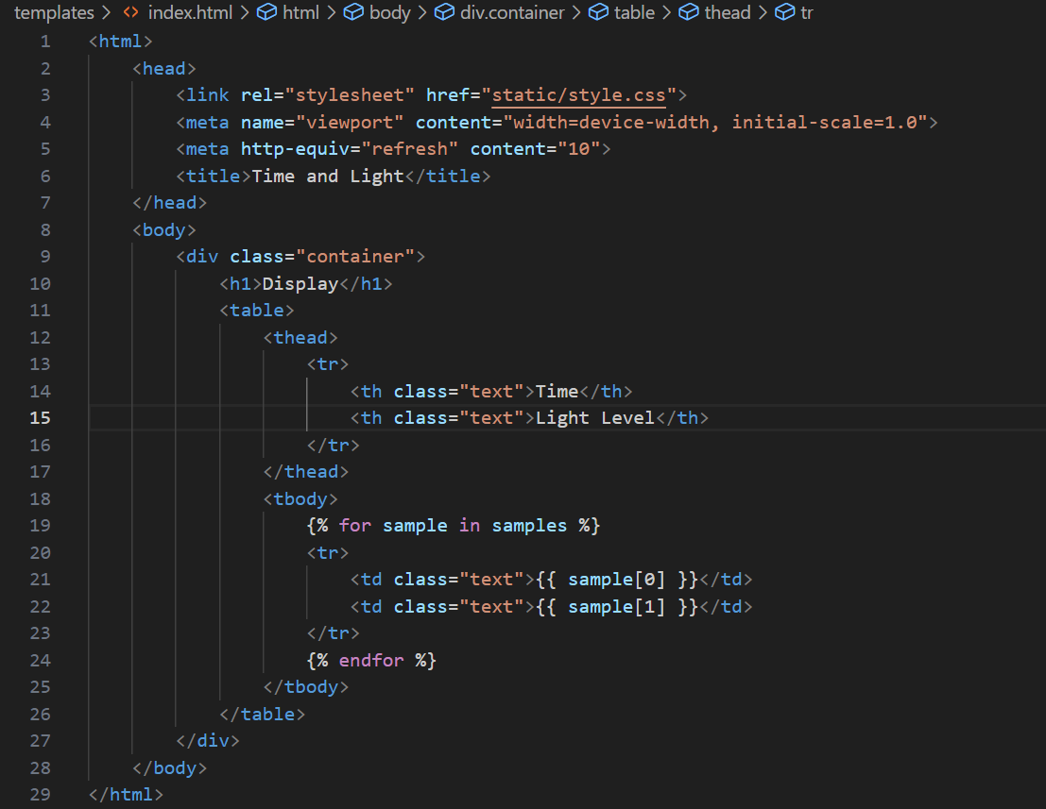*

*CSS code:*

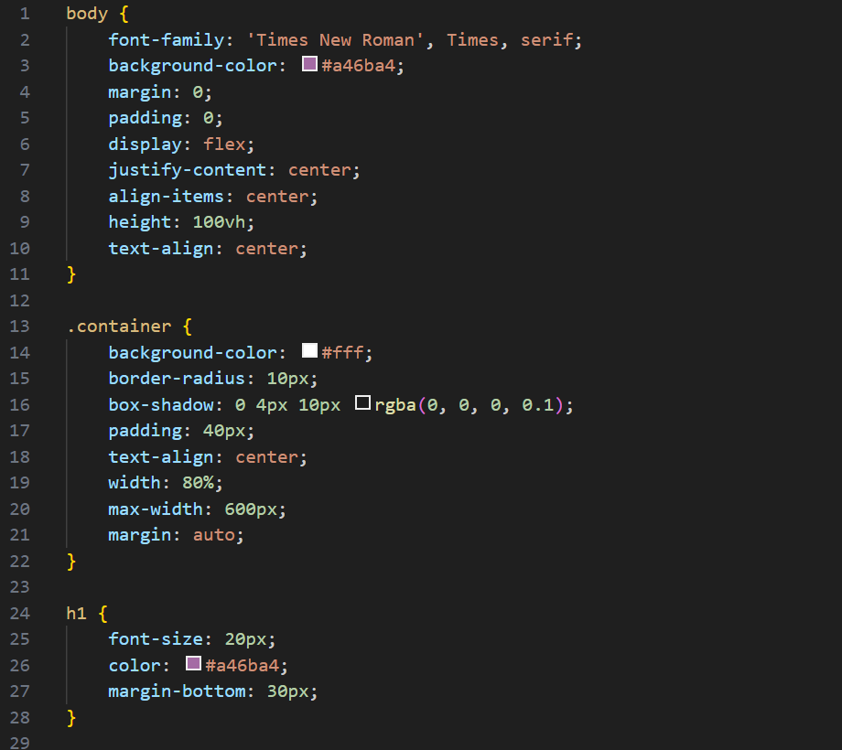

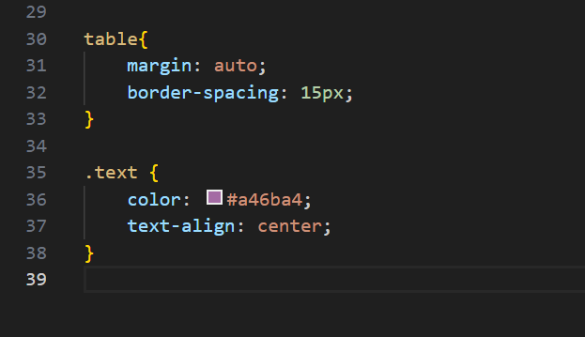

*Visualization:*

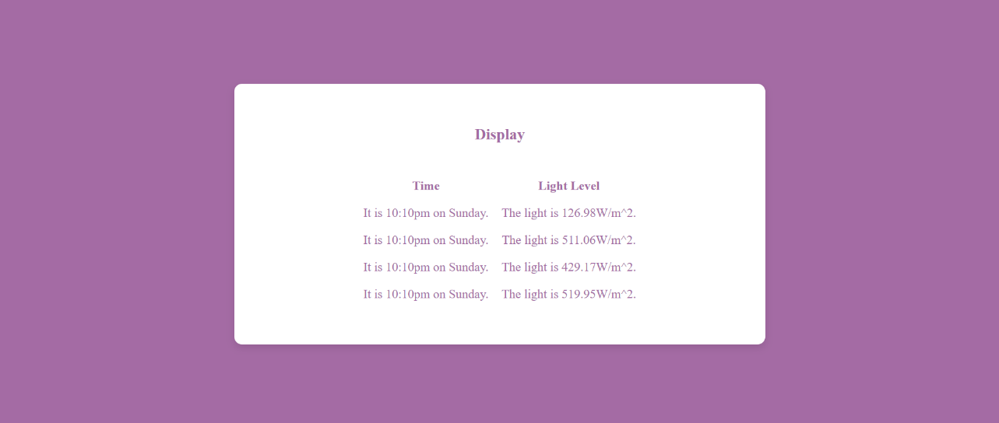

* ***Reflection:***

*I tried to keep the prevous css, because this is just a modification of the previous task.*

***My Fontys prototype:***

[***https://www.figma.com/design/gQUjbNg8LMUsypzoW5HGUT/Untitled?node-id=0-1&t=DyYhkhjtu65jWEtV-1***](https://www.figma.com/design/gQUjbNg8LMUsypzoW5HGUT/Untitled?node-id=0-1&t=DyYhkhjtu65jWEtV-1)

* ***Action:***

*Creating prototype in order to imporve a service that annoyes our group. Our group – PizzaBytes has to create a prototype of a service in order to improve it and present it to our classmates. The main problems were that the app had these features but they were not working, so basically it was empty and was not very useful. Click here to see tha presentation:* *My Fontys presentation*

*Here you can see the prototype:*

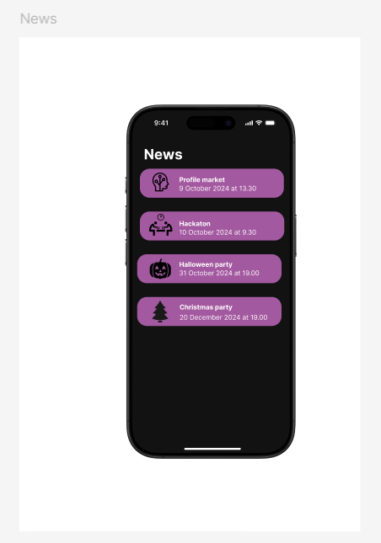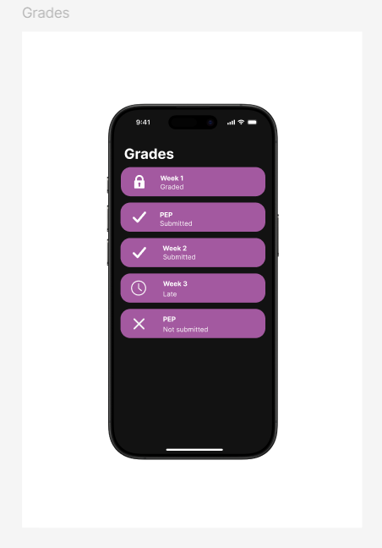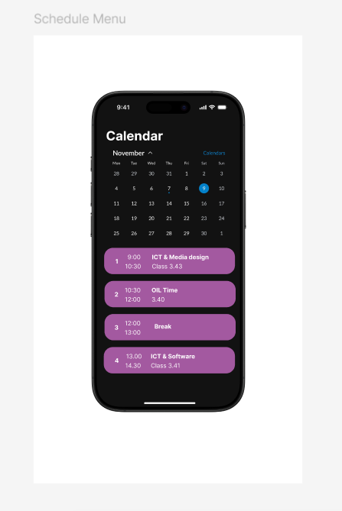

* ***Feedback:***

*After prsenting it to the class, our teacher suggested improving the calendar features, so that the customer could choose if he want to see the whole month, the week or only the day.*

* ***Reflection:***

*We agree that this new features could make the idea more user-friendly. For now we were inspired by the functionality of Canvas.*

* ***Future actions:***

*We will consider improving the calendar and think about other ways to improve the visuality.*

***Greenhouse monitoring system – html:***

* ***Action:***

*Creating html and css code for the visualization of the greenhouse project. Firslty, it was implemented to work with the random data, but I made some changes so that it would display the received data from the arduino. Go to* *python**,* *arduino*

*Here is the code:*

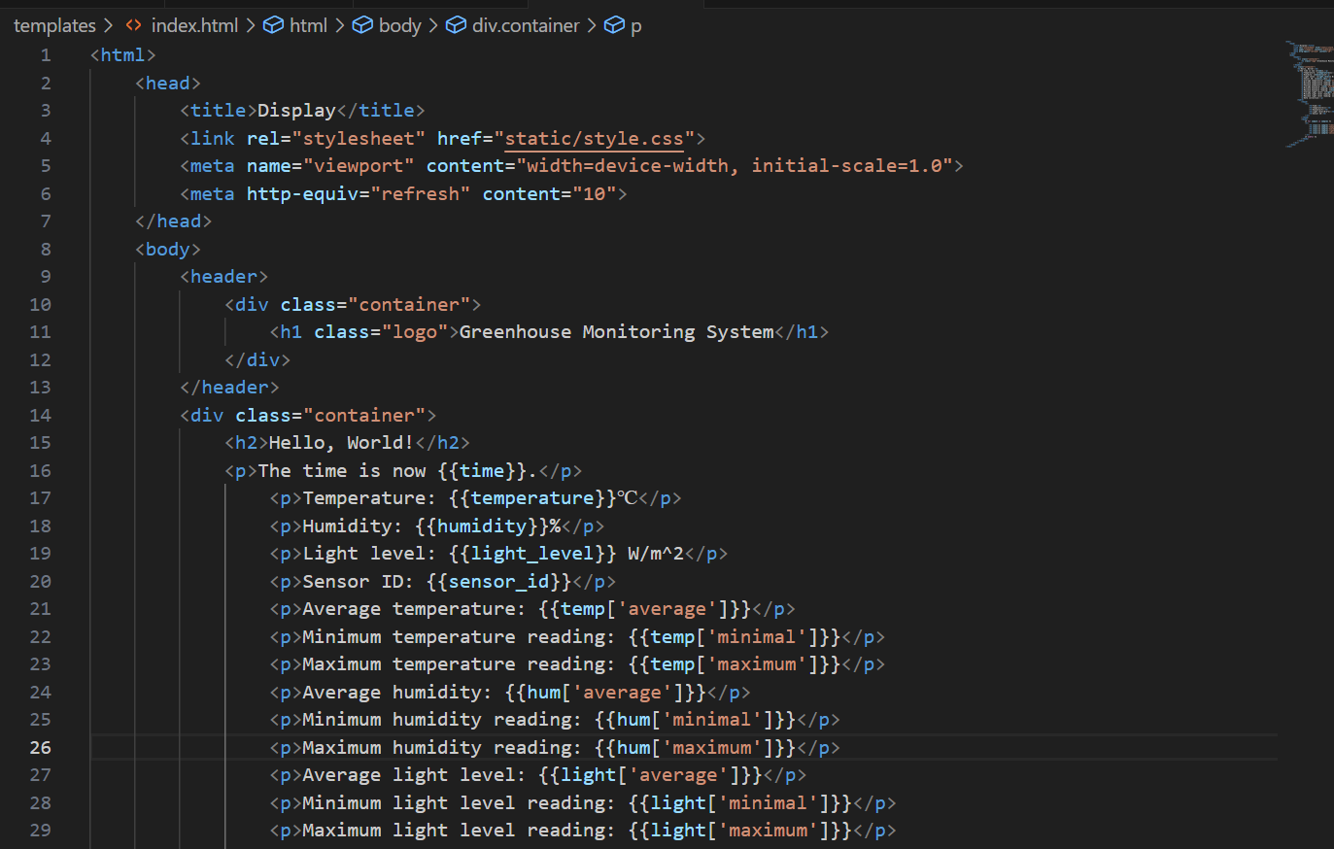

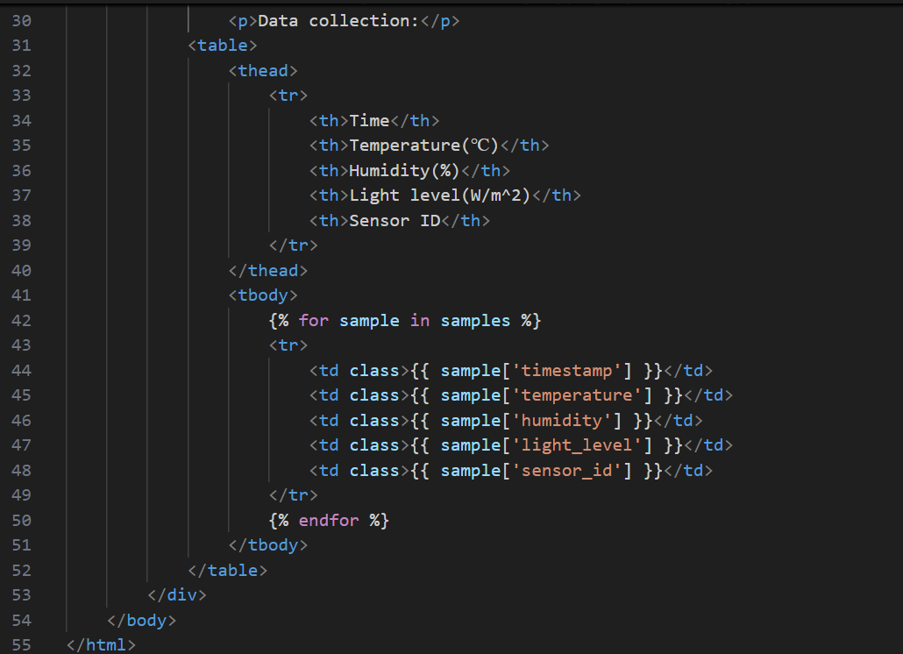

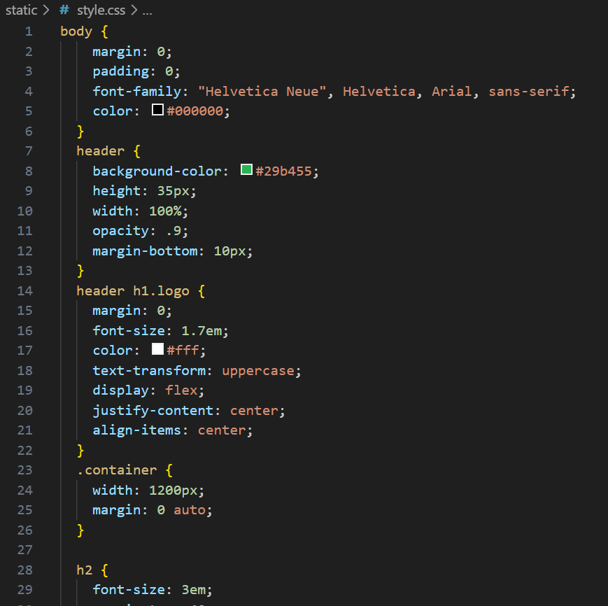

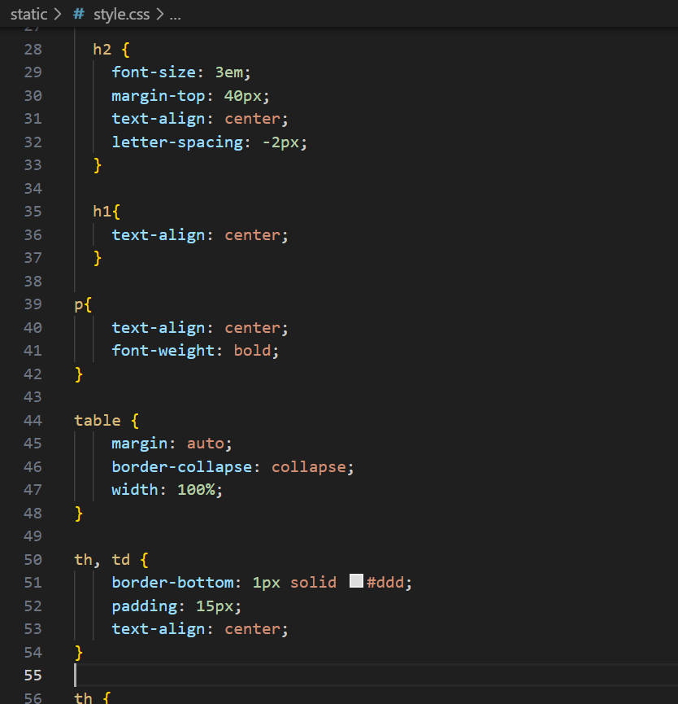

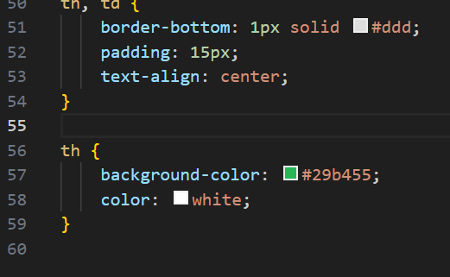

*Here you can see the visualization of the mock data:*

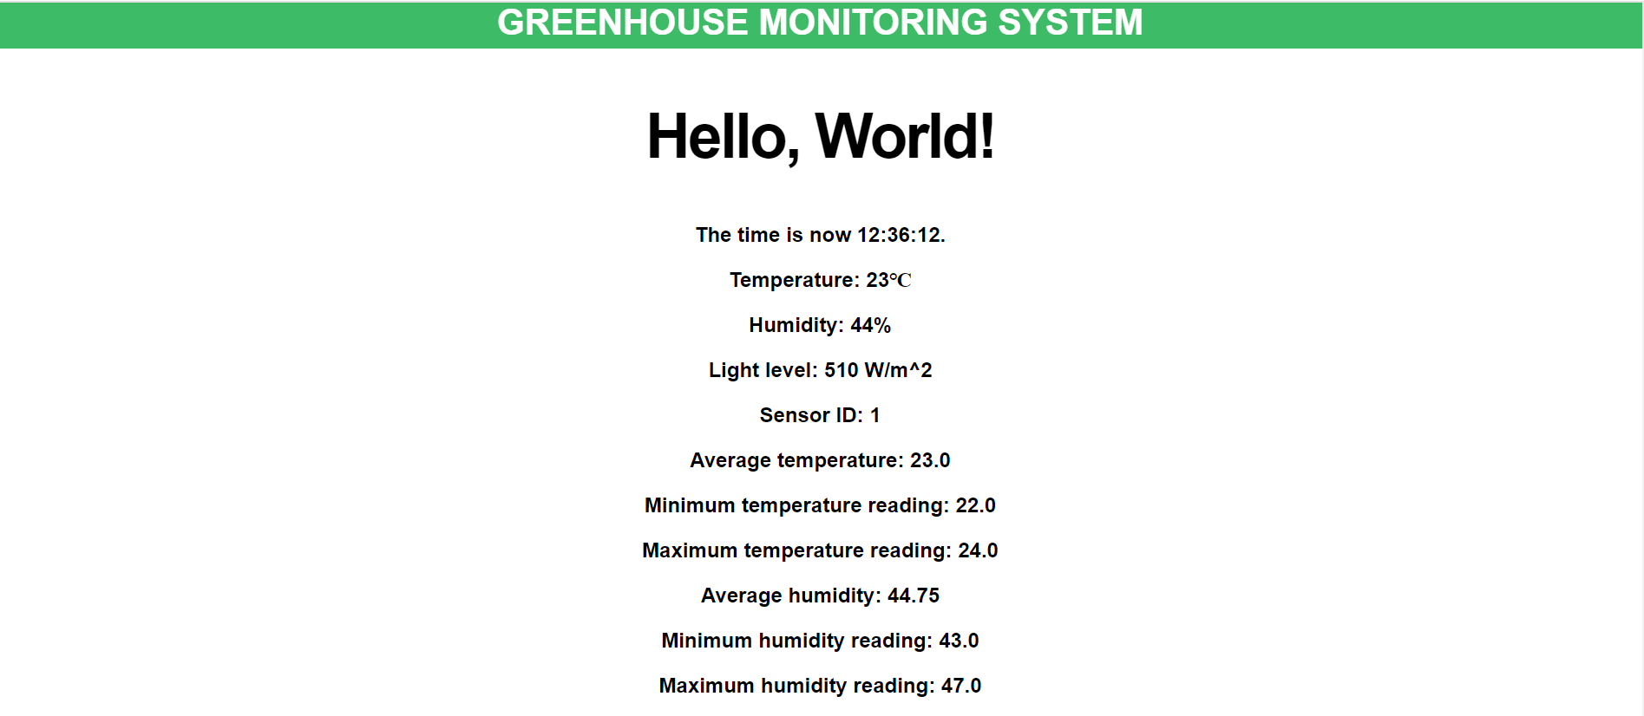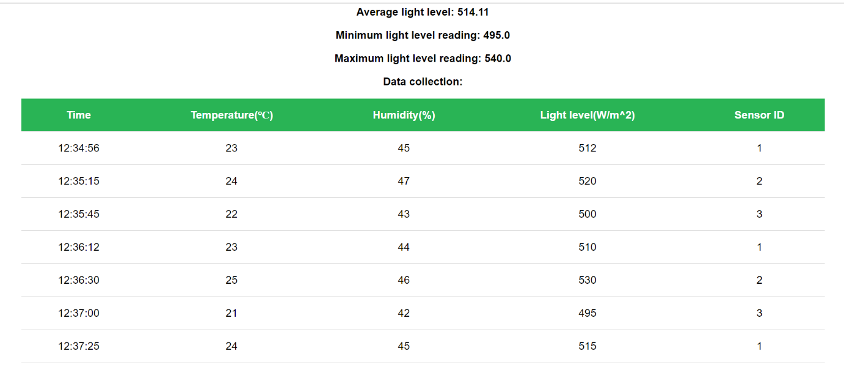

*Here you can see the visualization of the arduino data:*

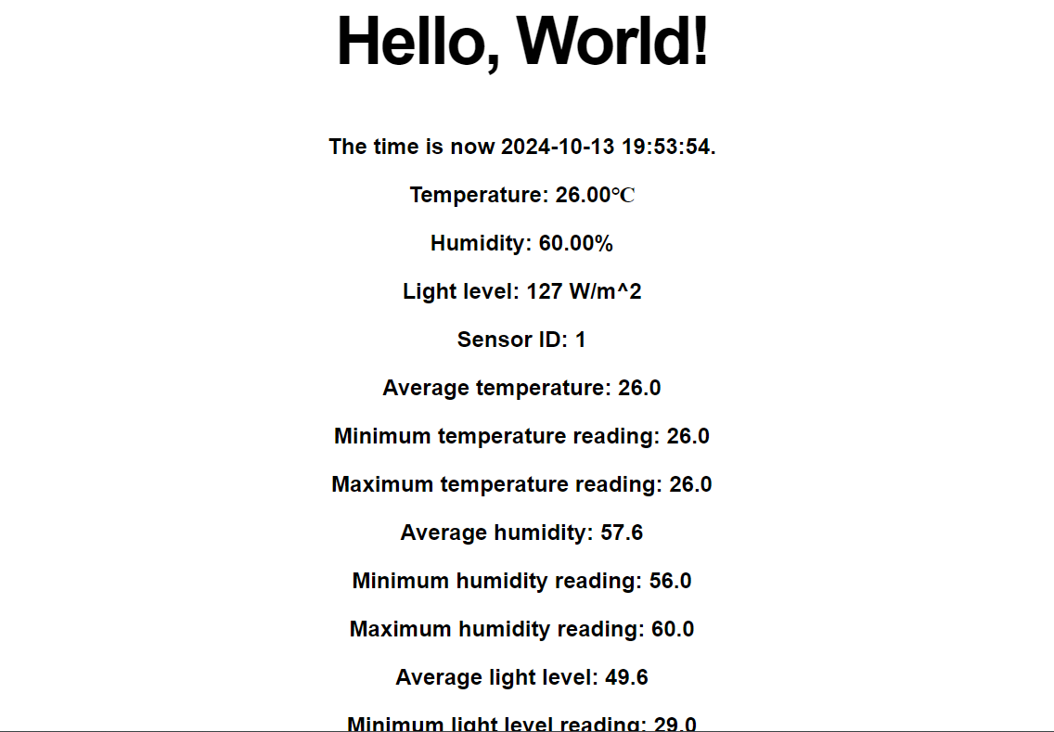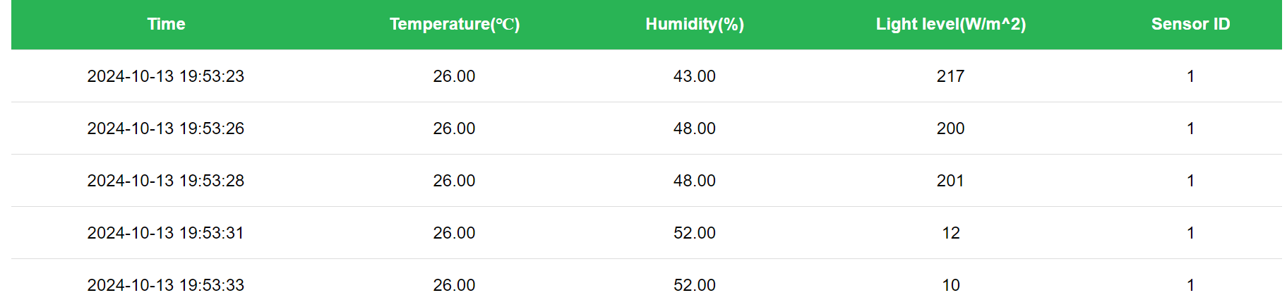

* ***Reflection:***

*I tried to follow the css code that was given in the structures but made some additional changes, because I have a table. I learned how to connect html template with flask serve in order to display the needed data.*

***Mario and Luigi’s Pizza prototype:***

* ***Action:***

*Creating a prototype for Mario and Luigi’s Pizzaria. Our group created a version of how the website for the project should look. We created pages for the client and for Mario and Luigi.*

*Here you can see the prototype:*

[*https://www.figma.com/design/HmWk4sX0K7T7sacLa8ZE4X/Pizza?node-id=0-1&t=jlFYaesC12H8MrQm-1*](https://www.figma.com/design/HmWk4sX0K7T7sacLa8ZE4X/Pizza?node-id=0-1&t=jlFYaesC12H8MrQm-1)

* ***Feedback:***

*We showed our teacher the prototype and he liked it. He advised us to start with implementing the backend of the website and then focusing on the frontend, but that doesn’t mean that the appearance of the website is not important.*

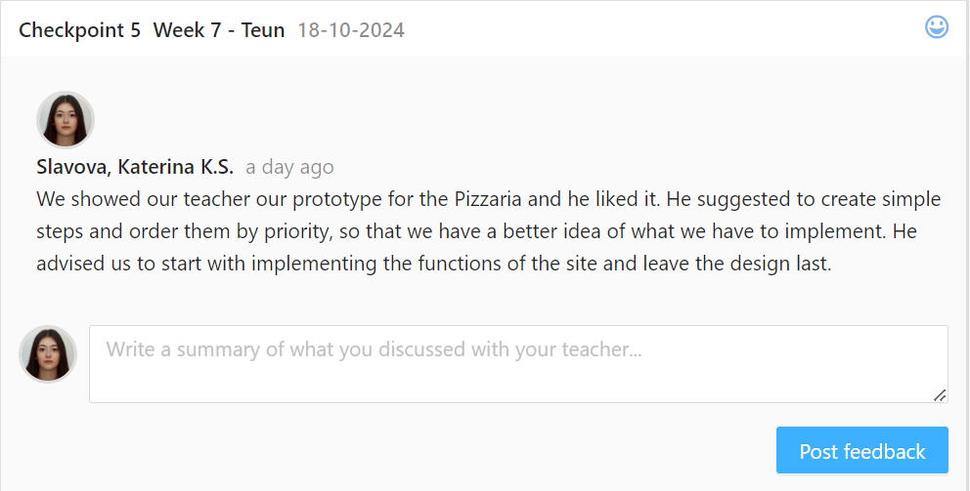

* ***Reflection:***

*We will listen to our teacher and start implementing all functions one by one. We tried to keep the Italian theme in the website and make it user-friendly.*

* ***Future actions:***

*We will devide our tasks by priority and start working on the actual site.*

### Software Engineering

You develop software applications with attention for algorithmics and hereby demonstrate the basic skills of object-oriented programming.

***The High IQ Game:*** <https://drive.google.com/file/d/1N4mmHy6yCK6NJjyJ13CUGd9WlOpI5Ays/view?usp=sharing>

* ***Action:***

*For this program I had to create a program that asks for a number lower than ten. If the player enters 10 or more, the computer prints message that says that the number is not in the correct input. If the number is lower than 10, then the computer adds +1 to the input. If the result is still lower than 10, the computer wins. If the result is 10, then the player wins. In the end, the player is asked to play again. If he enters “J” the game starts again. If he enters “N” the game stops. I started by creating a flowchart:*

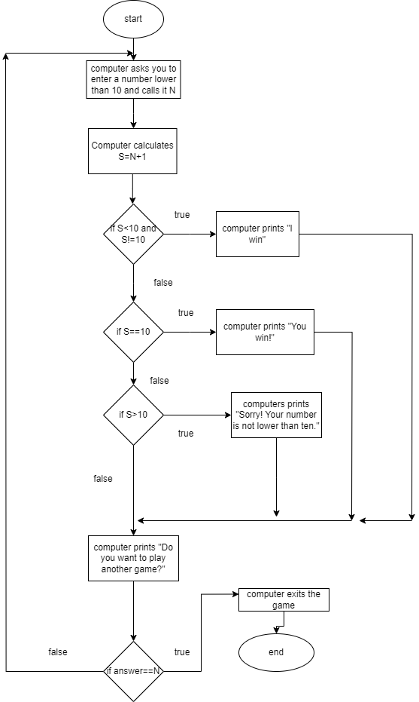

*Then I tried to follow the flowchart and create the game: 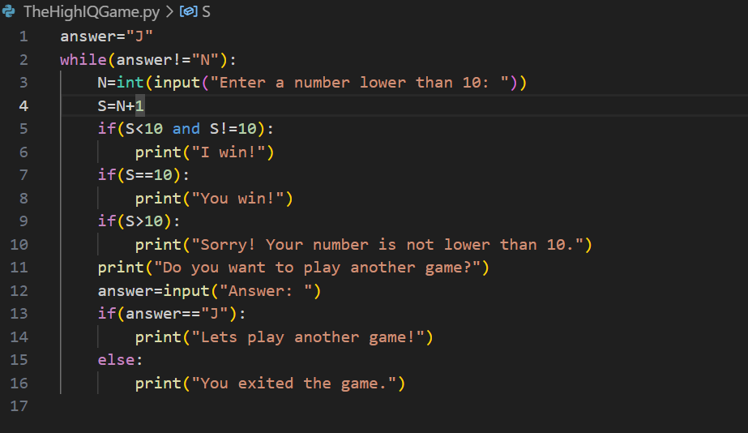*

* ***Feedback:***

*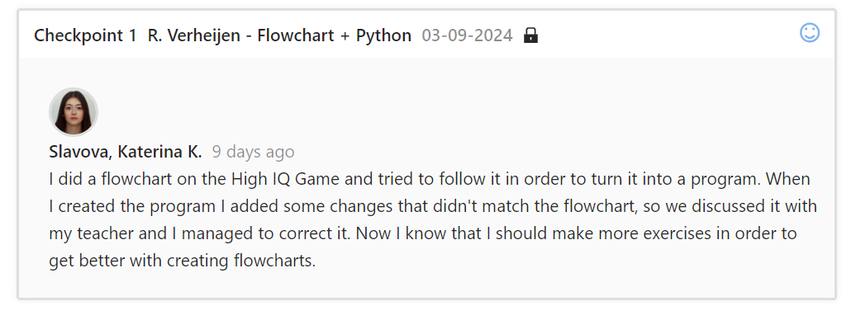While I was creating the flowchart, I did not added start, but my teacher corrected me. After I created the code, in my first if I added S!=10, because the computer was getting confused, but in my flowchart this wasn’t added, so I went back and made the needed changes.*

* ***Reflection:***

*The flowchart is very important part of the programing, because it describes how the code works.*

* ***Future action:***

*Next time, I will carefully check my code and flowchart for any differences.*

***Find The Leap Year:*** <https://drive.google.com/file/d/15fg8_EGOOz46TNqp6mmePnFIC6_fS4lc/view?usp=sharing>

* ***Action:***

*I had to create a program that asks the user to enter a year and tells the user whether it is a leap year or not. Leap years are years that can be divided by 400 or by 4 but not by 100. I started by creating a flowchart:*

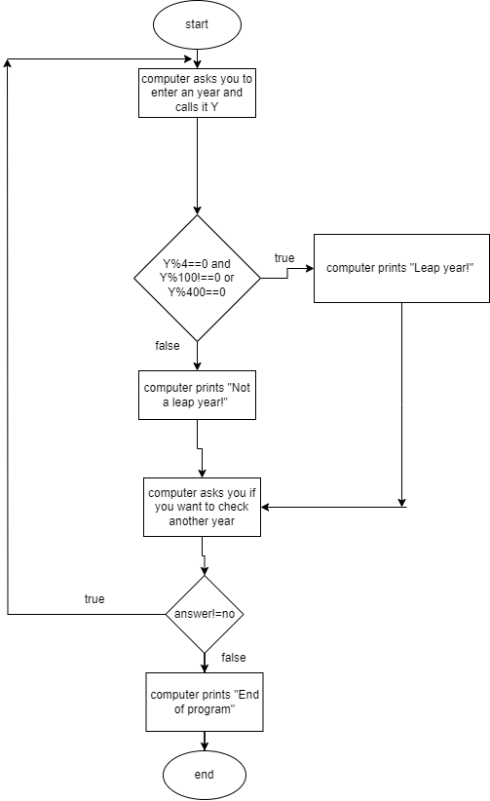

*I added a loop that checks if the user wants to check another year. If the answer is yes, the program starts again. If the answer is no, the program ends. Here is the python code:*

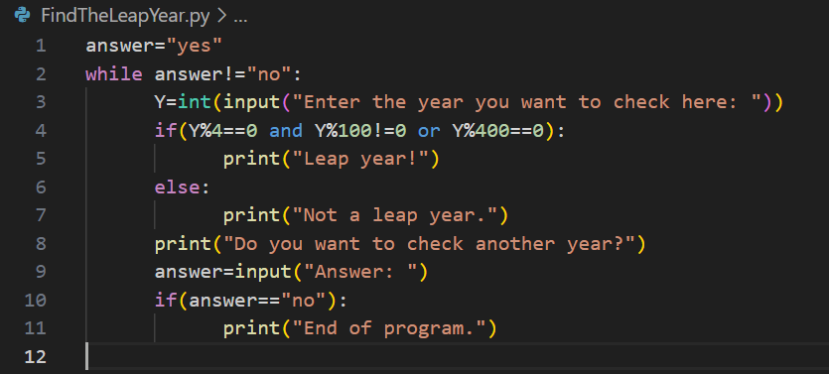

* ***Feedback:***

*My teacher had no remarks.*

* ***Reflection:***

*I feel motivated to keep learning python. It was really easy for me to do this task.*

* ***Future actions:***

*I will continue working hard in order to improve and learn more about python.*

***Check the password:***

<https://drive.google.com/file/d/1fIwI16La3km_e_bEcxnZ4qPUqZFNXM9h/view?usp=sharing>

* ***Action:***

*I had to create a program that stores a secret code. The user has three attempts to enter the correct password or his account will be blocked. If the user enters the correct password, he will see the message “Password correct!”. If he enters the wrong password, the message “Password incorrect” will be printed on the screen. I started by creating a flowchart:*

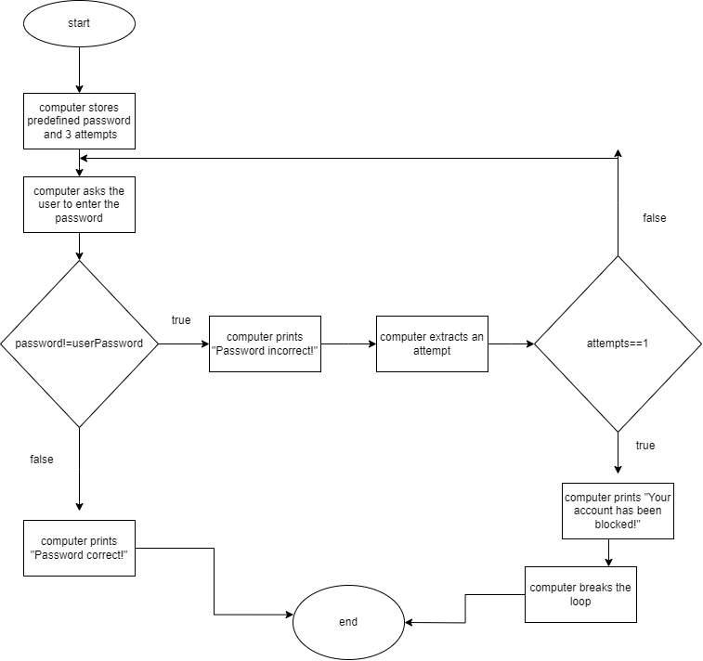

*Then I created the, but not intentionally I created an endless loop, so I added a break in my code and made the needed corrections in the flowchart. Code: 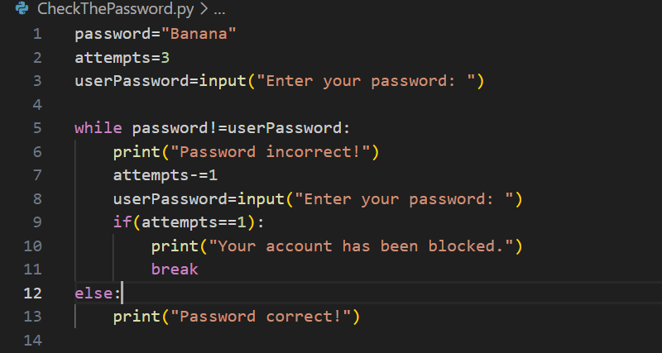*

* ***Feedback:***

*After I talked with my teacher, he told me even that it was not wrong, I should avoid using break for now, because we have not learned it yet.*

* ***Reflection:***

*I understand that there are more things to learn before mastering my knowledge.*

* ***Future actions:***

*I will try to avoid using break, until I am better educated about it. I will, also read more about it, so I can improve my abilities.*

***Find The classroom:***

<https://drive.google.com/file/d/1fjFLSRGR4QhBQRdUkDFhln_TjwxjX3zc/view?usp=sharing>

* ***Action:***

*I had to create a program that helps a student to find his classroom by entering his subject. The program should include at least 3 subjects and an error message if the user enters a subject that is not in the dictionary. The computer also asks for the user’s name, so he can call him by his name when telling him where to go. The flowchart for this assignment looks like this: 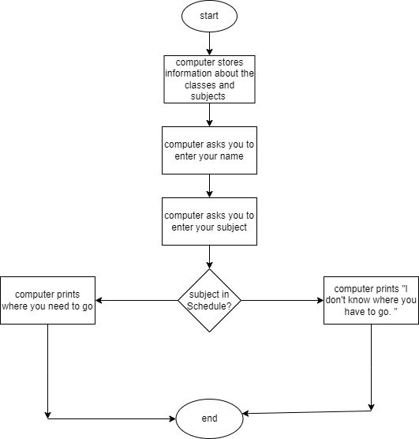*

*The code: 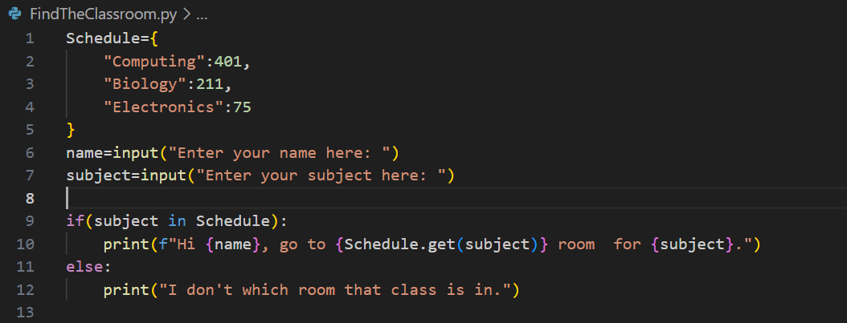*

* ***Feedback:***

*My teacher had no remarks.*

* ***Reflection:***

*I have a basic knowledge on how to use dictionaries, but my there is still things I want to know.*

* ***Future actions:***

*I will practise more on how to use dictionaries, because I know that there is more to learn.*

***Find The Tallest Player:***

*<https://drive.google.com/file/d/1ris7pUOQVr20A72K51MmoIop6_CIAI-t/view?usp=sharing> .*

* ***Action:***

I had to create a program that asks for the names and heights of three players and prints the name and the height of the tallest one. Firstly, I created a flowchart:

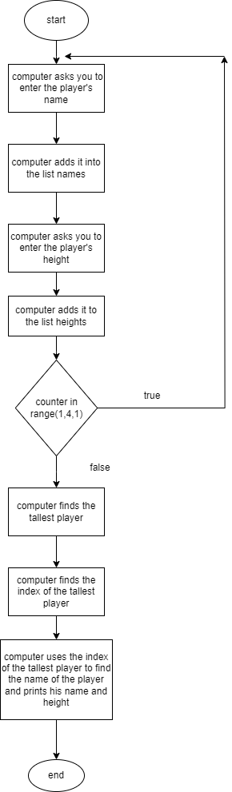

For my code I use two list to store the players’ names and heights. After that I find the tallest with the max() function and use the index() function to find the index of the tallest player(the name has the same index as the biggest number). 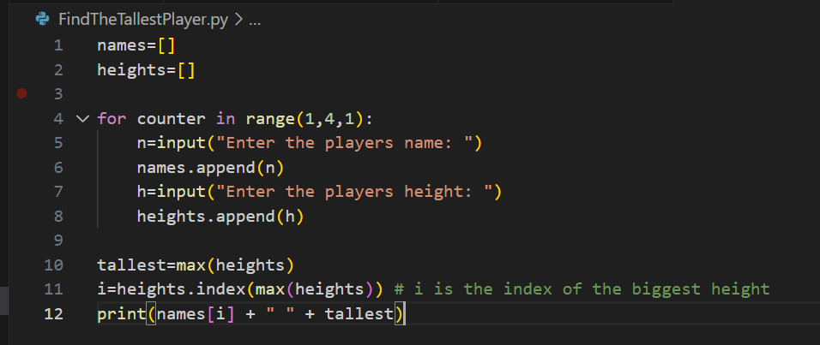

* ***Feedback:***

*After I showed my teacher the code, some things were a little unclear to him so he advised me to put comments so that it is more understandable.*

* ***Reflection:***

*I agree that as I future programmer, it is my responsibility to make my code understandable and clearer for others, because every programmer works with a team.*

* ***Future actions:***

*I will start adding comments in my code, to make it more understandable and not as confusing to others.*

***Guess The Number Game:***

***<https://drive.google.com/file/d/1vx2HtLWCXRVBHM301wvCdRUae0Uc4uZ3/view?usp=sharing>***

* ***Action:***

*I had to create a game that imports the random library and genarets a number between 1 and 100. The user should then enter his guess and will recieve a hint such as “Too high” if his guess is bigger than the number or “To low” if his guess is smaller. The game counts the attempts and when the user guesses the number, the computer prints the attempts and what is his best score of attempts. Then the game will ask the player if he wants to play again. If the user inputs a number that is lower than 1 or higher than 100, there will be an error message. Here is my flowchart:*

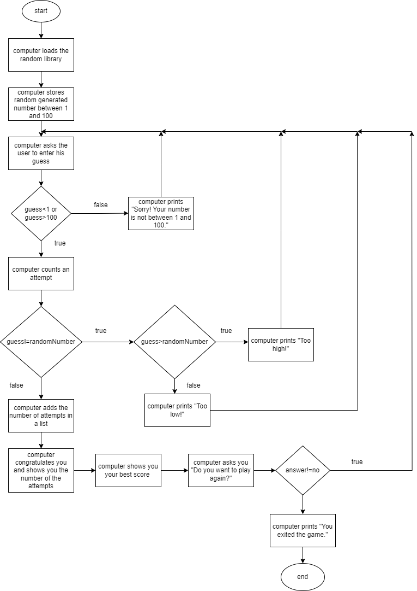*In my code, I use a list to save all scores and then find the minimal: 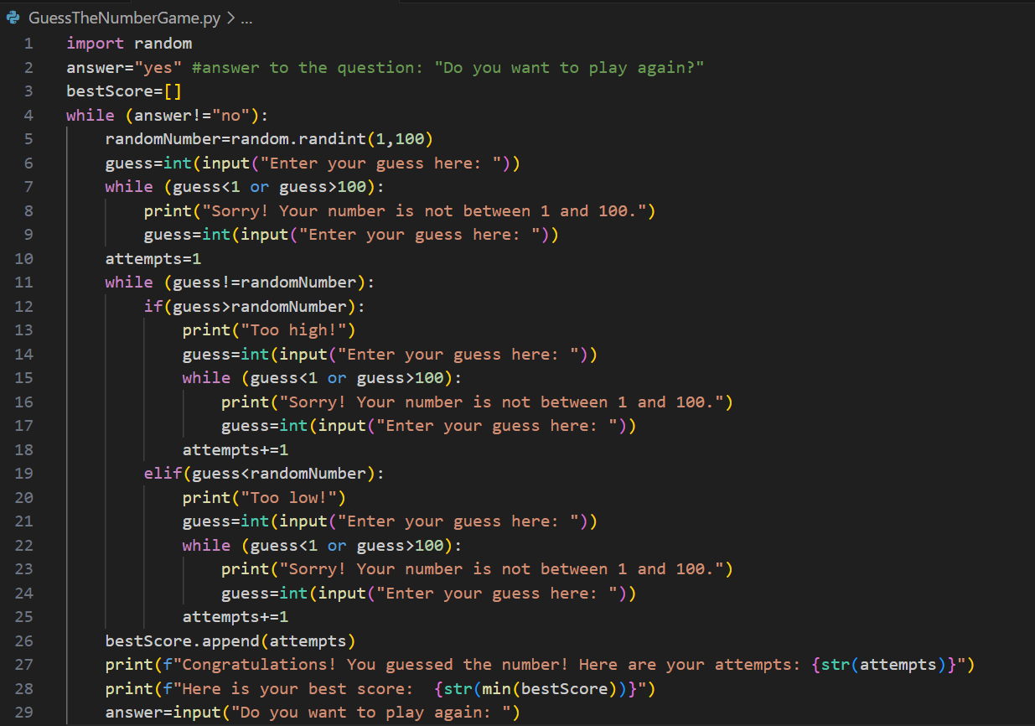*

* ***Feedback:***

*I went to talk with my teacher about my code. He said that everything worked correct. Because it was not set in the task, I asked if the invalid attempts should be caunted as an score. He said that it is up to me. So in my code the wrong inputs are not counted as an attempts.*

* ***Reflection:***

*I had a little difficulties while creating this code to think of a way to save the best score. My mistake was that I misplaced the empty list in the while and because of that with every new game, the list emptied itself. But I managed to see my mistake on my own.*

* ***Future actions:***

*I will be very carefull where I place my variables because it is very important for the right output.*

***Inform The Boss:***

***<https://drive.google.com/file/d/1NQyskkpAwIVxmbddivEaOnarq37TUKoi/view?usp=sharing>***

* ***Action:***

*I had to create a program that asks for a command. When entered “s”, the user should enter the name of the flower and then the price. If he enters “i”, the whole information should be printed. The information should be about how many bunches of flowers were sold, which was the most expensive and which – the least expensive, and the average value. I created a flowchart:*

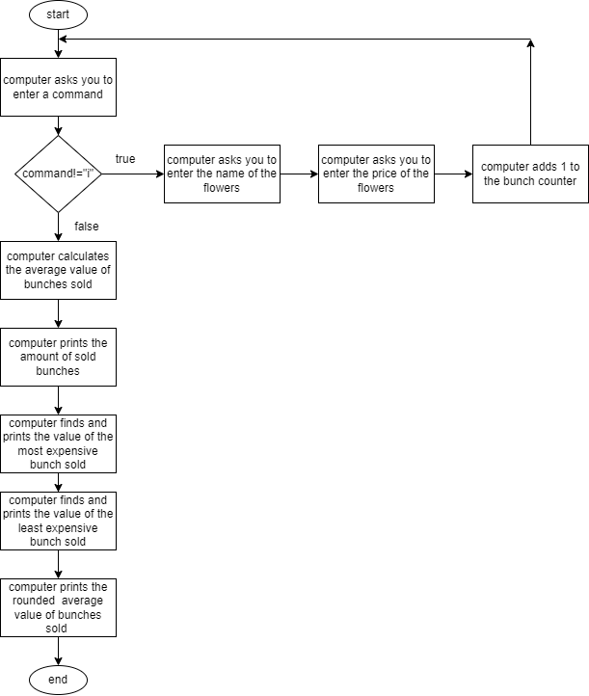

*And a code based on the flowchart: 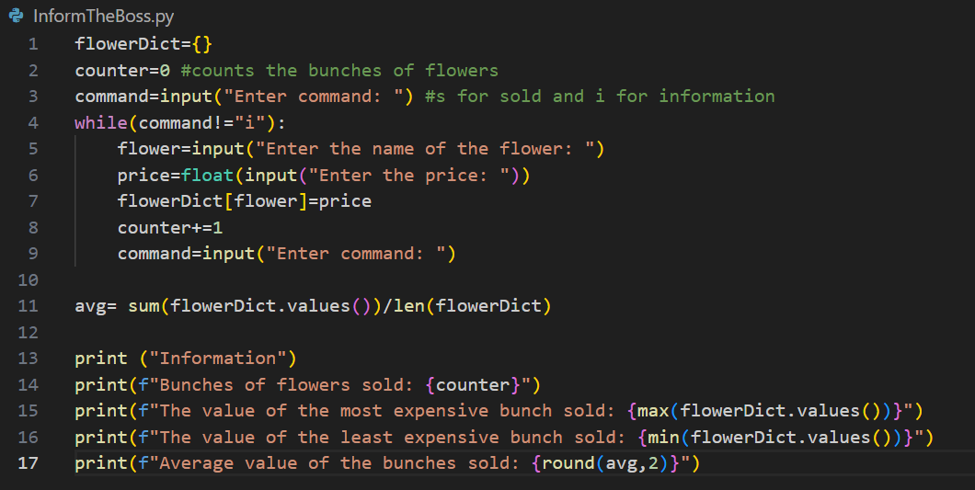*

* ***Feedback:***

*My teacher showed me that that dictionaries could not save reapeting information. So if i had two bunches of roses, only one would be saved, which was a problem. I also had to put validation for incorrect command input. 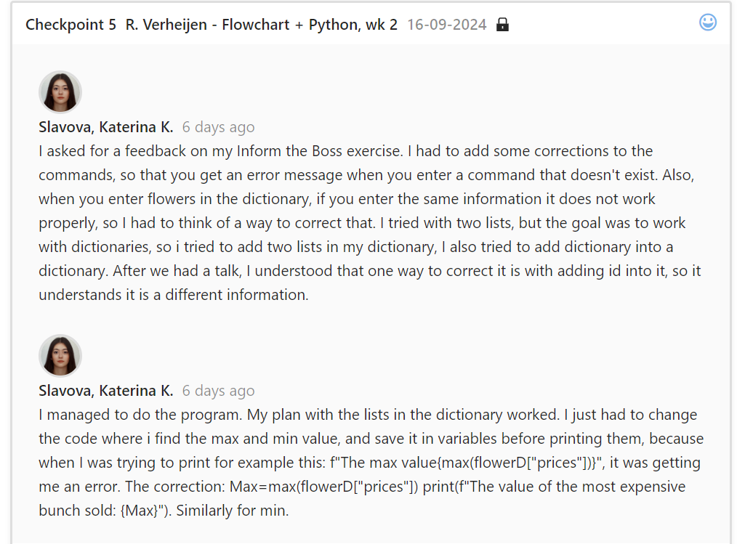*

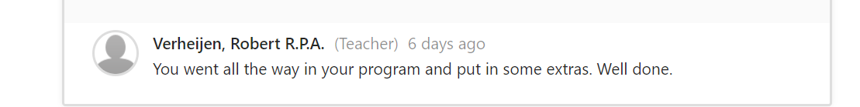

*This was my teachers feedback when I showed him how I managed the problem.*

* ***Reflection:***

*This placed a new challenge in front of me which motivated me to work. I added a function in my code to check for invalid commands. I came up with the idea to create a dictionary with two lists in it. This way the lists will save the repeating information. I changed my flowchart and rewrote my code:*

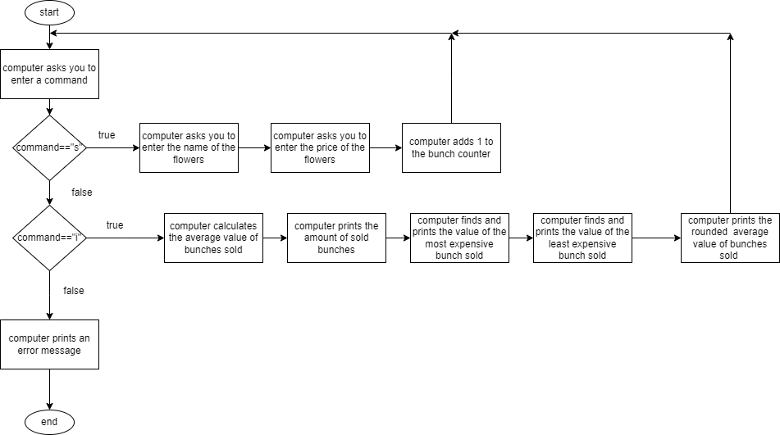

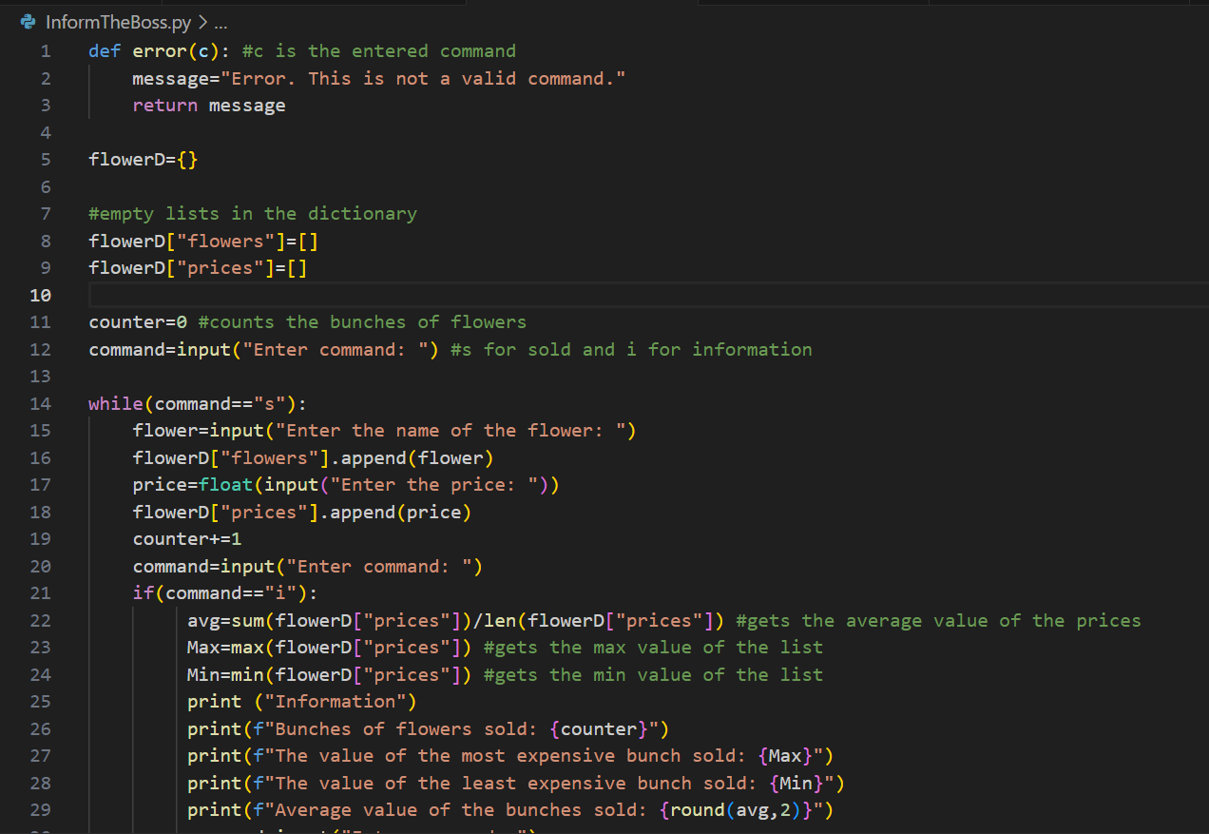

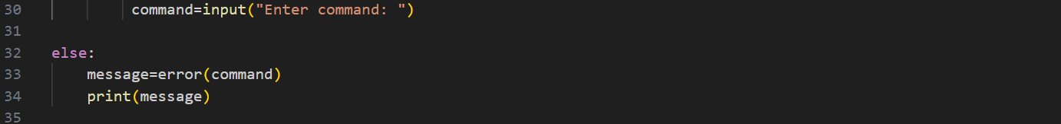

*It took me some time to put my plan in action but at the end I succeeded.*

* ***Future actions:***

*Now that I learned that dictionaries cannot save repetitive data, I will keep that in mind for the future, but even if I come against the same problem I will know how to manage it.*

***Rainfall Measurements:***

[***https://drive.google.com/file/d/1eNbyqsaAx4zNyDxgBtNRTu7SOs9f6q85/view?usp=sharing***](https://drive.google.com/file/d/1eNbyqsaAx4zNyDxgBtNRTu7SOs9f6q85/view?usp=sharing)

* ***Action:***

*I had to create a program that takes the a list of daily measurements and prints the weekly and monthly analysis. First, I createted a function that gets an empty list and prints the average of the lists values.*

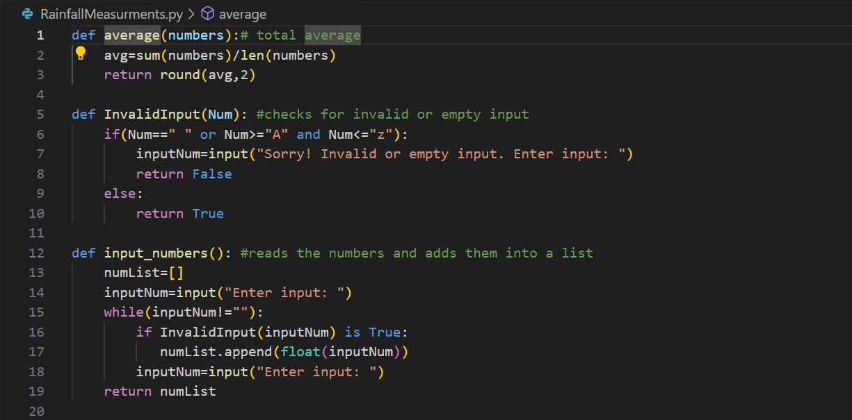

*Then I added function that reads the input that the user enters and adds it into a list. I added another function that checks for correct input.*

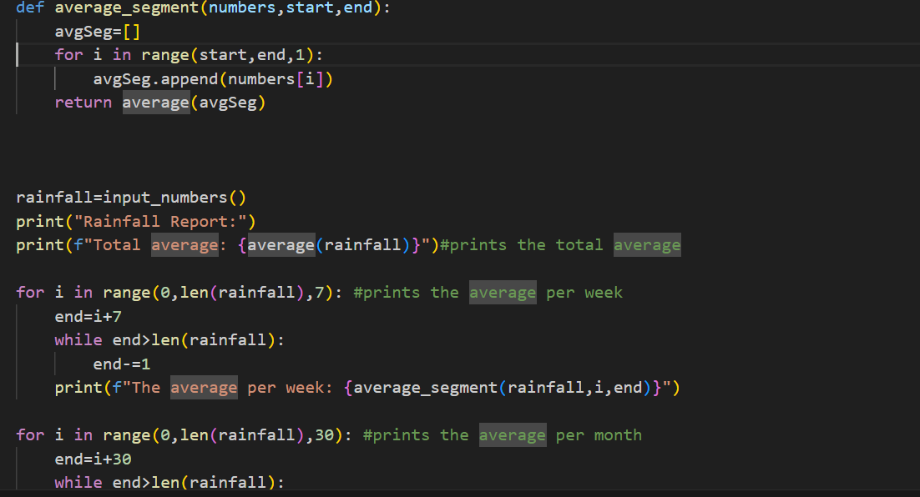 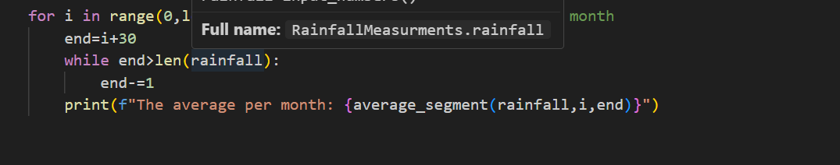

*I added a function that calculates the average of a segment of the list. With for and while loops I managed to do the weekly and monthly slicing. So if you enter a week and then three numbers after, it should print the average for both weeks even though the second is not full. The same i did for the months.*

* ***Feedback:***

*My teacher was really happy with my code. He even told me that python has this “slicing ” function that will makes really easy to get my segments.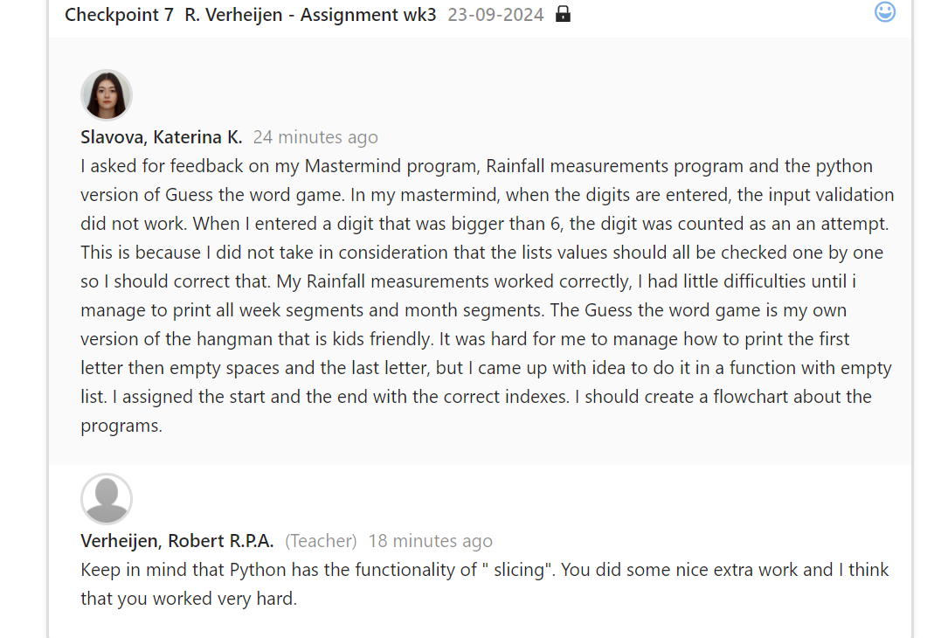*

* ***Reflection:***

*I had some difficulties how to manage the empty weeks and months, but the program itself was not hard for me to create.*

* ***Future actions:***

*I will work read more about the slicing function and implement it in my code. This way I will be able to use it for other tasks.*

***Extending the athletics analyser:***

[***https://drive.google.com/file/d/1tqjtrMnSQc9A6f3ufH7dzGY-30W4CrVA/view?usp=sharing***](https://drive.google.com/file/d/1tqjtrMnSQc9A6f3ufH7dzGY-30W4CrVA/view?usp=sharing)

* ***Action:***

*I had to adjust two functions in a program that read the attemps of two players who make long jumps. The new version should be able to read even the failed jumps and then find the player with the highest jump.*

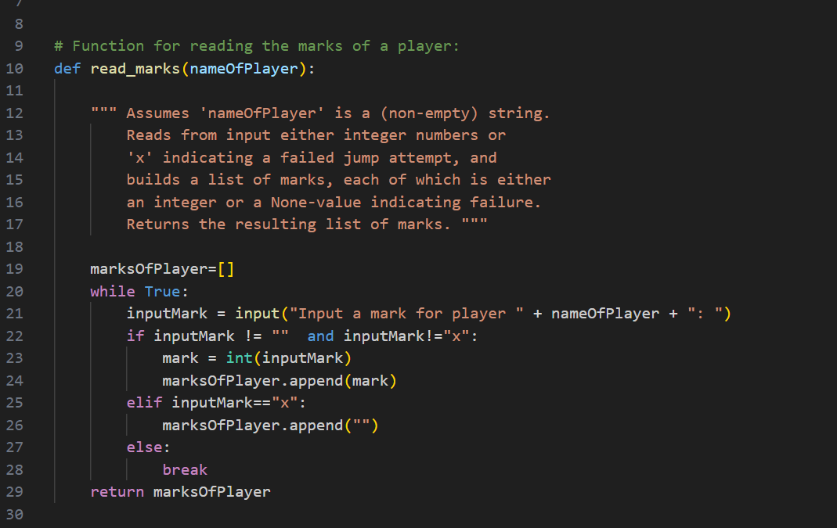

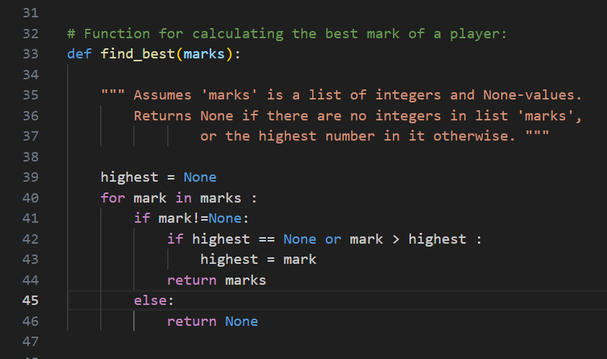

* ***Feedback:***

*At first, my program was working correctly, but when I entered the “x” sign for a failure, I got an error message, so I went back in my code and find that I was missing this part in my if “and inputMark!=”x””. After that, I showed the code to my teacher and he was happy that I managed to find my mistake on my own.*

* ***Reflection:***

*This was an easy code for me. I am even more happier that I found where I was wrong and it was very useful.*

* ***Future actions:***

*I will practise more on my conditionals and how to set if statements, so that i do not miss an important step.*

***Guess the word game:***

[***https://drive.google.com/file/d/1XHW5XYK4ITDg_TejEl0ldYkJRjLTRGz1/view?usp=sharing***](https://drive.google.com/file/d/1XHW5XYK4ITDg_TejEl0ldYkJRjLTRGz1/view?usp=sharing)

* ***Action:***

*I had to create a python program of my version of the Guess the word game. The idea was to create a hangaman game version that is kids friendly. I created two lists with words and hints. Every index of the word eaquals to the index of the hint. I used the random library to choose a random word from the list and print the hint that eaquals the word. I created a fucntion that creates a list with the first and last letter and adds empty spaces between them. Then a function that fills the empty spaces when entered the correct letter. And a print method, to print the list without brackets and commas.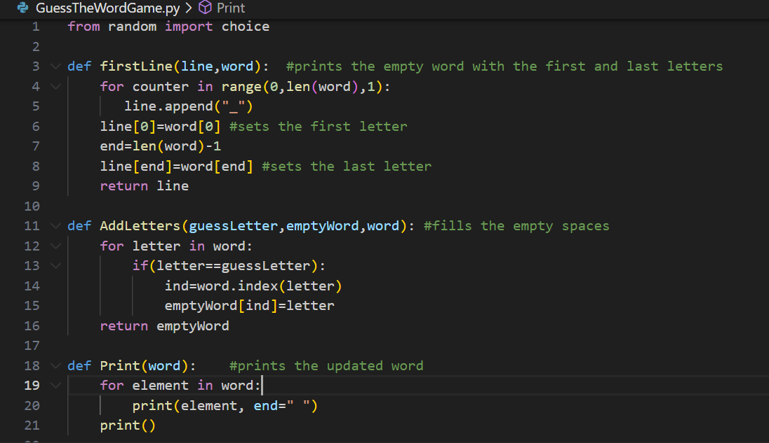*

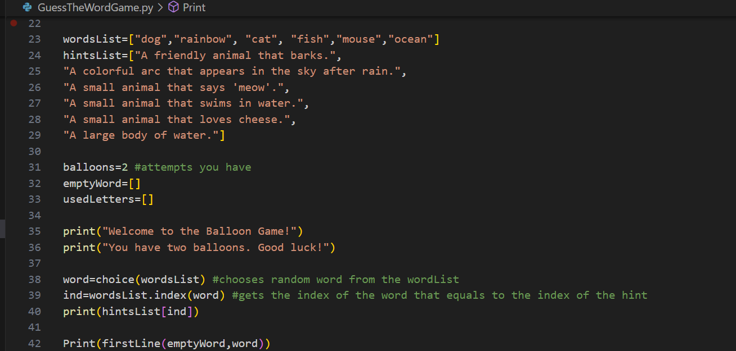

* ***Feedback:***

*My teacher was happy with my coding and did not have any remarks.*

* ***Reflection:***

*As i said in my feedback, I had to think hard to come up with idea on how to print the spaces and the letters all together, but after some reaserch in the old presentations I managed to do it.*

* ***Future actions:***

*I will keep up with practising and reading about functions.*

***Mastermind:***

[***https://drive.google.com/file/d/1SjamuSsuu01qJaQtIats4KGHnPXDJgRE/view?usp=sharing***](https://drive.google.com/file/d/1SjamuSsuu01qJaQtIats4KGHnPXDJgRE/view?usp=sharing)

* ***Action:***

*There was an optional program called The Mastermind, where I had to create a game with four random generated numbers between 1-6. The user should then try to guess the digits. After each input there will be an error message for incorrect inputs. If the inputs are digits, between 1-6, then the computer prints the amount of guessed digits that are on the correct position and the amount of guessed digits with wrong position. The user has 12 attempts before the game ends.*

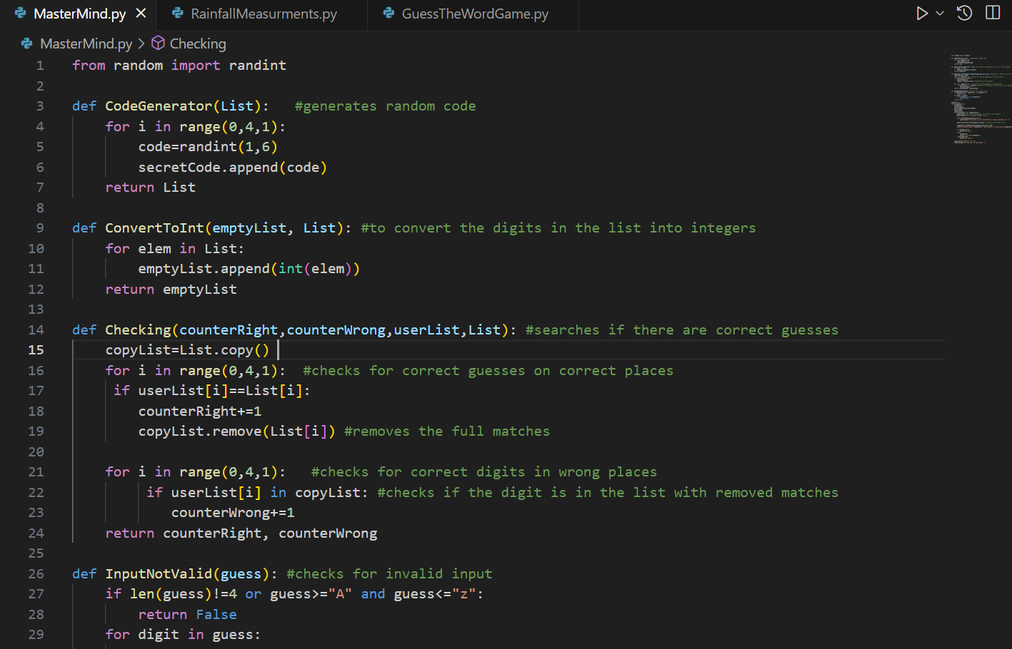

*I use functions to generate the four random numbers, to check for valid input, to convert the input into integers and add them to a list and then check if there are correct digits. 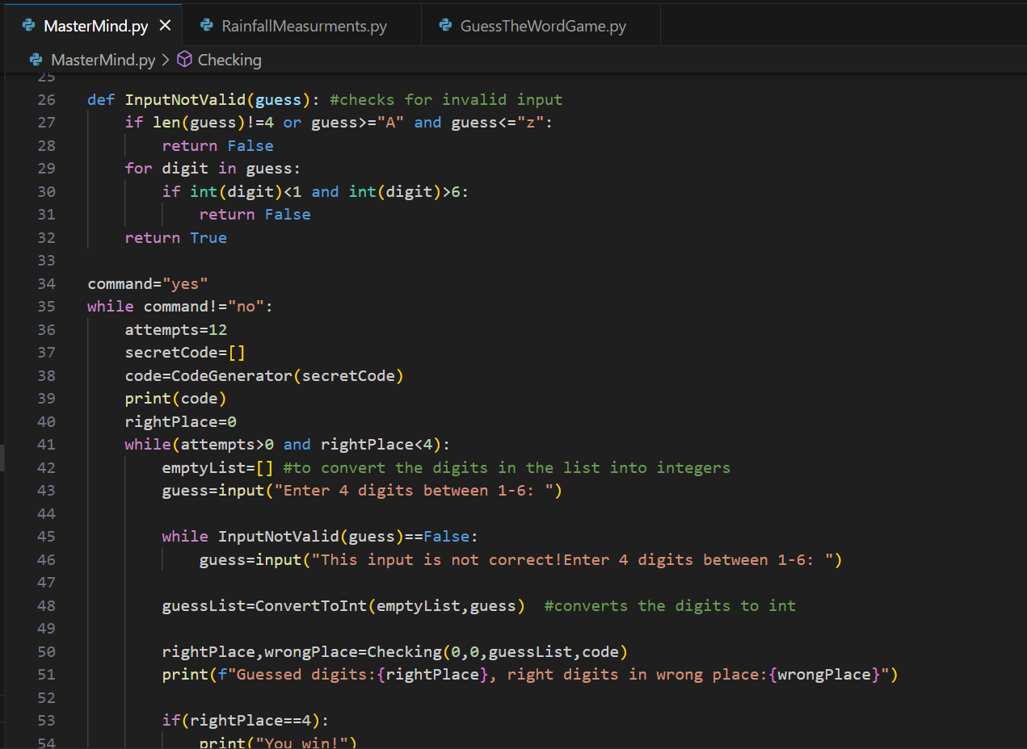*

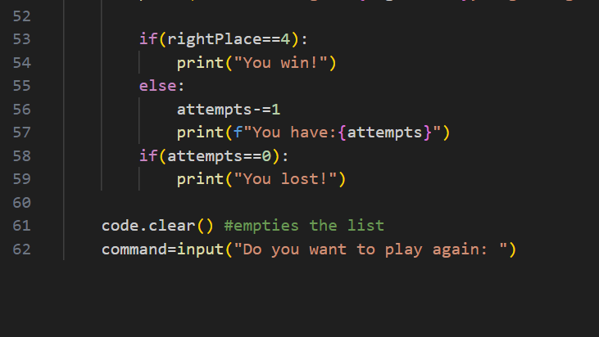

* ***Feedback:***

*I had an error in the invalid function, where I try to check if a list equals “A”. After I showed my work to my teacher, he managed to find my mistake and we talked about different ways how to correct this.*

* ***Reflection:***

*The only part that was a little bit hard for me was the part where I had to check for the right guessed digits that are in wrong positions, but at the end I managed to do it with copy() function like it was said in the task. I should never forget that lists have their own values in them, so I have to go through every value in order to compare the whole list to something.*

* ***Future actions:***

*I will be more careful with the use of lists because they are not like other variables. I will implement a loop that checks all the values in the list.*

*Code with corrections: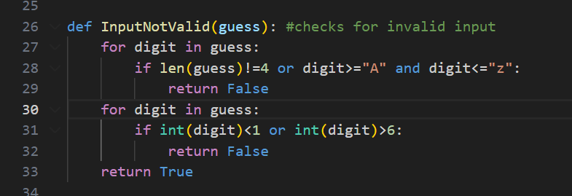*

***Time and random light level – python:***

[***https://github.com/KSlavova/Fontys-University/tree/5a2a1ecf7254b32d22bc4424e3c018a563692450/ICT%20and%20Software%20Engineering/Week5/TimeAndRandomLightLevel***](https://github.com/KSlavova/Fontys-University/tree/5a2a1ecf7254b32d22bc4424e3c018a563692450/ICT%20and%20Software%20Engineering/Week5/TimeAndRandomLightLevel)

* ***Action:***

*Creating a Flask server, which renders my html template in order to show the current time, day and random generated light level. To see the html template go to: Time and random light level – html*

*Here you can see the code:*

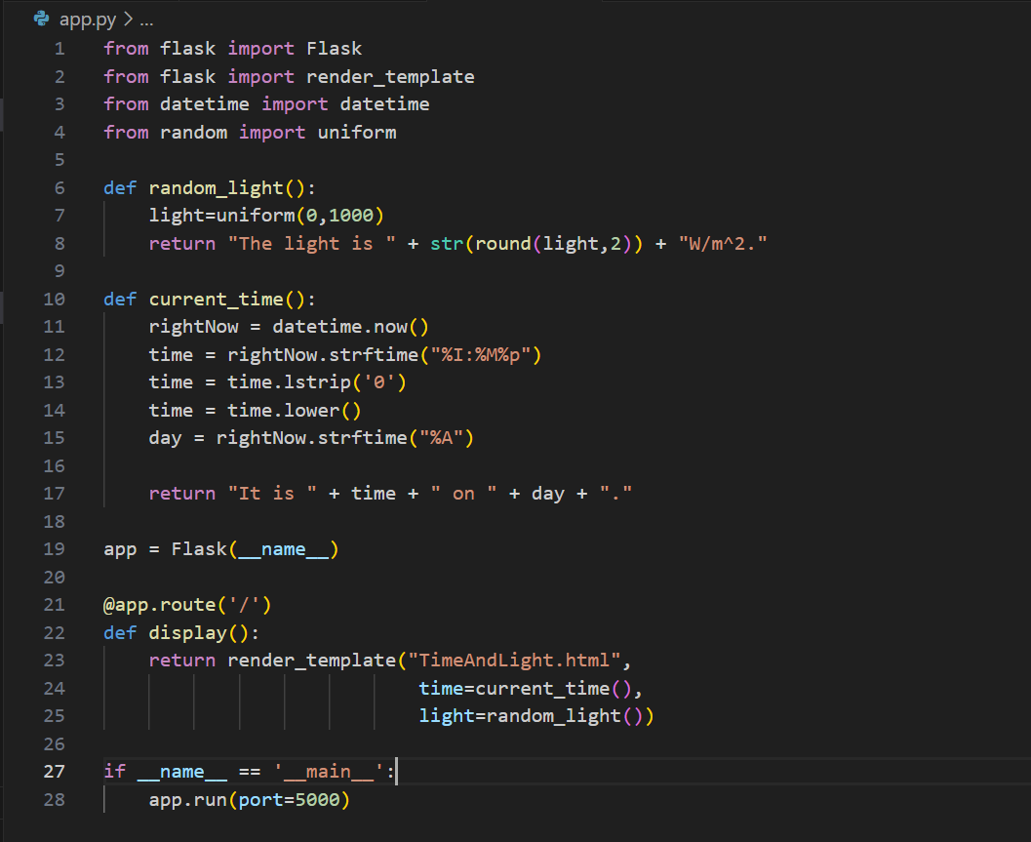

*Here is the visualization:*

**

* ***Feedback:***

*When i tried to start my program there was an error, that would not let me start it. I asked my teacher for help and he explained me that i needed to add the if – statement, before the last line, in order to check if the script is being run as main program.*

* ***Reflection:***

*I learned a new how to get the current time and visualize it. I learned how to implement flask in simple programs.*

* ***Future actions:***

*I will find more information about the if - statment.*

***Updates and Styling - python:***

[***https://github.com/KSlavova/Fontys-University/tree/8f0fcc3694242718f04000a8ae0e6af00c2cd523/ICT%20and%20Software%20Engineering/Week5/Updates%20and%20styling***](https://github.com/KSlavova/Fontys-University/tree/8f0fcc3694242718f04000a8ae0e6af00c2cd523/ICT%20and%20Software%20Engineering/Week5/Updates%20and%20styling)

* ***Action:***

*Extending the previous application so that it the values are automatically and periodicaly updated. If you want to see the html part visit: Updates and Styling – html*

*Here you can see the code:*

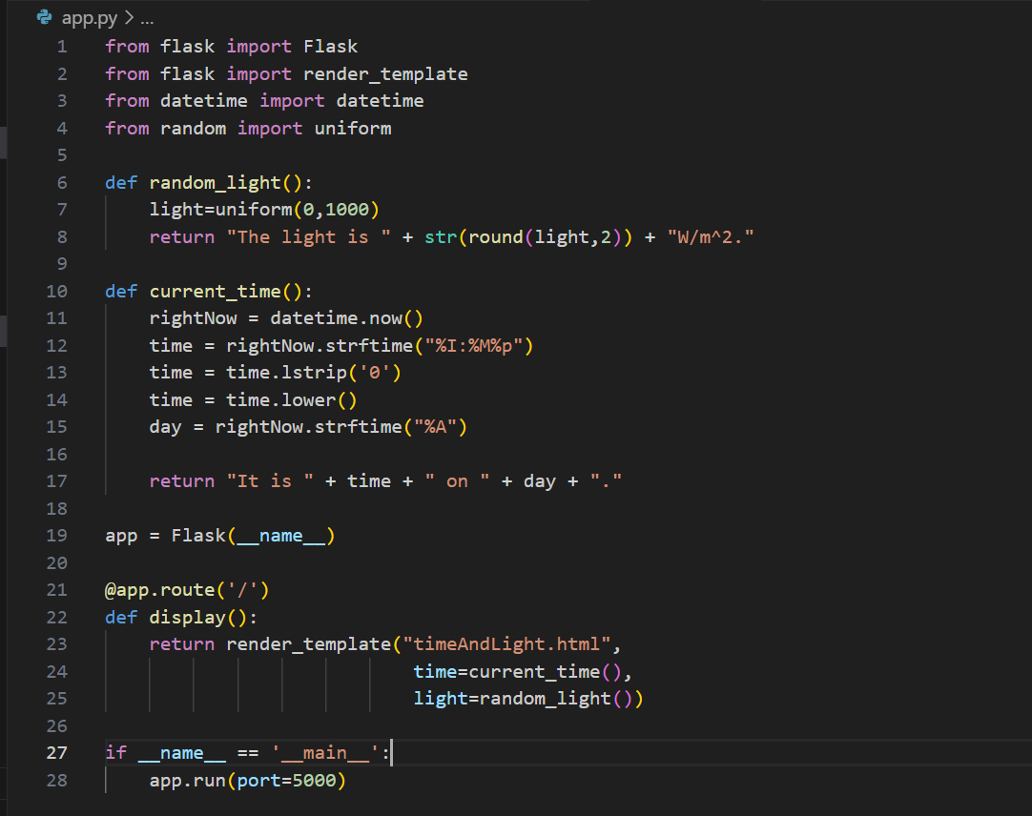

*Here you can see the visualization:*

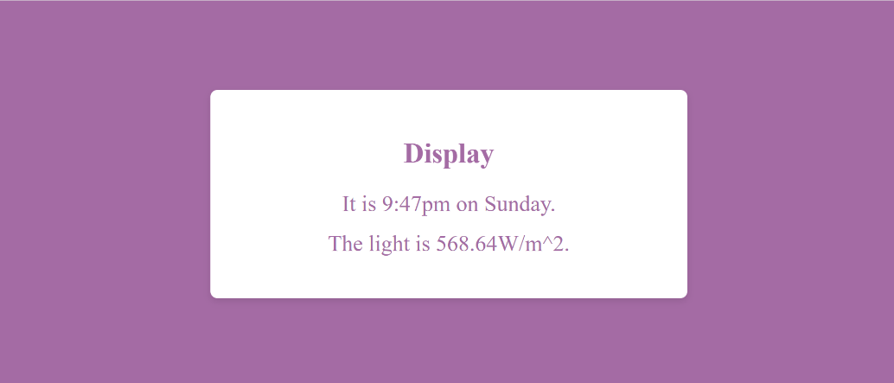

* ***Reflection:***

*I learned how to epdated information on a particular time. I did not need any feedback, because every step of the code was explained in the task.*

***Multiple samples – python:***

[*https://github.com/KSlavova/Fontys-University/tree/c5bc44161706b2baec337ff5a4f570733f8659db/ICT%20and%20Software%20Engineering/Week5/Multiple%20Samples*](https://github.com/KSlavova/Fontys-University/tree/c5bc44161706b2baec337ff5a4f570733f8659db/ICT%20and%20Software%20Engineering/Week5/Multiple%20Samples)

* ***Action:***

*Extending the Flask server(previous exercise) to remember a list of samples. The html code: Multiple samples - html*

*Python code:*

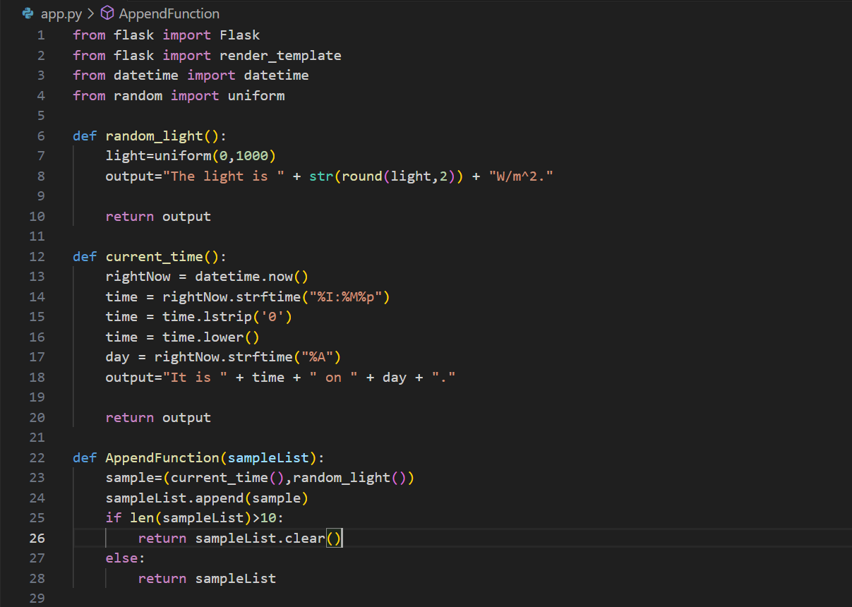

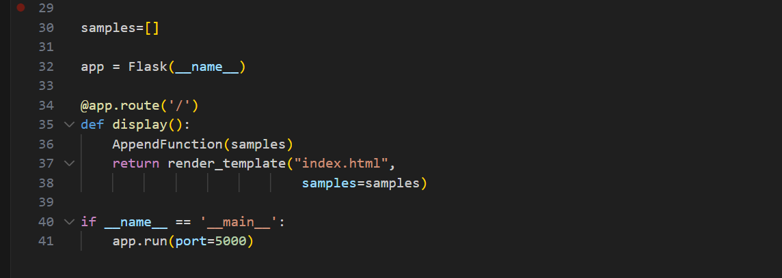

*Visualization:*

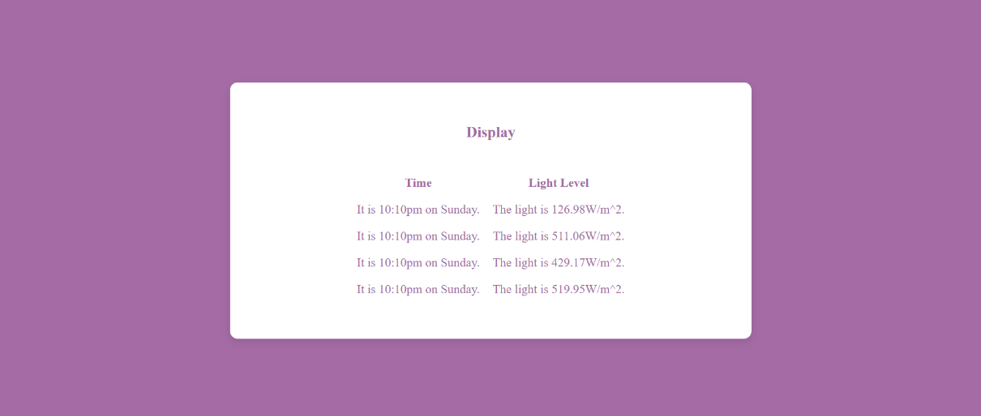

* ***Feedback:***

*I showed my teacher this program and he had no remarks on it. The thing that I will change is the time between generating new data, because right now is a little bit long.*

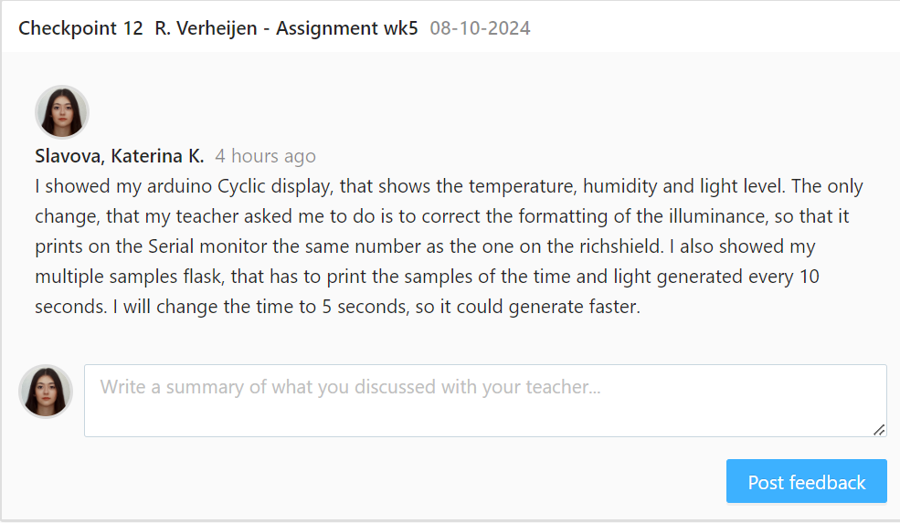

* ***Reflection:***

*It was not hard for me to create this program because I followed the simple steps in the exercise. I learned how to implement flask and connected tpython code with the html, so that it visualize the elements.*

* ***Future actions:***

*I will exercise more on flask and will shorten the amount of time between data generation.*

***Greehouse monitoring system – python:***

[*https://github.com/KSlavova/Fontys-University/blob/f6c72124244888960554a726c3be3d0d8287eabd/ICT%20and%20Software%20Engineering/Week6/Greenhouse%20Monitoring%20System.zip*](https://github.com/KSlavova/Fontys-University/blob/f6c72124244888960554a726c3be3d0d8287eabd/ICT%20and%20Software%20Engineering/Week6/Greenhouse%20Monitoring%20System.zip)

* ***Action:***

*Creating the main app, the client, the test client and the json file for the Greenhouse project. At first, I used random data and functions to visualize some data on the server, then I added the json file and the test client, which uses the mock data from the json file. After that I created the client code that takes the data from the arduino. Go to: html,* *arduino*

*Here you can see the main app:*

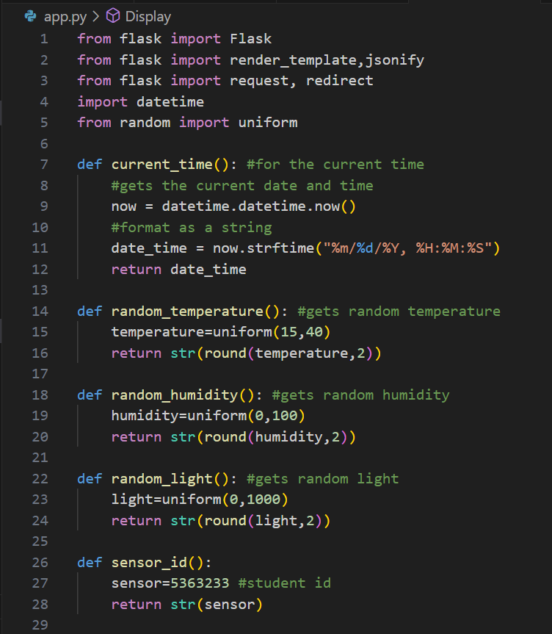

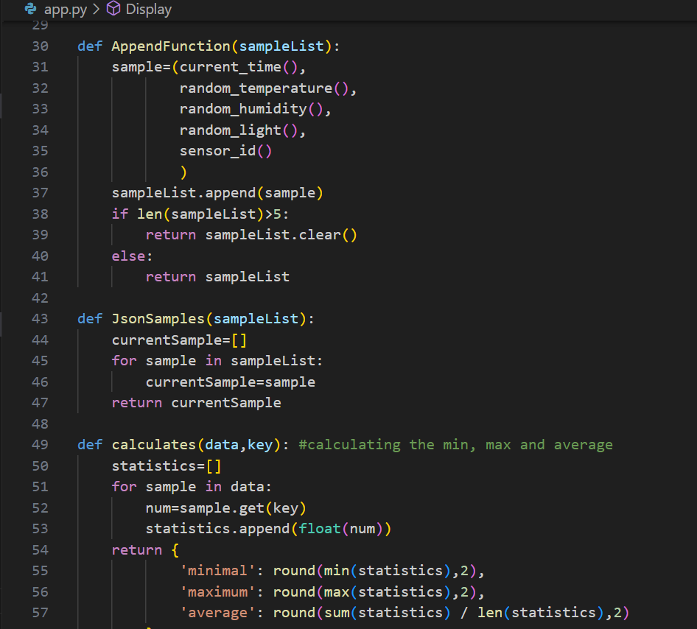

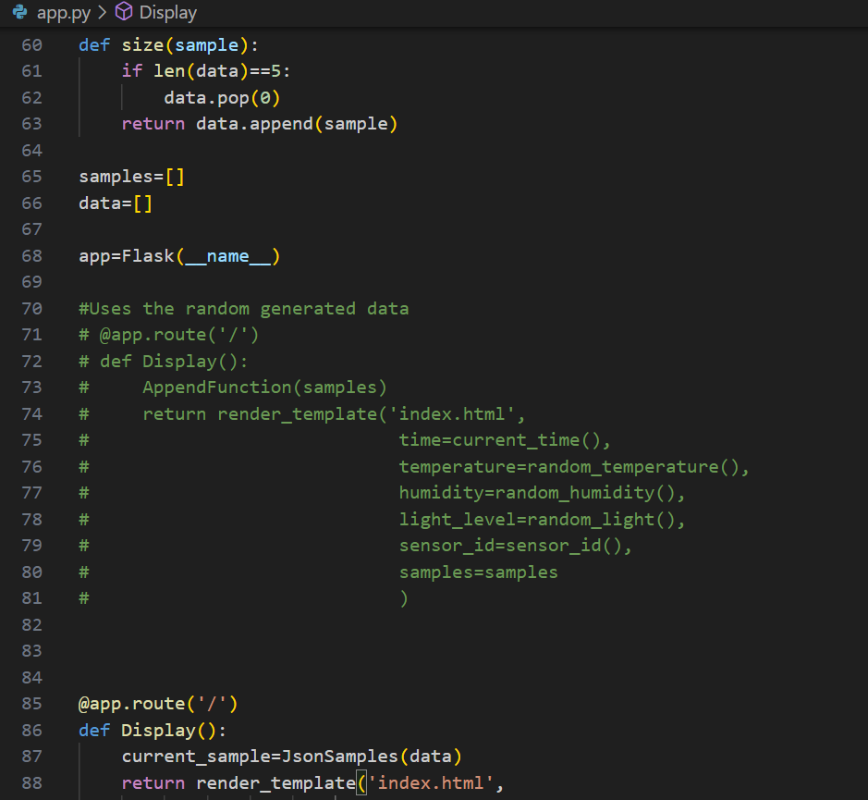

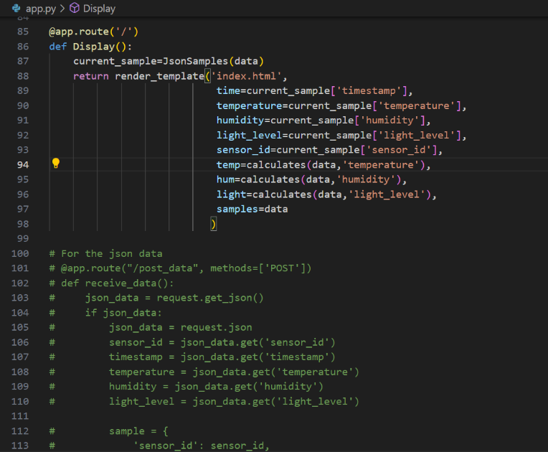

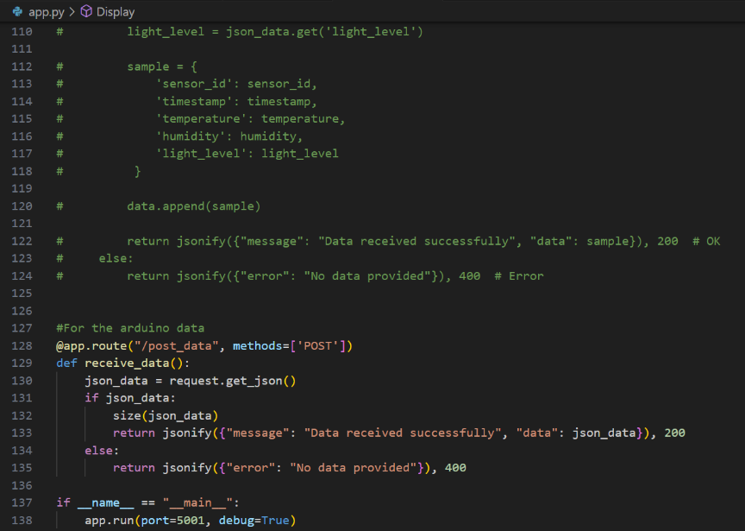

*Here you can see the client:*

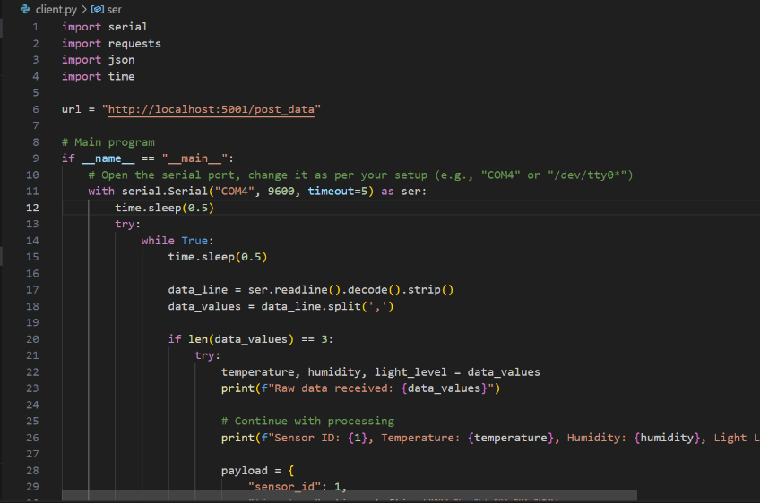

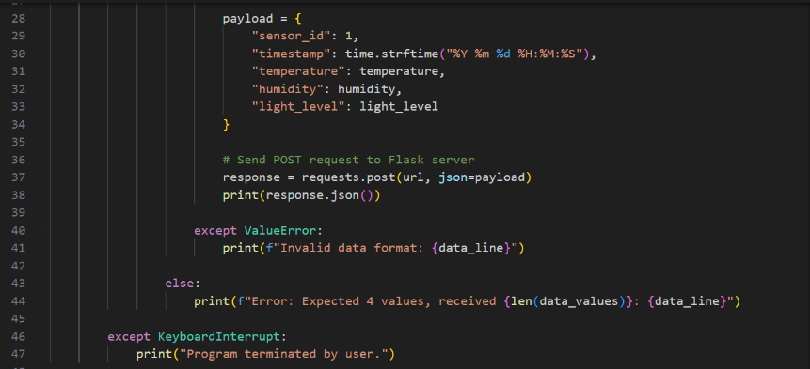

*Here you can see the test client:*

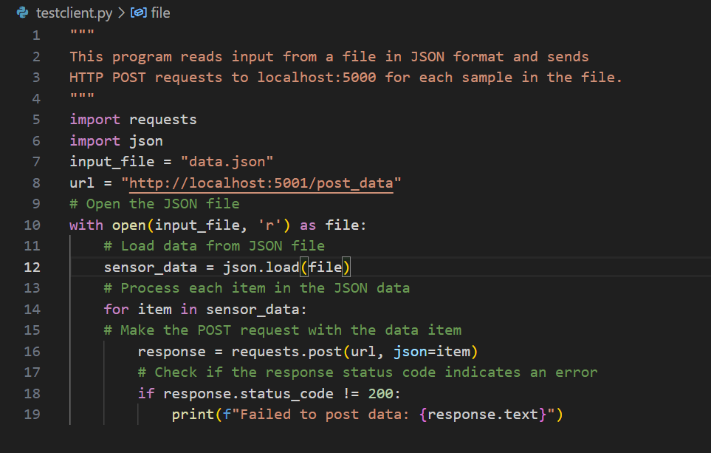

*Here you can see the json file:*

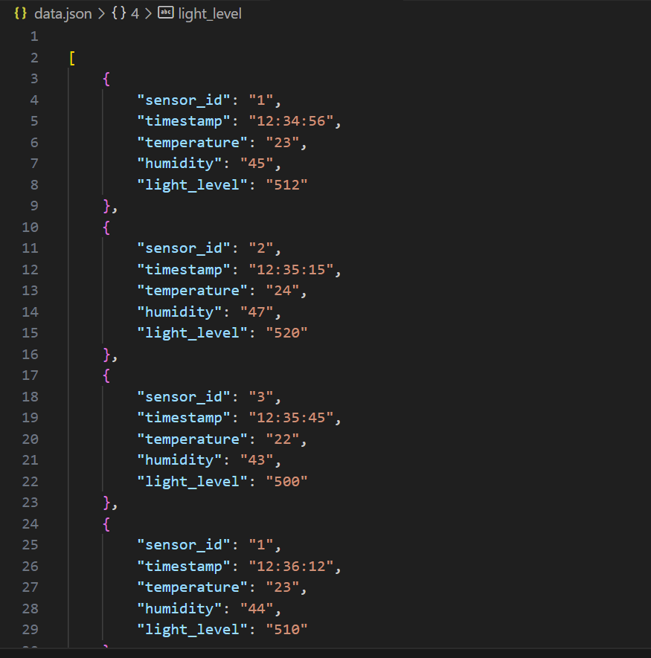

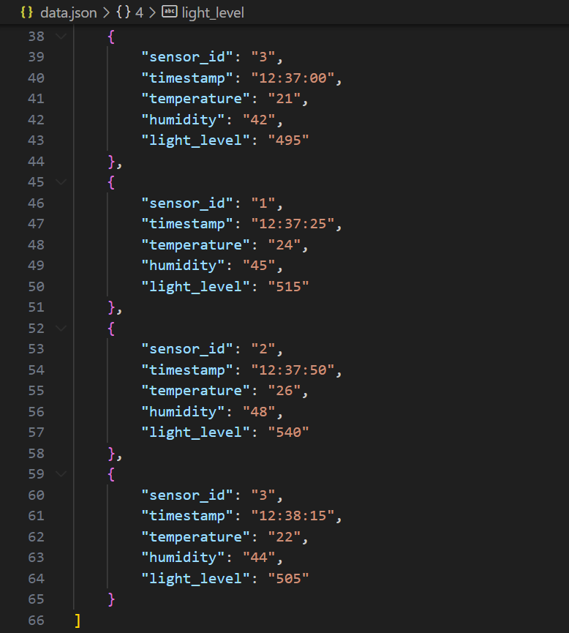

* ***Feedback:***

*I showed my program to my teacher, it was reading the data from the arduino, but it was not visualizing it correctly because all the numbers were the same with every refresh.*

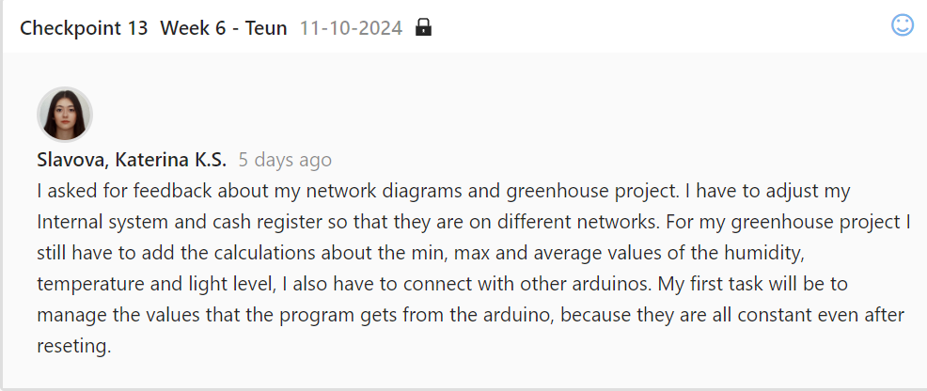

* ***Reflection:***

*At first I had a problem with my ports and the code was not working properly, so my teacher advised me to change the port from 5000 to 5001. I managed to remove the constant values, with an if-statement that checks the amount of data that is received from the arduino. I Iearned how to work with json files and commands and how to connect arduino with python.*

* ***Future actions:***

*I will use the knowledge that I gained for the group projects. I will try to learn new json commands in order to use them for the next tasks, because it was really hard for me to work with it.*

### ICT & Technology

You develop and programme interactive embedded systems in which you use sensors and actuators and apply various I/O techniques.

***Final LED Blink Challenge:***

***<https://drive.google.com/file/d/1if4H460QrB4CXSXn4vLX4K_3VrM5m8L-/view?usp=sharing>***

* ***Action:***

*I had to create an Arduino code that makes the four LEDs blink one after another and then go back. I filmed a video to show how it works:* [*https://drive.google.com/file/d/1bCKj_w3zKaVEYU1MMmR8C1ihfqzXOMbY/view?usp=sharing*](https://drive.google.com/file/d/1bCKj_w3zKaVEYU1MMmR8C1ihfqzXOMbY/view?usp=sharing)

*This is my code: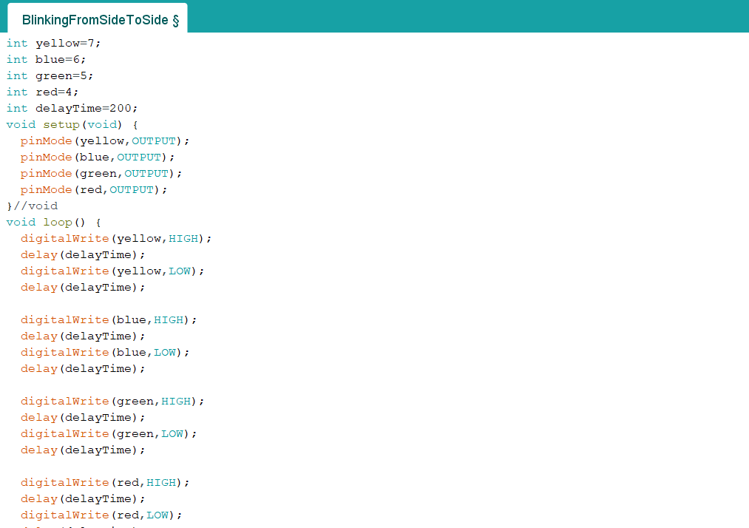*

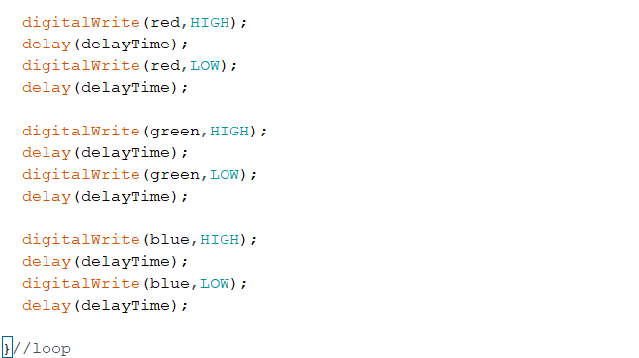

*I have to describe all methods that I’ve used:*

pinMode() – sets the pin to behave as a input or an output; in my case – as a output

digitalWrite() - commands the pin what to do; if the value is High – it is on, if the value is Low – it is off

delay() – shows the interval that the program pauses for

***Feedback:***

*I showed my teacher my code and we talked about it. It was not wrong, but I made the red and yellow blink twice because they are at the end and the start of the loop.*

***Reflection:***

*I removed the repeating parts of the code, because I agree that the Arduino works better without them and now it works exactly how it was supposed to work.*

***Future actions:***

*In the future, I will try not to overcomplicate my code.*

***Single Button Challenge:***

[***https://drive.google.com/file/d/10LMuk8F7XDdwmGQeq2AIMCxeSx7vzgyT/view?usp=sharing***](https://drive.google.com/file/d/10LMuk8F7XDdwmGQeq2AIMCxeSx7vzgyT/view?usp=sharing)

* ***Action:***

*I had to create a program that counts the people that are entering into a festival by clicking a button and show the time that this button has been pressed.*

*This is my code:*

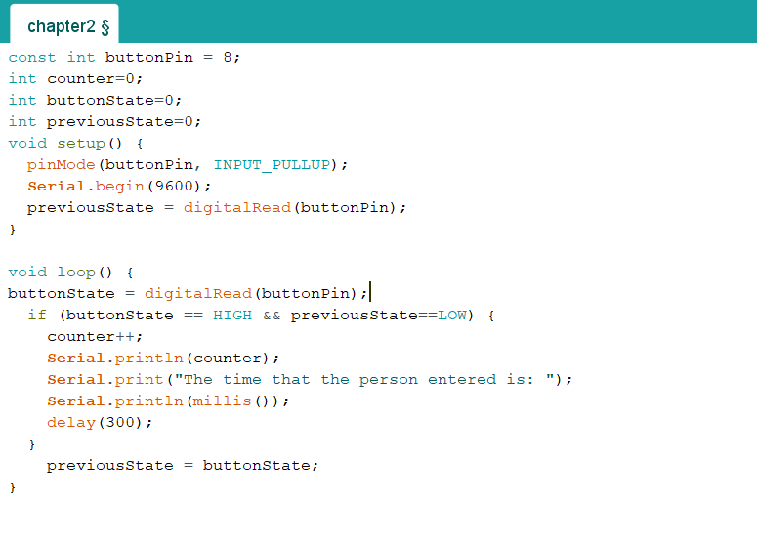

*This is a clip of how the program works:*

[*https://drive.google.com/file/d/1fHhQceWT15j11DZ7lGO3GdN_pgwT5uX7/view?usp=sharing*](https://drive.google.com/file/d/1fHhQceWT15j11DZ7lGO3GdN_pgwT5uX7/view?usp=sharing)

* ***Feedback:***

*When I showed my work to my teacher, he told me that did not have to check the previous state of a button because it is LOW when I push it and HIGH when I release it. I did not know that and thought it was the opposite.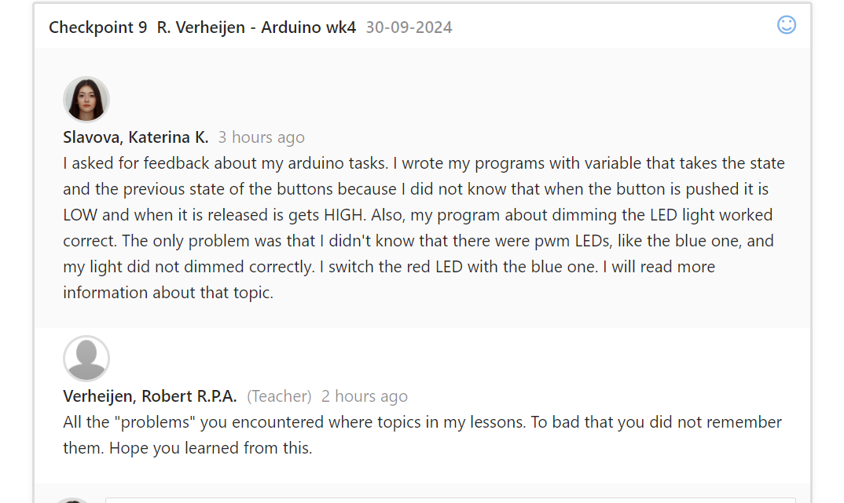*

* ***Reflection:***

*The exercise was not difficult for me, but I should pay more attention in my classes, so I do not miss information like this.*

* ***Future Actions:***

*I will start getting more rest in order to concentrate better.*

*Here is the code without the previous state:*

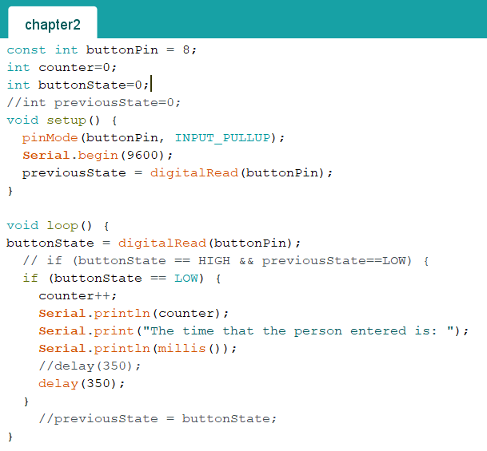

***Two Buttons Challenge:***

***<https://drive.google.com/file/d/120Rn-TtLAV1Gb3w8u5pCK82xajLSpdp_/view?usp=sharing>***

* ***Action:***

*I had to create a new version of the previous exercise that not only counts the people that enter the festival, but also shows how many people are on the festival after someone leaves.*

*Here is my code after I got feedback from my teacher: 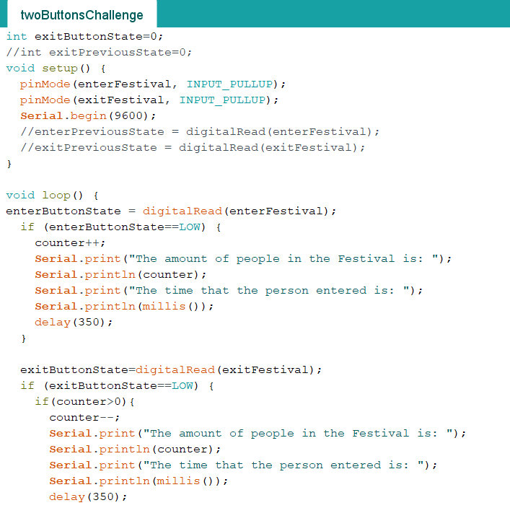*

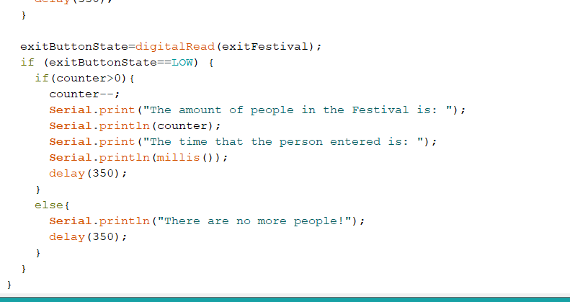

*I did the same mistake with previous state, so I changed it.*

* ***Feedback:***

*Beside the previous state problem, I had to experiment a little bit with the delay, because when a person was leaving the festival, the program removed two instead of just one. That was because I was pressing the button for a longer and the program was counting it as two people.*

**

* ***Reflection:***

*I learned that the delay is very important part of my code. It was not hard to manage my code after I understand the when a button is HIGH or LOW.*

* ***Future actions:***

*I will practise working with delays in order to learn how to use it properly. I will also pay more attention I class.*

***Arduino LED Dimmer:***

[***https://drive.google.com/file/d/1ij30kU4-P8XUAjYwm39P2_4mcalQbB8m/view?usp=sharing***](https://drive.google.com/file/d/1ij30kU4-P8XUAjYwm39P2_4mcalQbB8m/view?usp=sharing)

* ***Action:***

*I had to create a program that uses a potentiometer to control the light of the red LED and shows the percentage on the Serial Monitor.*

*This is my code:*

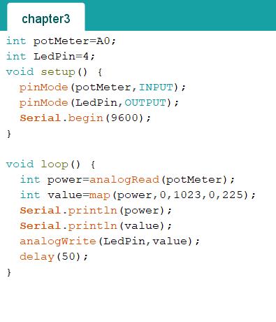

*This is a clip that shows how the program works:*

[*https://drive.google.com/file/d/1th9CTS-c6e_8Ir7h0E_W9lenH1Uu1H70/view?usp=sharing*](https://drive.google.com/file/d/1th9CTS-c6e_8Ir7h0E_W9lenH1Uu1H70/view?usp=sharing)

* ***Feedback:***

*After a talk with my teacher I learned that in order to see how the LED get dimmed I should change to the pwm LED, because the red one did not have that function.*

*This is my code after I change the red LED with the blue one:*

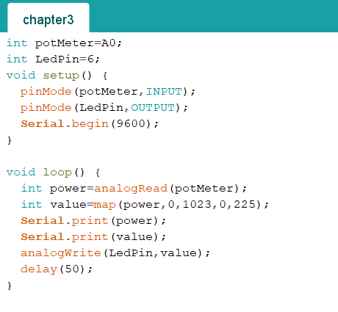

*Here you can see the clip of how it works:*

[*https://drive.google.com/file/d/1l2IpRYy21Pm0hxtRQyupb-Bt1e5nIZJa/view?usp=sharing*](https://drive.google.com/file/d/1l2IpRYy21Pm0hxtRQyupb-Bt1e5nIZJa/view?usp=sharing)

* ***Reflection:***

*The code was not hard to create. The only thing that I should have read more about is the dimming light part.*

* ***Future actions:***

*From now on I will read more about something before I use it. Also, I will not only read about pwm LEDs, but abut everything on the Richshield so I know how it should work.*

***Cyclic display:***

[***https://github.com/KSlavova/Fontys-University/tree/4aa37ceae31e1828b29622e77de919a2e27fd5de/ICT%20and%20Technologies/Week5***](https://github.com/KSlavova/Fontys-University/tree/4aa37ceae31e1828b29622e77de919a2e27fd5de/ICT%20and%20Technologies/Week5)

* ***Action:***

*Creating a cyclic display sequence. The display starts with none, then it shows the temperature, the humidity and the brightness.*

*Video:*

[*https://github.com/KSlavova/Fontys-University/tree/94d1f8065fe04f4d39207781a5c6e4e46d7904e0/ICT%20and%20Technologies/Week5/video*](https://github.com/KSlavova/Fontys-University/tree/94d1f8065fe04f4d39207781a5c6e4e46d7904e0/ICT%20and%20Technologies/Week5/video)

*Here you can see the code:*

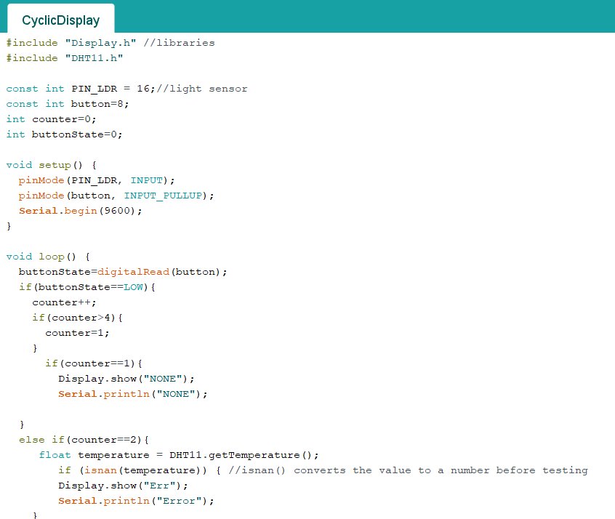

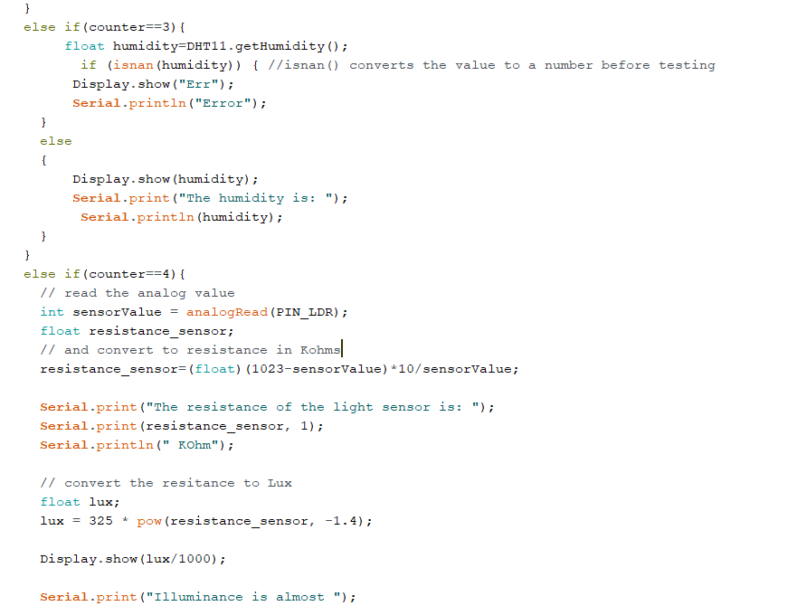

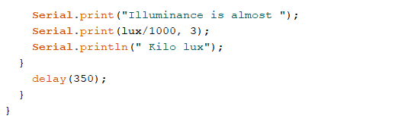

* ***Feedback:***

*My teacher liked how my program works. He told me to change the formatting of the illuminance, so the number on the Richshield and the one the Serial monitor are the same.*

**

* ***Reflection:***

*I learned how to use the DHT11 sensor and visualize data on the Richshield. I learned how to find what the temperature, the humidity and the light are through Arduino.*

* ***Future actions:***

*I will adjust everything we talked about with my teacher and will try to implement it for the greenhouse project for week 6.*

***Greenhouse monitoring system - arduino:***

* ***Action:***

*Creating cyclic display that works without a button. I had to adjust my code for the cyclic display in order todisplay the data without pressing any buttons. Click here to see the python and the html code.*

*Here you can see the code:*

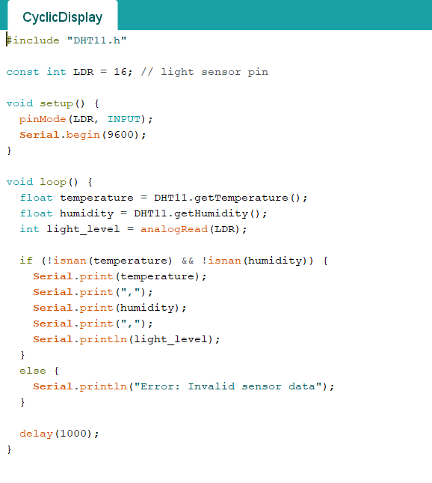

* ***Reflection:***

*I followed the given examlpe in canvas and removed the button implementation. I order to work properly I added a delay at the end of the program.*

# Professional skills

### Professional standard

You apply professional practice, both individually and in teams, in the areas of project organization, communication with stakeholders, exploratory research, and reporting.

***Personal plan to increase effort and engagement:***

* ***Action:***

*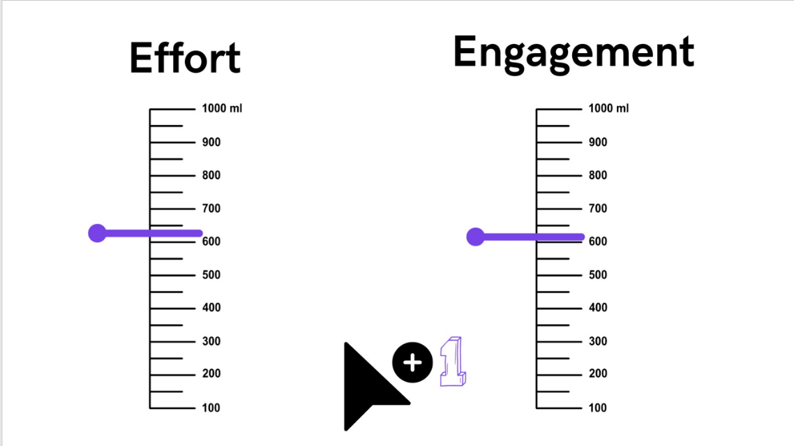I had to come up with plan how to increase my effort, engagement and quality of work.*

* ***Result:***

*My plan to increase my effort and engagement consist of keeping myself motivated; keeping myself humble, because there are always new things to learn; giving myself enough time to relax and sleep, so I can have more energy to keep going. Other tips could be: switching off my phone when doing my tasks, so that I don’t get easily distracted and listening to music as it helps me concentrate.*

* ***Reflection***

*After I thought about this idea, I came with the conclusion that there is always a way to improve yourself.*

* ***Future actions:***

*I will follow the steps I talked about in my plan and think about what other things I can change.*

***Presentation on ICT and Software engineering profile:***

* ***Action:***

*Me and all people from my class that are thinking about getting into software engineering had to create a presentation on a whiteboard about the daily tasks, the most used languages, the organisations that you could work for and show what this field looks like.*

*Targets to present this field:*

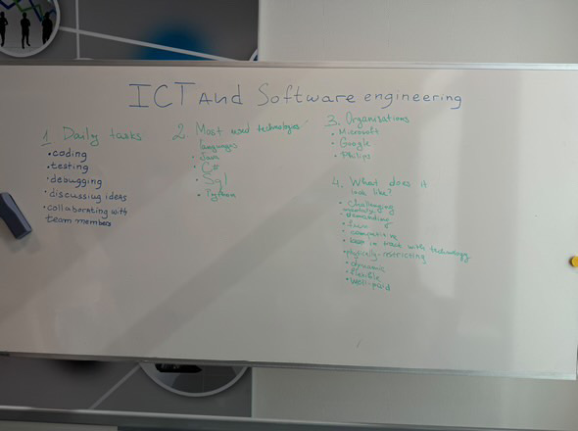

*After that, we all talked about each field with our teacher.*

* ***Reflection:***

*This task helped me to understand better what each field is about, so that I can think about it when coming up with my decision in the future.*

* ***Future actions:***

*I will rethink carefully about my future choice, now that I have more information.*

***Presenting my Research report:***

*<https://github.com/KSlavova/Fontys-University/blob/e719f41595fa46405307cbd202b9ad4664f382fc/Professional%20standard/Week5/PresentationResearchReport.pptx>*

* ***Action:***

*Presenting my research idea to my classmates. We all gathered in small groups of four and presented our researches, after that we gave each other feedbacks and asked questions about our topics.*

*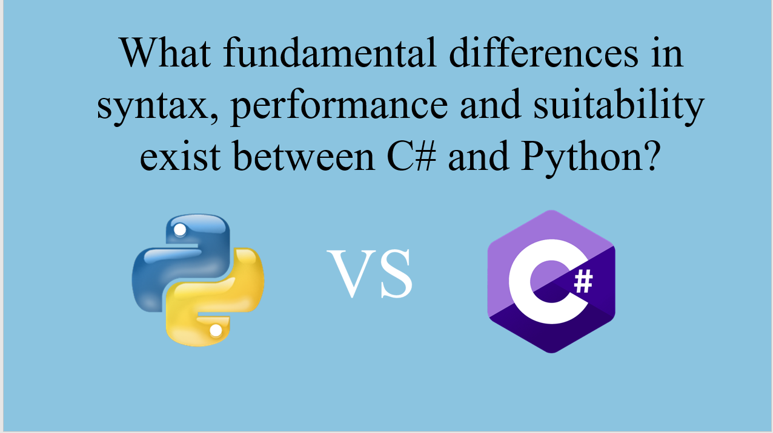Here you can see the main topic in my presentation:*

* *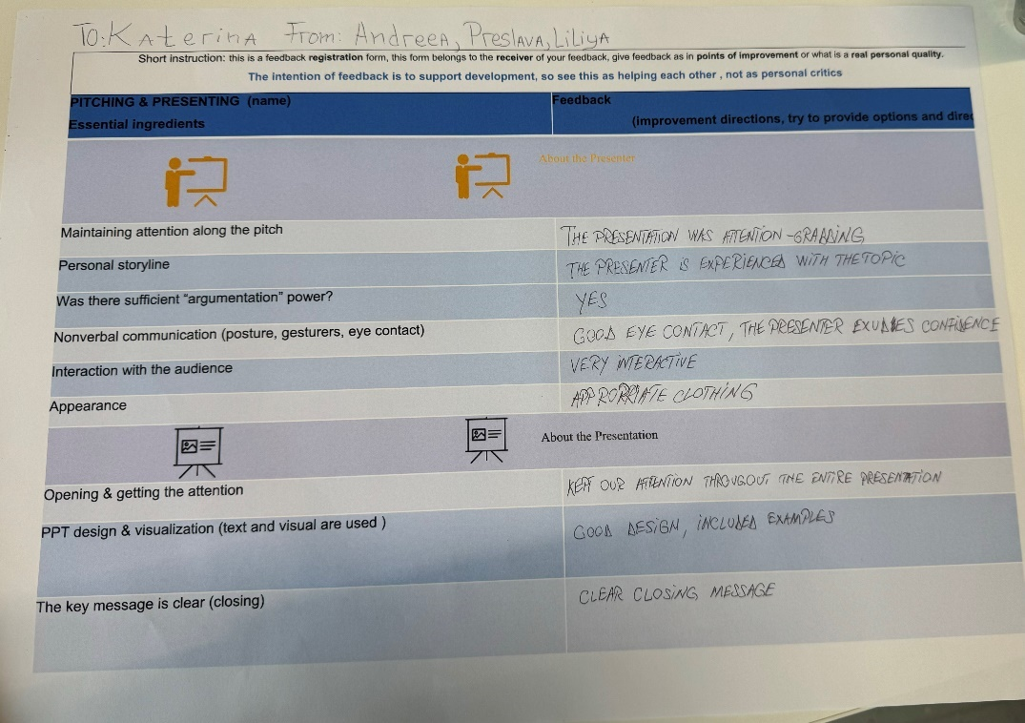****Feedback:***
* ***Reflection:***

*At first, it was a really scary moment for me, but after that I learned that these are opportunities that help to develop your presenting skills, which is really important for your future.*

* ***Future actions:***

*I will continue practicing my presentation skills and try to be calmer while talking.*

***Presentation about my future profile choice:***

*<https://github.com/KSlavova/Fontys-University/blob/e719f41595fa46405307cbd202b9ad4664f382fc/Professional%20standard/Week5/Software%20Engineering.pptx>*

* ***Action:***

*Presenting what I profile I plan to choose. I had to create a presentation that explains what my choice is and why.*

*Here you can see the main reasons:*

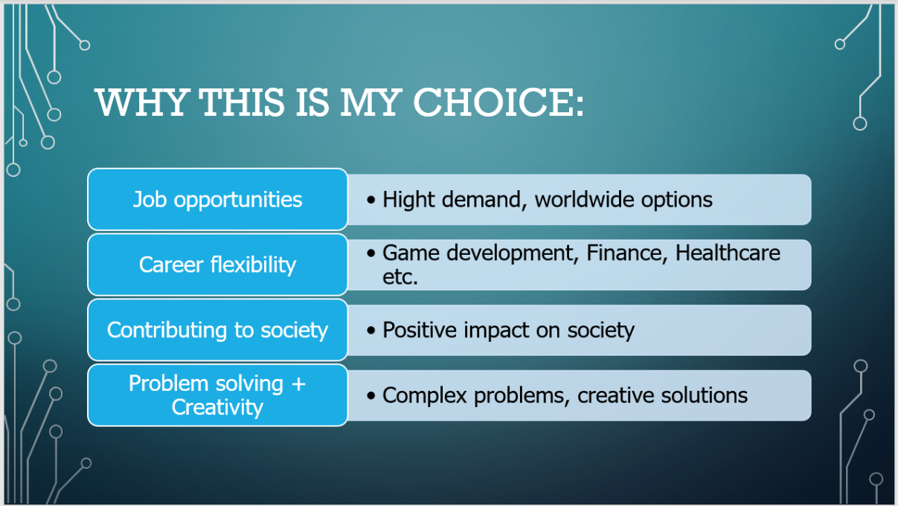

* ***Feedback:***

*From Preslava:*



*From Liliya:*

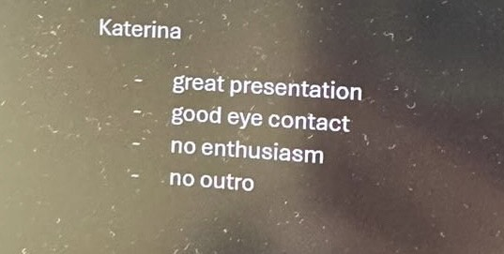

* ***Reflection:***

*For now, this is what my personal choice is, but I will wait until the Profile Market and see what will happen.*

* ***Future actions:***

*I will work on my presenting skills and I will try to be more enthusiastic for the next time.*

***Creating a group:***

* ***Action:***

*Forming a group for future projects. We all wrote down what our strengths and weaknesses are and what we want to learn from working as a group.*

*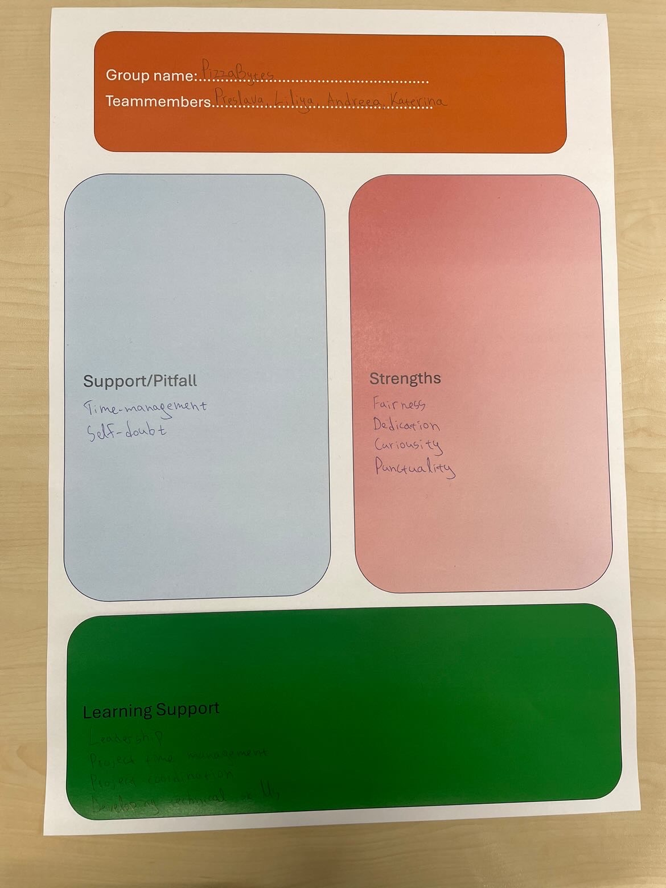Here you can see the group’s information:*

* ***Reflection:***

*We all had similarities in all areas, but everyone was so unique at the same time. I have talked and shared feedback with those people. We were always truthful with one another and I believe that we will have no problems with each other.*

***Marshmallow challenge:***

* ***Action:***

*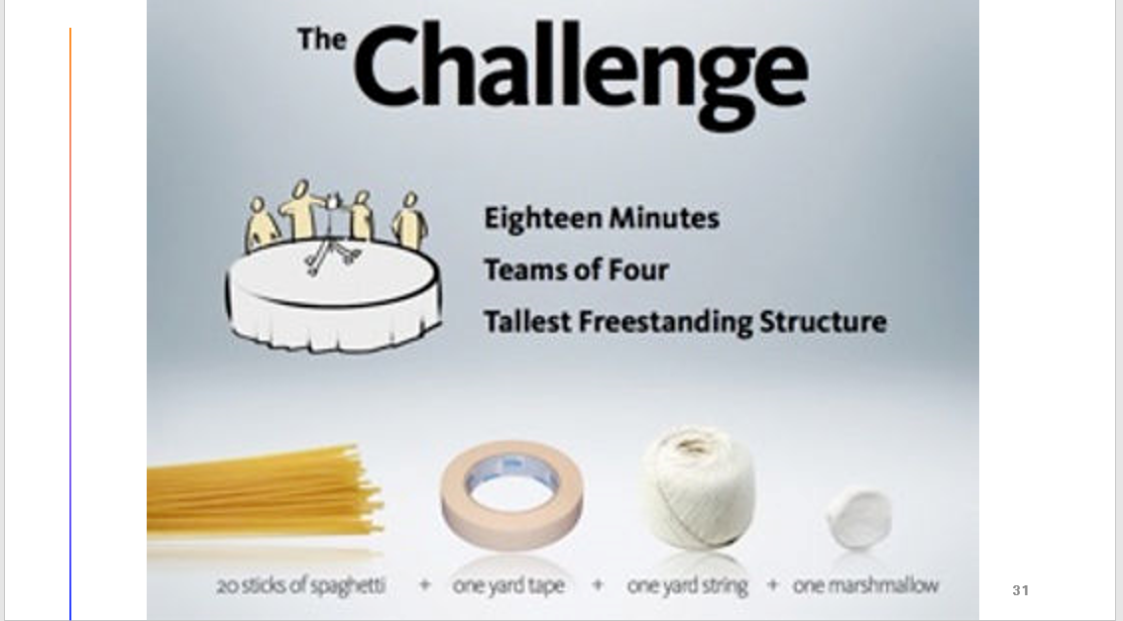Creating the tallest freestanding structure. Every team had to come up with an idea how to create the tallest structure that holds a marshmallow at the top of it. We used spaghetti for the structure.*

*This is our structure:*

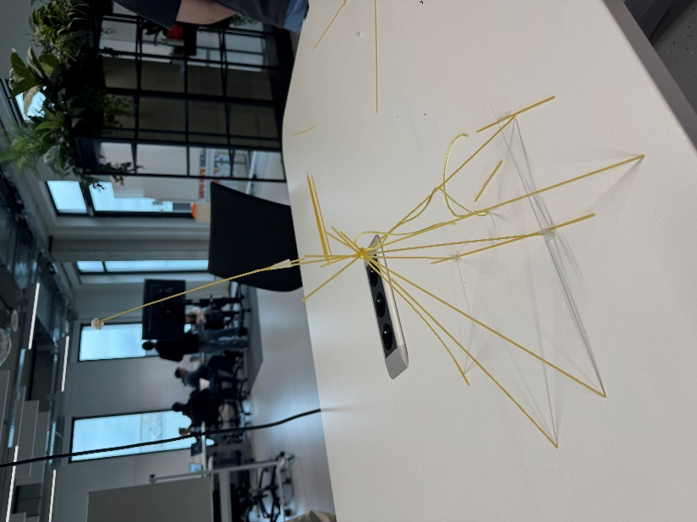

* ***Feedback:***

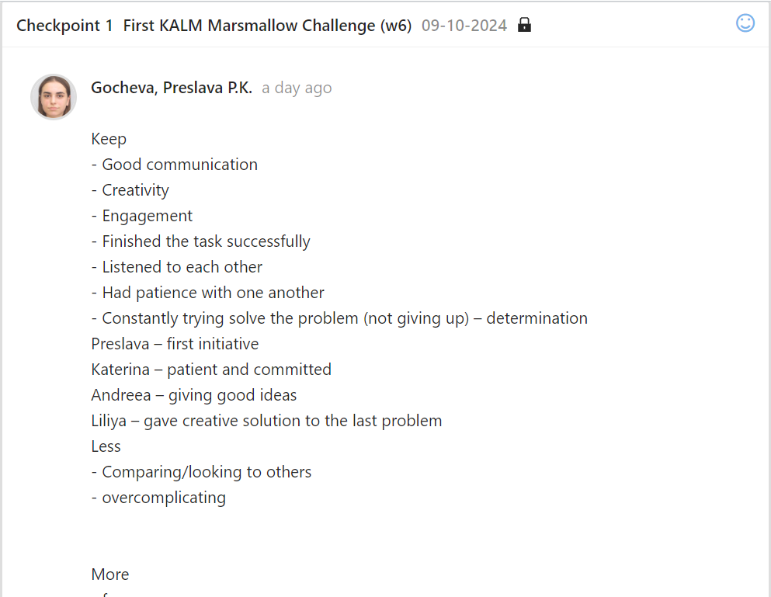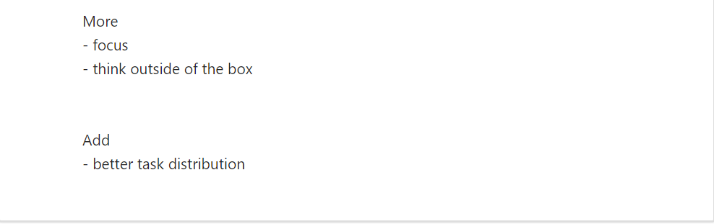

* ***Reflection:***

*We all managed to collaborate and create something together, even if we did not win, we learned how to a lot about how we think and how to communicate.*

* ***Future actions:***

*We will try to stop comparing us to others, because this was the only thing that held us back. We will have to continue working together and keep the good energy in the group.*

***Agreements how to work together:***

*<https://github.com/KSlavova/Fontys-University/blob/81d04f5b1979d0fd2482b9d1e1c938a9d73a0b99/Professional%20standard/Week6/Worksheet%20working%20together.pptx.png>*

* ***Action:***

*Creating rules and agreements on how to work as a group. We used the google drive shared environment, so that everybody could take part in writing and editing the document at the same time. We all agreed to follow the agreements and be punctual.*

*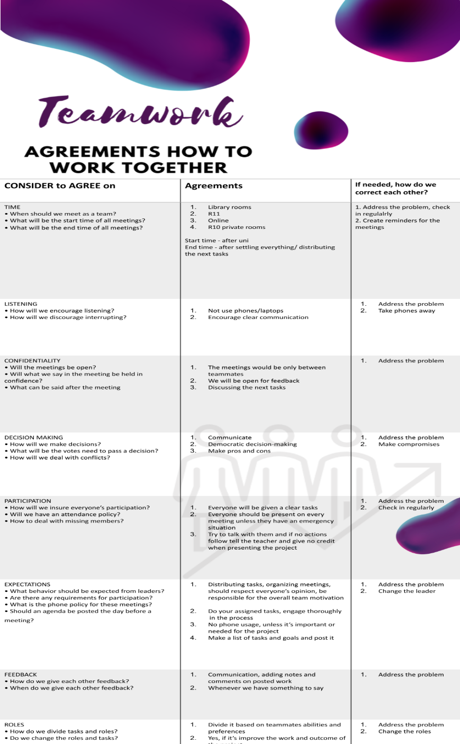Here you can see the document:*

* ***Reflection:***

*We all agreed that these will be very useful for our further work, even though, in our opinion we would not have any problems because we communicate a lot.*

***My Fontys:***

***<https://www.canva.com/design/DAGTKATYoho/RM-xr-uZgocWz757gOB2Cg/edit?utm_content=DAGTKATYoho&utm_campaign=designshare&utm_medium=link2&utm_source=sharebutton>***

* ***Action:***

*Improving a service that we use and has annoying features. Our group – PizzaBytes came with an idea about how to improve My Fontys app. For some of use the app has never worked and for the other part it just stopped working. So, we created a figma prototype presenting out solutions and presented it to our classmates. Click here to see the prototype:* *My Fontys prototype*

*Here you can see the whole presentation:*

[***https://www.canva.com/design/DAGTKATYoho/RM-xr-uZgocWz757gOB2Cg/edit?utm_content=DAGTKATYoho&utm_campaign=designshare&utm_medium=link2&utm_source=sharebutton***](https://www.canva.com/design/DAGTKATYoho/RM-xr-uZgocWz757gOB2Cg/edit?utm_content=DAGTKATYoho&utm_campaign=designshare&utm_medium=link2&utm_source=sharebutton)

*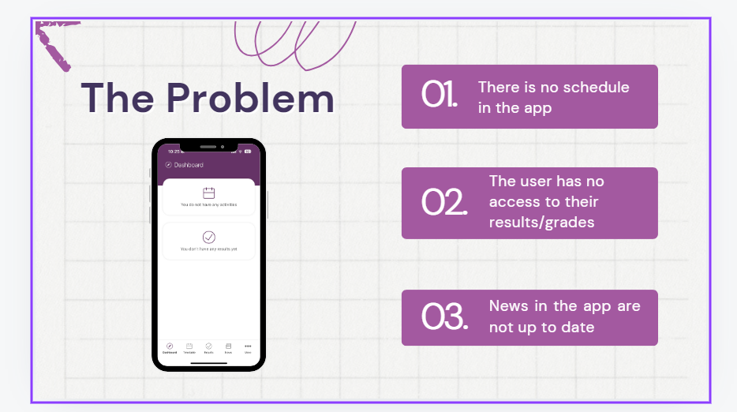Here you can see the outlined problems, the reviews of the actual app and the rating:*

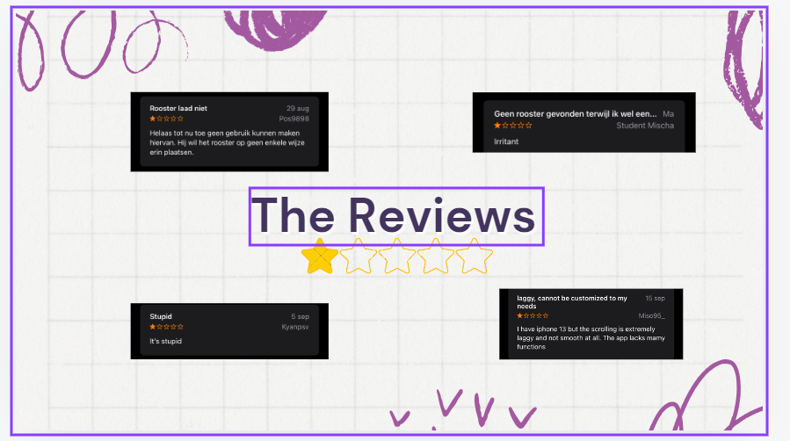

* ***Feedback:***

*After presenting it, our teacher suggested improving the way we introduce the topic so that it is more professional.*

* ***Reflection:***

*I learned how to work with others, listen to their opinion and exchange knowledge. We all worked as one and manage to create a product.*

* ***Future actions:***

*We will practice more on how to present our products.*

***Research report:***

* ***Action:***

*Creating a Research report that outlines a specific problem with solutions to it. I had to choose a specific topic and write a research. I had to use the APA style.*

*First, I came up with the idea and the methods that I was supposed to use:*

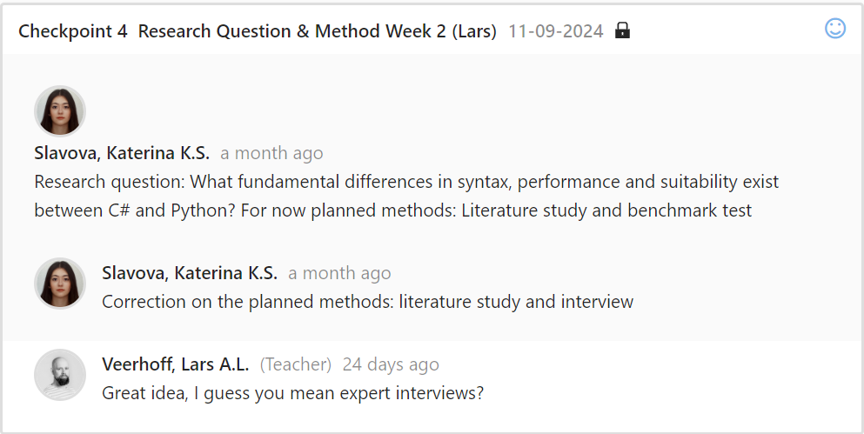

*After that, I came up with a plan on what to write:*

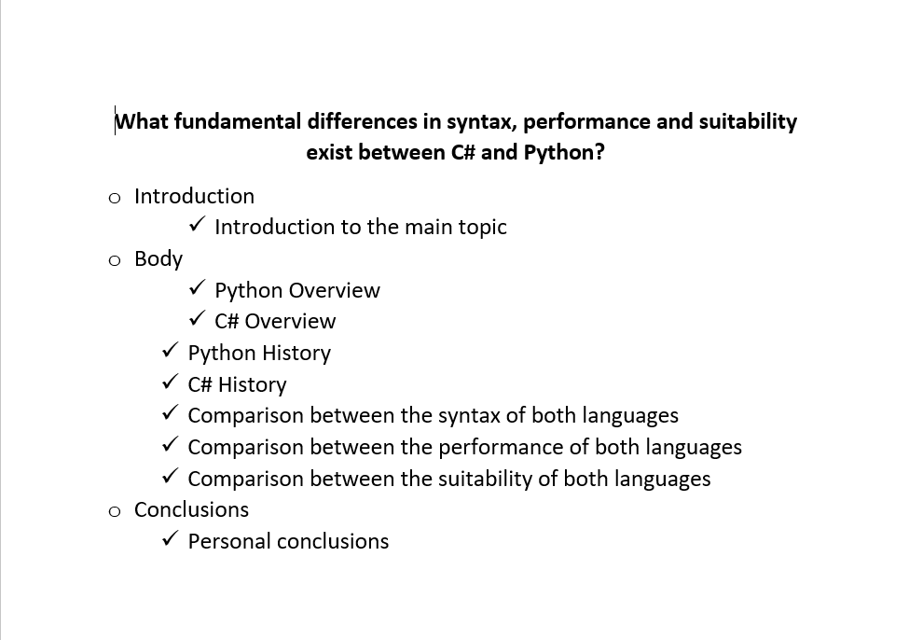

*Then, I started working on my research. You can find it here:*

[*https://github.com/KSlavova/Fontys-University/blob/22b4f400ad44317c7f452329ff2330b89325abde/Professional%20standard/Week6/Research%20report.docx*](https://github.com/KSlavova/Fontys-University/blob/22b4f400ad44317c7f452329ff2330b89325abde/Professional%20standard/Week6/Research%20report.docx)

* ***Feedback:***

*After showing it to my teacher, he explained me more about the structure and how to improve it. Also, I had to add methods in my research and use the APA style to manage my references.*

* ***Reflection:***

*I learned how to create a research. I learned a lot about the differences between python and C# and now I have a better vision on how and when to use them.*

* ***Future actions:***

*I will work on my structure and references.*

***GitHub:***

[*https://github.com/KSlavova/Fontys-University.git*](https://github.com/KSlavova/Fontys-University.git)

* ***Action:***

*Creating a github repository that will have all my tasks from semester 1.*

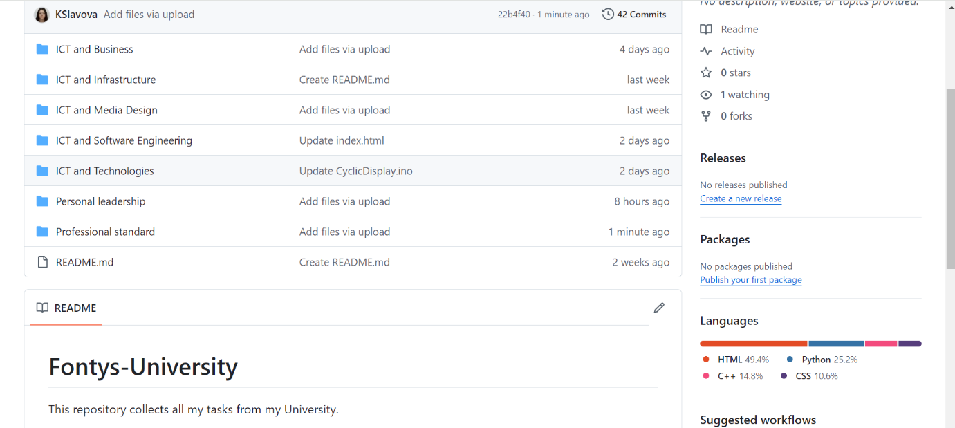

* ***Reflection:***

*I have previous experience with github. I tried to follow the structure of the PEP, so everything is easily accessed. This account will help me with my group projects, because we will have a platform, where we can share all the sources we have.*

***Team charter:***

* ***Action:***

*Creating a team charter that contains the group’s rules, roles and results from the Belbin test.*

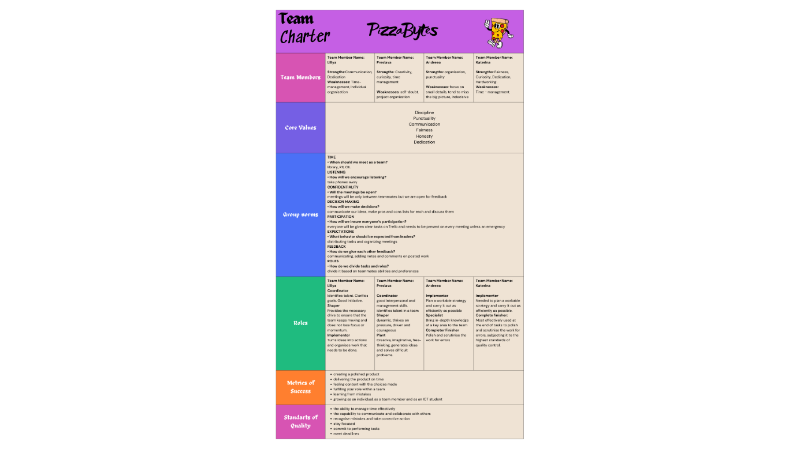

* ***Feedback:***

*After reading it, our teacher said that he had no remarks on it. He asked us how will we communicate, and we explained that we had created GitLab, Instagram group and a Trello calendar.*

* ***Reflection:***

*For now, everything is running smooth. We all work together on a shared documents in google drive and everyone is attending the group meetings.*

* ***Future actions:***

*I will follow the group rules and respect everyone’s opinion.*

***Pizza project plan:***

* ***Action:***

*Creating a project plan for the Pizza project. Our group created a plan that contains a project definition and phasing, where we describe what the problems are and how we plan to solve them.*

*Here you can find the document:* [*https://github.com/KSlavova/Fontys-University/blob/f994106efb9823be55ae977862b7da70efb34df2/Professional%20standard/Week7/Pizza%20Project%20Plan.docx*](https://github.com/KSlavova/Fontys-University/blob/f994106efb9823be55ae977862b7da70efb34df2/Professional%20standard/Week7/Pizza%20Project%20Plan.docx)

* ***Feedback:***

*We showed our teacher the document, he told us that we have to describe everything more specific and asked us to explain how our smart oven will work.*

* ***Reflection:***

*I learned how to write a project plan and that you should describe everything you will do, you should outline the problems and be very specific on the topic.*

* ***Future actions:***

*We will follow the plan that we implemented in the document in order to meet the deadlines.*

***Trello:***

* ***Action:***

*Creating a Trello account and project board for the group Pizza project. Me and my team use Trello to keep track of every task we have.*

*Here you can see our project board:*

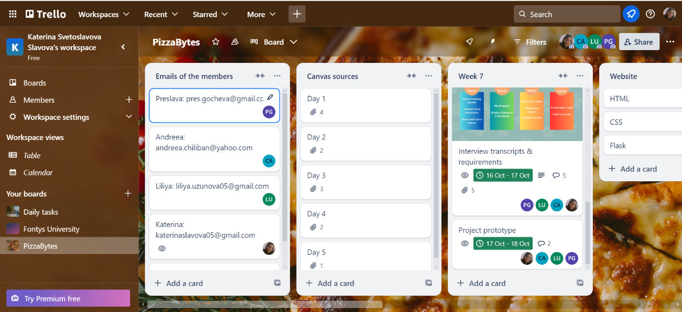

* ***Reflection:***

*This app is very useful for group projects, because it gives you the opportunity to share every tasks with your group members and you have a reminder before ever deadline.*

***MoSCoW:***

* ***Action:***

*Interviewing clients and outlining the important information using the MoSCoW method. Our group interviewed two potential clients and used the interview with Mr. Panuchi from the reader document.*

*Here you can find the interviews transcript and the MoSCoW:*

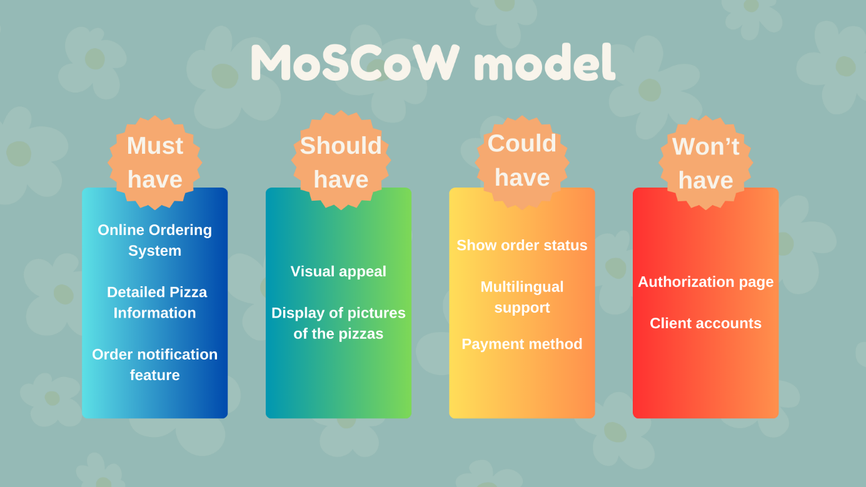[*https://github.com/KSlavova/Fontys-University/blob/506182131b4af5141dbe59246747f8fc2ff84c07/Professional%20standard/Week7/Interview%20Transcript%20(1).docx*](https://github.com/KSlavova/Fontys-University/blob/506182131b4af5141dbe59246747f8fc2ff84c07/Professional%20standard/Week7/Interview%20Transcript%20(1).docx)

* ***Feedback:***

*We showed our teacher the MoSCoW model and the Project plan and he liked how we structured everything. He suggested to make our Trello plan more specific, so that we have better time management.*

* ***Reflection:***

*We learned how to outline the most important information from interviews and sort it by importance.*

* ***Future actions:***

*We will structure our tasks in Trello by category and the person who need to implement the task.*

### Personal leadership

You take the initiative in asking for, and reflecting on, feedback. You identify your own core values as the basis for your study career and professional development.

**Core Values:**

View the full results:

<https://github.com/KSlavova/Fontys-University/blob/0e764044c798e53f2310f058a984b4102f28d39a/Personal%20leadership/StrengthsProfile-Katerina-Slavova.pdf>

* **Action:**

I took the character strengths survey in order to find what my personal core values are.

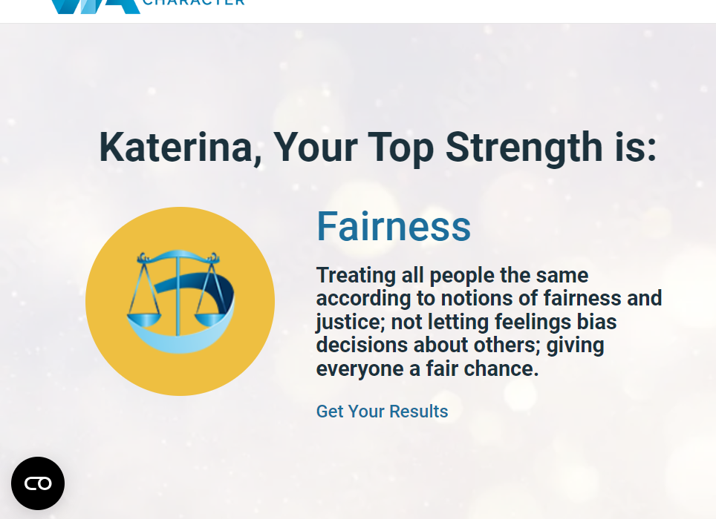

* **Reflection:**

It was very interesting finding more about yourself. I agree with the results and will try to work more on the improvement of my strengths.

**Profile Choice:**

* **Action:**

Making a very considered and mindful choice about my future career after visiting the Profile market. I visited all profile presentations on the market, and was hesitant between software engineering and media design, but the talks with the other students from media and software really helped.

* **Feedback:**

I talked with a boy from the software and he showed me some of his old projects. He also told me that it would be really hard and this field is for serios students. I talked with a student from media, who also showed me his past projects, which were very interesting, but it was not enough for me.

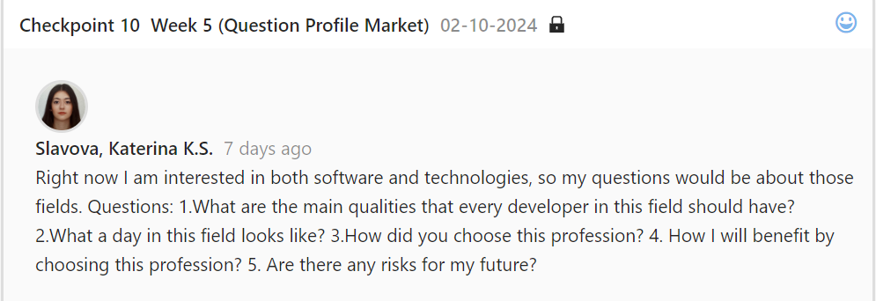

* **Reflection:**

I chose software engineering because I know that this is my passion and it felt right.

***Belbin Team Role Test:***

*<https://github.com/KSlavova/Fontys-University/blob/d68c95beeda447746a7c6e3f6623213b05b2b807/Personal%20leadership/Belbinrole%20copy.xlsx>*

* ***Action:***

*Finding my personal role in a group by completing the Belbin team role test.*

*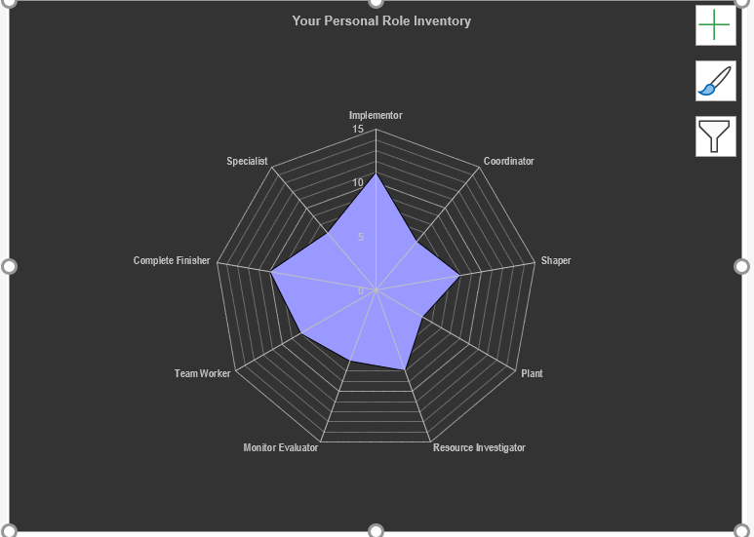Here you can see the chart and the table with the results:*

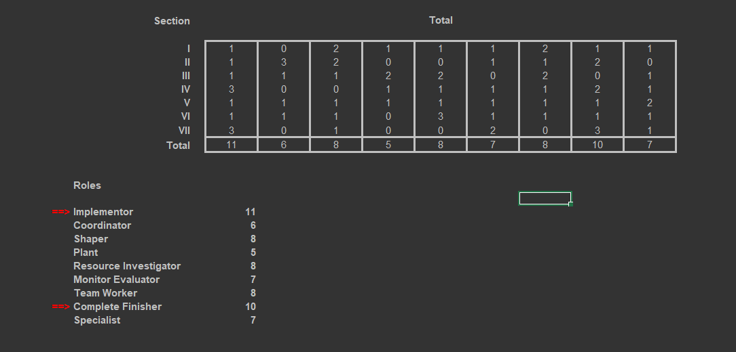

* ***Feedback:***

*After seeing the results, my teacher told me that I am more of a generalist.*

* ***Reflection:***

*I believe that the results on of the test are pretty accurate and I was not surprised at the end.*

* ***Future actions:***

*I will do my best to help my group and will try to help with everything I can. I will follow the group rules and will try to manage properly any confrontation that could appear.*